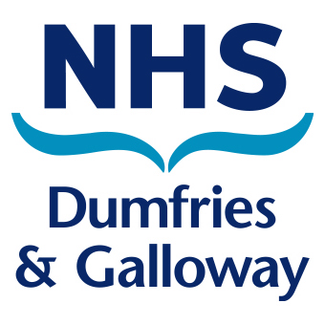COMMUNITY PHARMACY OPENING TIMES

AUGUST HOLIDAY PERIOD

Monday 28th August 2017

DUMFRIES PHARMACIES

The pharmacies listed below will be open at the times shown.

Pharmacy | Address | May | Times
G R Blount Pharmacy | St Michaels Bridge Road  Dumfries, DG1 2PX  Tel: 01387 262244 | Monday, 28 August | 8.45 a.m. – 6.00 p.m.
Boots The Chemist Ltd | 74 High Street  Dumfries  DG1 2BS  Tel: 01387 253859 | Monday, 28 August | 10.00 a.m. – 5.00 p.m.
Lochthorn Pharmacy | Lochthorn Medical Centre  Edinburgh Road Dumfries, DG1 1TR  Tel: 01387 251111 | Monday, 28 August | CLOSED
Lloyds Pharmacy | 12 Castle Street  Dumfries  DG1 1DR  Tel: 01387 262107 | Monday, 28 August | CLOSED
Lloyds Pharmacy | Gillbrae Medical Centre  Gillbrae Road  Georgetown  Dumfries, DG1 4EJ  Tel. 01387 248363 | Monday, 28 August | 9.00 a.m. – 1.00 p.m.
Your Local Boots Pharmacy | 21 - 23 Castle Street  Dumfries  DG1 1DJ  Tel. 01387 269183 | Monday, 28 August | CLOSED
Wm Murray Chemist | 35 Galloway Street  Dumfries  DG2 7TN  Tel. 01387 266248 | Monday, 28 August | CLOSED
Northern Chemist | 32 Lochside Road  Dumfries  DG2 0LW  Tel. 01387 240111 | Monday, 28 August | CLOSED

Logan East – 1st Floor, Crichton Hall, Bankend Road, Dumfries, DG1 4TG
Tel: 01387 244371; Fax 01387 247706 E-mail dumf-uhb.PCD@nhs.net

