Claim Form – Community Pharmacists Attendance at Meetings (full day)
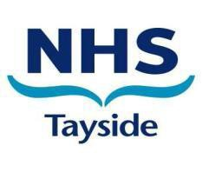

TITLE | DETAILS
1. Name
2. Address
(where payment should be sent)
Note: this is normally the Pharmacy address
3. Contractor Code
4. Name of Meeting Attended
5. Date of Meeting
6. Name of Officer organising meeting (if known)
7. Fee (to be completed by NHS Tayside)  Community Pharmacist Session for up to 7.5 hours | £229.72
8. Mileage = 37.4 per mile.  Please specify journey details and mileage | _____miles x 37.4p = £
9. Total claimed | £
10. Signature of Claimant

FOR NHS USE ONLY

1. Confirmation of attendance
2. Authorised for payment
3. Expenditure code

NOTES

1. | Please send claim forms to: | Marion Manzie
Pharmacy Development Manager
PharmacyDepartment
Kings Cross Hospital
Clepington Road
Dundee, DD3 8EA

- This form can only be used to claim expenses in connection with meetings organised by NHS Tayside.

- Completed forms must be returned to the above address no later than 28 days after date of meeting.

