Updating your Prescriber Details on TURAS

User Guide

This guide aims to outline the steps required to access and update your prescriber details on TURAS.

1. Go to the [Turas](https://turasdashboard.nes.nhs.scot/home/) homepage and select ‘sign in’

1. At the sign in page, enter your email address and password, or select forgotten your password if required.

1. To reach the TURAS Training Programme Management (TPM) , select ‘Training Management’ from the drop down menu ‘Applications’ or from the Application list on the main screen.

1. Select ‘My Details’

1. Click on ‘Prescriber Details’

*Please note if the ‘Prescriber’ tab is not visible you should select the green ‘Edit’ button, tick the box beside ‘Prescriber’ on the next page, then click ‘save’. This will make the ‘Prescriber Details’ tab appear.

1. In the Prescriber details page, check that all information is up to date and accurate and edit as required. For the following fields you can select more than one option:

‘Board(s)’

‘Areas(s) of Practice’

‘Sector’

Fields marked with a red asterix are mandatory.

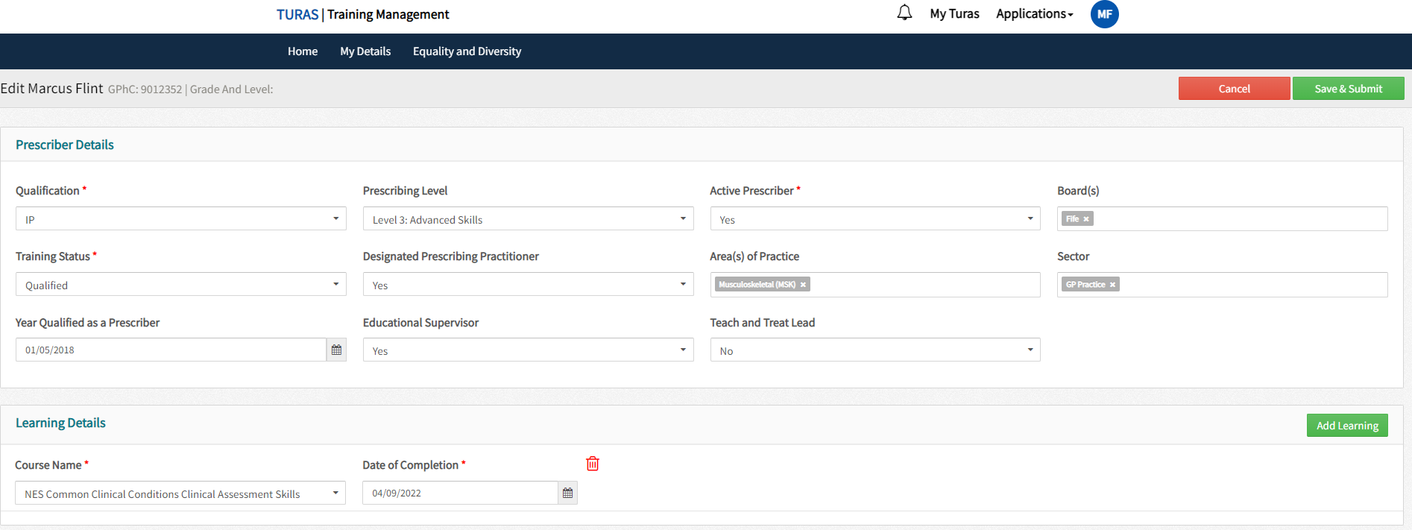

1. You can indicate prior learning by selecting “Add learning” and then selecting the details from a prepopulated list. You must add a date of completion (select the approximate date if you don’t know the exact date).

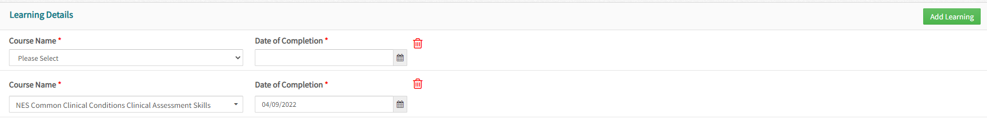

To add more than one learning you can either: save the first entry then click ‘Add Learning’ button and repeat the process or click ‘Add Learning’ for as many entries as are required then save.

8) Once all information is accurately entered click the green ‘Save and Submit’ button.

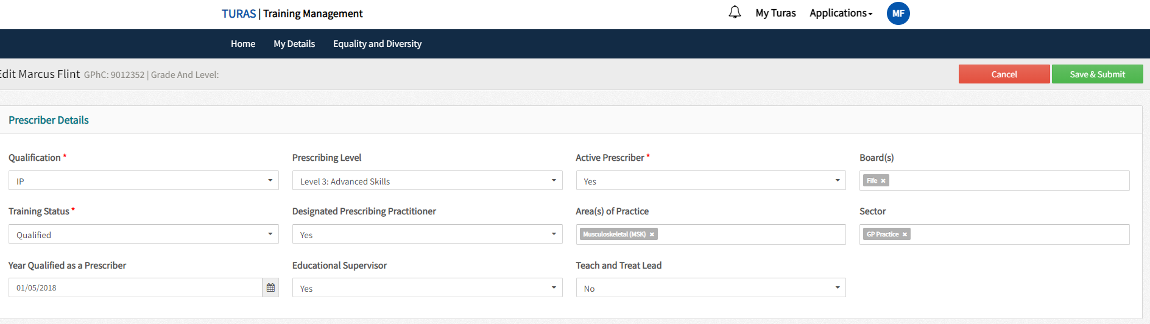

9) Changes can be made if required by clicking the green ‘Edit’ button. Once satisfied that all information has been updated and saved, click on your initials in the top right of the page and select ‘Sign out’

