Pharmacy / Prescribing Department
NHS Lanarkshire Headquarters
Kirklands
Fallside Road
BOTHWELL
G71 8BB

TO ALL COMMUNITY PHARMACISTS Date: 22nd September 2023 IN NHS LANARKSHIRE Enquiries to:
medsguidance@lanarkshire.scot.nhs.uk
PLEASE SHARE THIS WITH LOCUMS
AND SUPPORT STAFF AS
APPROPRIATE

Dear Colleague,

GLUTEN FREE FOODS SERVICE

A review of prescribable products available on the gluten free foods service has been undertaken. As a result the following changes have been made:

- Contact and delivery details have been updated where appropriate.

There are three product removals to this update of the formulary list:

Product | PIP code | Status
Bialimenta Potato Gnocchi | 351-1961 | Removed
Tritamyl self-raising flour | 228-0675 | Removed
Barkat Xanthan Gum | 282-8572 | Removed

There are fourteen product additions to this update of the formulary list:

Product | PIP code | Status
Juvela Spaghetti 500g | 280-7998 | Added
Glutafin Crispbread 150g | 338-4443 | Added
Juvela Flakes 300g | 371-1652 | Added
Glutafin High Fibre Loaf Sliced 350g | 401-4296 | Added
Glutafin Select Fresh Seeded Loaf Sliced 400g x 8 | 402-3685 | Added
Juvela Mixed Case Fresh Rolls | 839-2839 | Added
Juvela White Loaf Unsliced 400g | 031-4781 | Added
Pure Bakery Blend 1kg | 282-8580 | Added
Pure White Rice Flour 500g | 325-7904 | Added
Pure Brown Rice Flour 500g | 325-7912 | Added
Pure Potato Starch Flour 500g | 325-7920 | Added
Pure Tapioca Starch Flour | 325-7946 | Added
Pure White Teff Flour 1kg | 343-1483 | Added
Pure Brown Teff Flour 1kg | 343-1467 | Added

The formulary document detailing the full list of gluten free food products can be downloaded from the NHS Lanarkshire Community Pharmacy website https://www.communitypharmacy.scot.nhs.uk/nhs-boards/nhs-lanarkshire/pharmacy-services/gluten-free-food-service/

Yours sincerely,
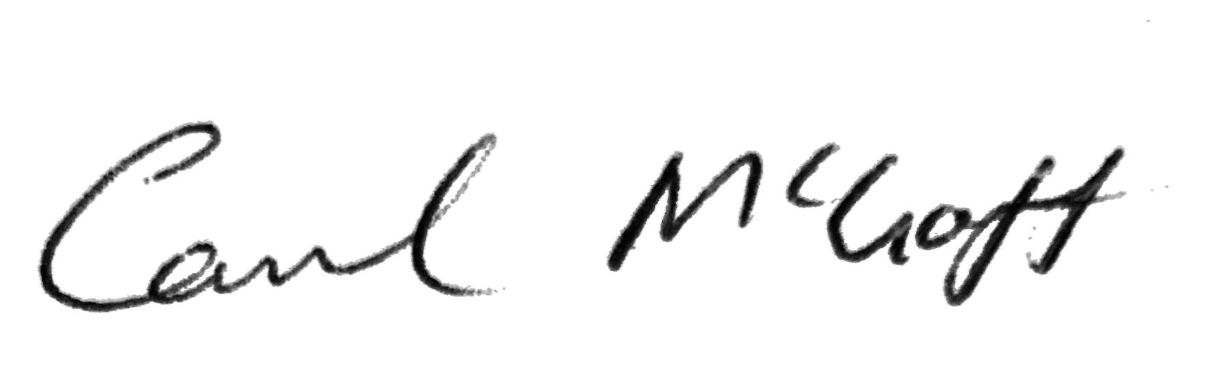
Carol McGoff, Formulary and Clinical Effectiveness Pharmacist, September 2023

