SECTION 1
Introduction and Logging into NHSL Network on your computer or laptop
IMPORTANT NOTE: This Summary is intended for any users who will use ECS to view patient clinical data. The find patient functionality will only be available to medical professionals who access clinical information as part of their role.
This guide assumes the user has minimal knowledge of the ECS Application.
About the Emergency Care Summary
ECS is a national system which provides a summary of basic health for all patients which may be important if the patient requires urgent medical attention including allergy, medication and palliative information, as well as the patients Key Information Summary where applicable. ECS is available 24 hours a day and was designed with out of hours and Accident & Emergency areas in mind when GP records may not be accessible.
Connection method
SWAN Network only: All of the above ECS environments are only available to users on the SWAN network. Any standalone PC’s on your own broadband or Wi-Fi will not connect to ECS. Message will appear –Page cannot be displayed.

Auditing of ECS Accesses
It should be noted by all users of the ECS Application that all accesses on patient information are audited and any suspicious accesses will be investigated
Please click on the Live link as given below.
Live Environment: https://ecsweb.mhs.scot.nhs.uk/ECS/Home/Login.aspx
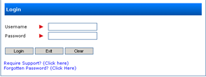
Enter your User Name and your Password provided then click on Log in Button.
Forgotten Password? You can select this option and will be prompted with security questions to reset your password.
You are allowed 3 incorrect login attempts before the account is suspended.
Should this happen you should contact the NHSL IT Helpdesk. For password resets and account issues: call NHSL IT Helpdesk: 01315365050
For technical issues on ECS: call ATOS : 0345 957 2700

QUICK GUIDE -EMERGENCY CARE SUMMARY
FOR COMMUNITY PHARMACIES

SECTION 2 Searching for a Patient and viewing their Records
The Home Page is now displayed.
You will only see patients in the recently viewed list if you have previously viewed patient records within ECS. If you do not have access to find patient functionality then you will see “No Data to Display” message.

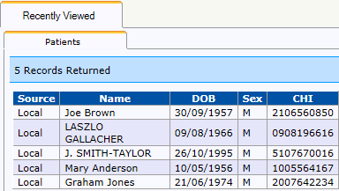
You can Log Out from the top right hand corner of the screen.
Select the Find Patient Option from the Menu Bar at the top left corner of the screen.
Enter the known details of the patient into the relevant search fields and click Search. You can use a combination of variables to narrow your search eg surname and date of birth. Using the drop down menu will refine the search.
Equals finds name 100% matches the search
Begins – names which begin with Search variable
Contains names which contain search variable
Soundex finds similar sounding names eg Watson and Watkins

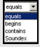
The system will return any matching Patient Details.

Confirm Patient Details and click on the patient name in the search list to display the ECS Consent Tab. Note once you have clicked on the patient record in the Search list, it is classed as a demographic access as you then view the patient’s demographic details.

Note the tabs shown for the patient highlighted below will depend on what information the patient has stored on ECS.
For the patient below, she has both clinical and Key Information Summary (KIS) record.
Some patients will have a Palliative Care section. If a patient has both a palliative care and a KIS record then you may see some data duplicated across both tabs.
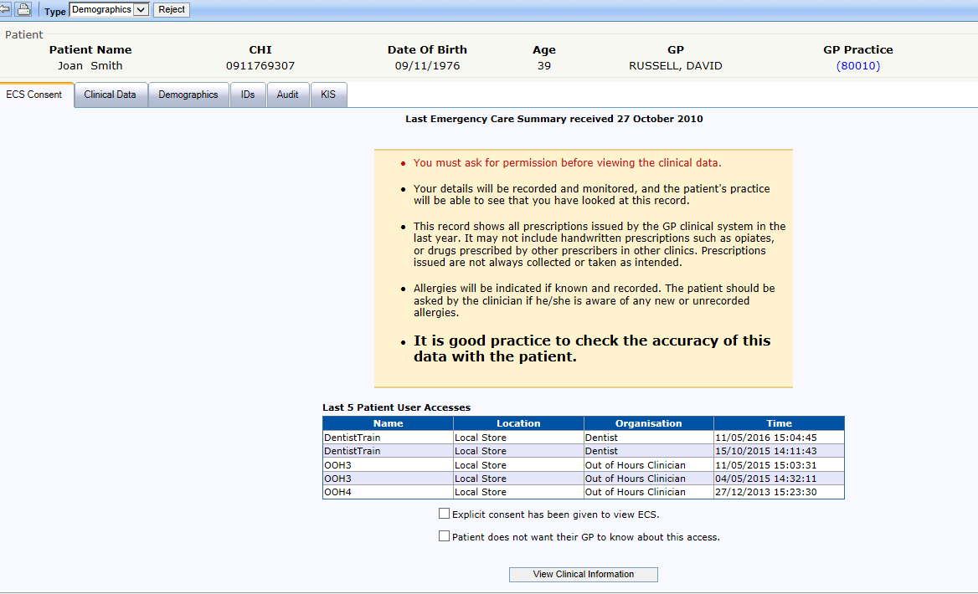
Please Refer to Appendix 1 for a screenshot of a Patient with both Palliative Care and Key Information Summary (KIS) information.

NOTE – Before you view the patient’s clinical or palliative care data you MUST ensure that you have gained the patient’s consent to view their information and that they have been asked if they wish their GP to be able to view the access. Check the relevant boxes as highlighted above as per the answers given by the patient.

Once permission has been granted, click View Clinical Information or select the Clinical Data tab to view the patient’s clinical data.
NOTE – as soon as you enter the clinical data tab, this counts as a clinical access (shown as “ECS” access on the ECS access report)

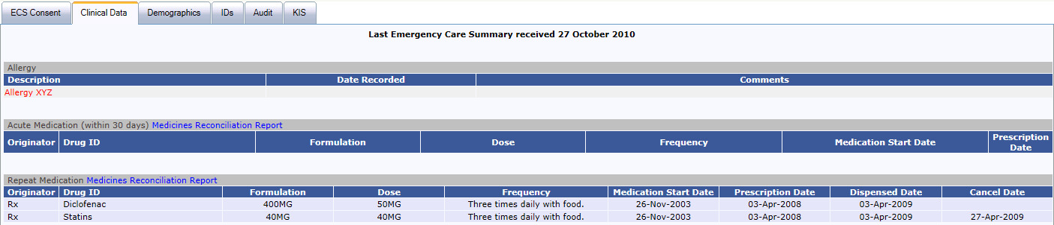
The above screenshot shows the patient’s Clinical Data Tab. In this example, it is split into Allergies/Acute Medication (last 30 days only) and Repeat Medication (Prescriptions). To view any acute information prescription prior to the last 30 days, click on Show All Medication Information.

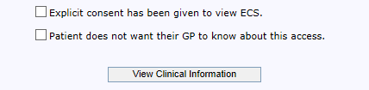
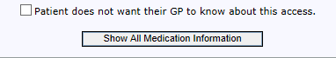
You can update the ECS GP Consent at any time if the patient changes their mind about whether they want their GP to know about access by checking or unchecking the checkbox at the bottom of the screen.

Patient has withdrawn Consent
Patients have the right to opt out of the system and withhold their details.
If a patient has opted out- no sex or address or postcode details are displayed on the Find Patient Search screen.
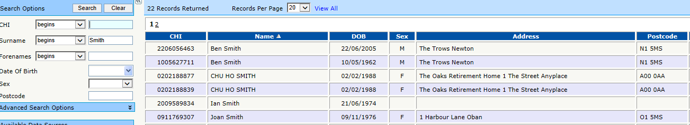
On the example above, we searched for Ian Smith (21/6/74). No sex, address or postcode are displayed.

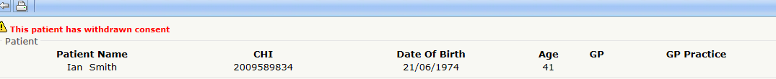
Clicking on his name where a patient has withdrawn consent will not give you access to any further information. A message will be clearly displayed to notify you that the patient has withdrawn consent. No other tab will be present.

Finding More Details
ECS may hold further information about the patient, for example telephone numbers and previous names. To view this information click on the Demographics tab.
Within this Tab, there are 3 further tabs which you can select, Name, Address or Telecomm.

View screenshot below to select the information as you require.

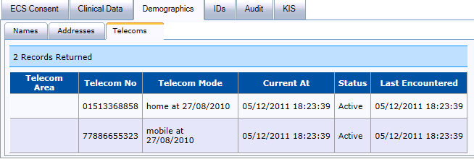

SECTION 3 Printing the ECS Summary
Patients have a right to request they see the information that is currently held on them within the ECS. As a result users who have permission to access the Find Patient functionality can also print off ECS Records by following the steps below.

You must first view the patient’s clinical data. Refer to Section 1.
Depending on what you wish to print, click on the Print Preview button in the toolbar.

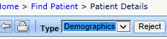
You will then be shown a print preview of what will be printed. If you wish to return to the ECS record click on the Return button.
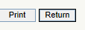
If you wish to print the record click on the Print button.

Note: Depending on your printer you will be presented with different option. However in order to ensure minimum waste of paper choose the option only to print Page 1 in the “Page Range” section of the print settings. See screenshot below.

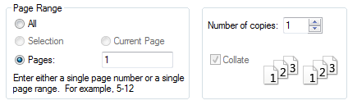
Now click on Print to print out the Summary.

Note: You can also print out palliative data or KIS data if requested to for a patient. Simply select the Palliative Care or KIS tab on the patient’s ECS record and follow steps above.

SECTION 4 Further Information and Help Nos
To recap:
You are allowed 3 incorrect login attempts before the account is suspended.
Should this happen you should contact the NHSL IT Helpdesk as below.

For password resets and account issues: NHSL IT Helpdesk: 01315365050.
For technical issues on ECS: call ATOS : 0345 957 2700.

SECTION 5 Appendix 1

Example of a Patient’s Palliative Care and/or Key Information Summary Record.
This Patient has KIS history with Social Work Agency Information and Preferred Place of Care. She also has a Home Oxygen plan at home.
