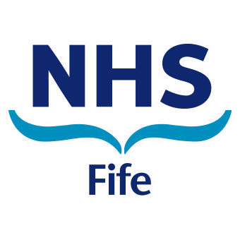NHS Fife Community Services | 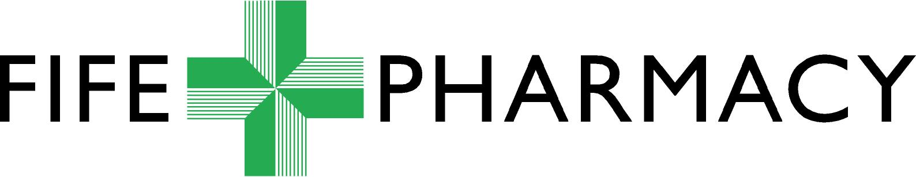  Pharmacy Services  Pentland House  Lynebank Hospital  Halbeath Road  DUNFERMLINE  Fife  KY11 4UW  Tel 01383 565 397
To:  Fife Community Pharmacies | Date:  Enquiries to:  Email:  Phone:  Web: | July 30, 2026  Rebecca Creighton  Fife-UHB.SpecialsUnlicensedMedicines@nhs.net  01383 565 397  www.nhsfife.scot.nhs.uk

Dear Colleague,

RE: Specials/ Unlicensed Medicines Authorisation Process

As you will be aware from previous communication, NHS Fife Pharmacy Services are required to stop using fax as a means of communication as of 1st May 2019. As a result the following changes will be made to the Specials/Unlicensed Medicines Authorisation Process:

- A new Specials/Unlicensed Medicine Authorisation Request Form has been produced. Most of the details on the form remain unchanged however there is a new section which allows the Patient CHI Number to be added. For this reason authorisation requests must be sent from an “@nhs.net” email address as this will ensure encryption of this confidential data.
The form is available as a Word Document as well as an editable PDF; it should be filled out electronically and sent via email as an attachment.

- In most cases a response to the authorisation request will now be provided by email only. In more complex cases, where a telephone discussion is required, any response given over the phone will also be followed up with an email confirmation.

Given these changes it is extremely important that the inbox is checked regularly and that all members of staff have access to the inbox that the request has been sent from. It is therefore advised that your generic community pharmacy “@nhs.net” email address is used and that all staff are trained on the new Specials/Unlicensed Medicines Authorisation process.

Please do contact me on 01383 565 397 or Fife-UHB.SpecialsUnlicensedMedicines@nhs.net if you have any questions.

Yours sincerely,

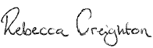

Rebecca Creighton
Prescribing Support Technician
NHS Fife Pharmacy Services
 01383 565 397 | Flat 1 | Pentland House | Lynebank Hospital | Halbeath Road | Dunfermline | KY11 4UW

