**First things first! – Prepare for first use**

**KEY INFORMATION**

These apps should not be downloaded onto shared devices.

**Before you start**, you will need your Office 365 username and password.

**STEP 1 – Downloading Outlook App to your personal IOS device**



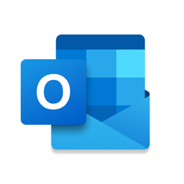

1. **Go** to **Apple App Store**
2. **Search** for or **MS Outlook** app

1. Select to **Download** and **Open** the **Outlook 365** app
2. You will be asked for your username and password.

Example: [test.test2@nhs.scot](mailto:test.test2@nhs.scot)

1. You may also be asked to authenticate your device (see the [**Logging in and Authentication Guide**](https://app.joinblink.com/#/hub/3a2304d0-6ed9-47e8-9040-a7528a889c95)**)**

**Congratulations**, you are now setup to use **MS Outlook 365** on an iOS mobile device.

**Contact us**

If you have any questions, please do not hesitate to get in touch via the below options:

* Contact the IT Service Desk on 01592 648028
* Office365 login queries or other issues - email [fife.office365@nhs.scot](mailto:fife.office365@nhs.scot) or <fife.gmsfacilitators@nhs.scot>