How to search for your Shared Mailboxes in NHS Mail

From the Portal Screen, Click on Profile tab.

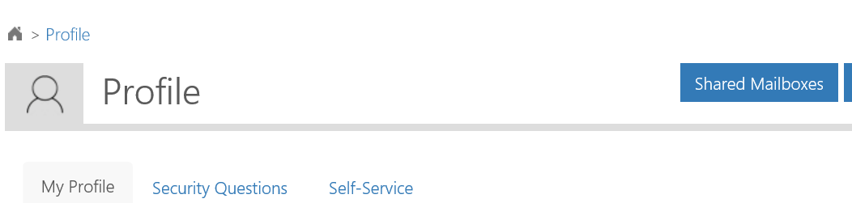Then click on the Shared Mailboxes Button

You will see the following screen

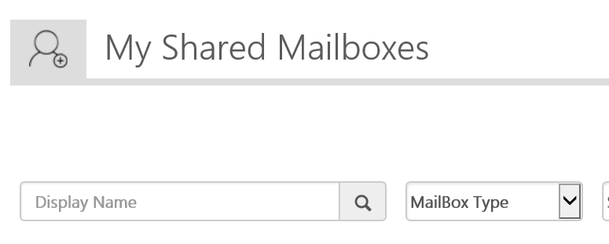

Click on the Search Button

This will return a list of Clinical (Shared) Mailboxes you currently have access to

