
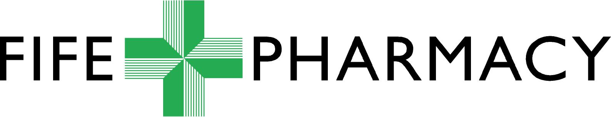

FIFE COMMUNITY PHARMACY
PRESCRIBED SHARPS DISPOSAL SERVICE
ANNUAL RETAINER CLAIM FORM

Period of Claim: 1 April ____ to 31 March ____

Pharmacy Stamp

This form should be submitted in February or March each year for the previous 12 months.

Service Provided | Fee Applicable
Annual Fee for providing Pharmacy Prescribed Sharps Disposal Service | £500.00

Authorised Signatory for Participating Pharmacy …………………………….. Date………….…….

Contractor Code………………………………..

Authorised Signatory for NHS Fife Pharmacy Services………………………. Date………………..

Financial Code:………………………………………

Send completed form to:

Email fife.fifepharmacycommpharm@nhs.scot

Or by post to

Sheila Dall
Pharmacy Services
Pentland House
Lynebank Hospital
Halbeath Road
Dunfermline
KY11 4UW

