GGC clinical portal can be accessed from your pharmacy using the following link:
https://www.ggc-portal.scot.nhs.uk/concerto/Login.htm

Login using the username and password provided

- Community Pharmacist usernames have the prefix CPP  - CPP Forename Surname  - Community Pharmacy Technicians usernames have the prefix CPPT  - CPPT Forename Surname  - Enter your username and password and click login to access the system | 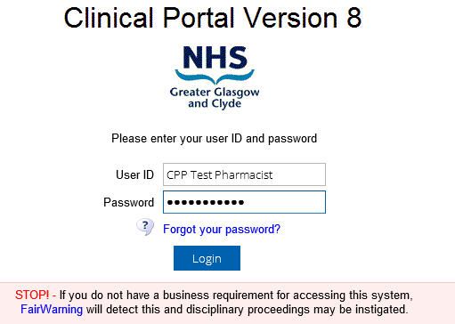
Setup your User details and Secret Question to allow you to reset your password if you forget it.
- Click on COMMON  - Select MY DETAILS  - Start Screen – click on arrow and select Patients  - Click Set SECURITY QUESTION, select a question and enter your answer. This enables to reset your password using the FORGOT YOUR PASSWORD link on the login screen.  - Click UPDATE PREFERENCES to save your changes | 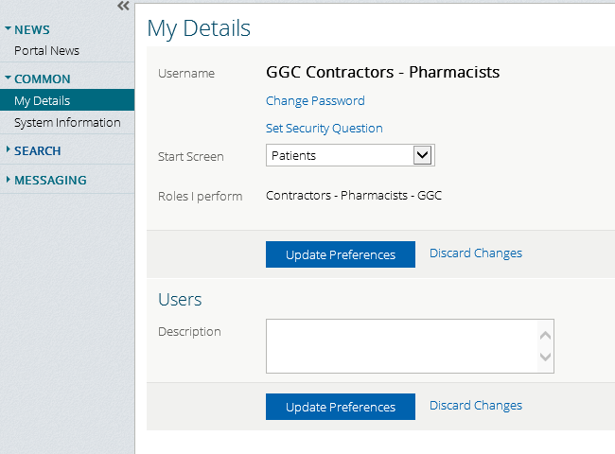

Search for a Patient
- Click on PATIENT  - Enter the CHI number in the PATIENT ID Field  - Enter a REASON FOR SEARCH. This is mandatory, a warning will appear if a reason is not selected and you will not be permitted to continue until a reason is selected. | 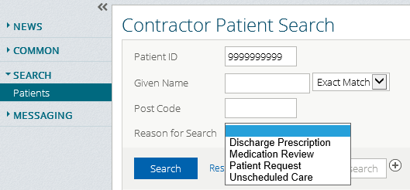
- The result of the patient search is displayed in a table below the SEARCH button.  - The CHI number, patient name, date of birth, gender and postcode displays  - Click on it to select the patient | 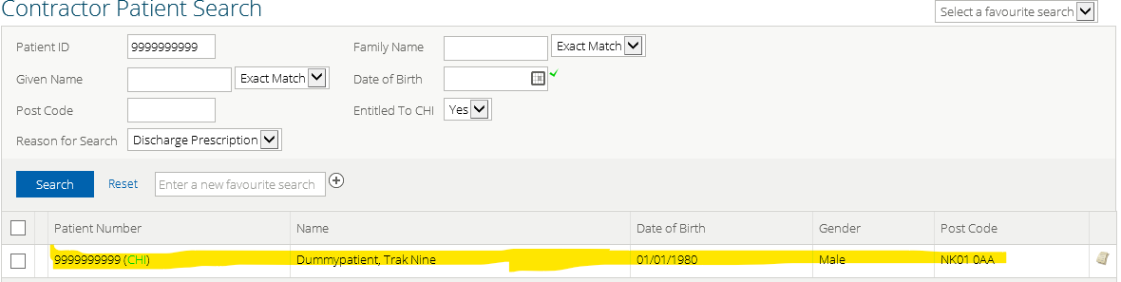
- The patient’s clinical record will display  - The ACCESS CONSENT WITHDRAWN tab is available for PHARMACISTS only and contains highly sensitive documents that can be viewed if necessary. | 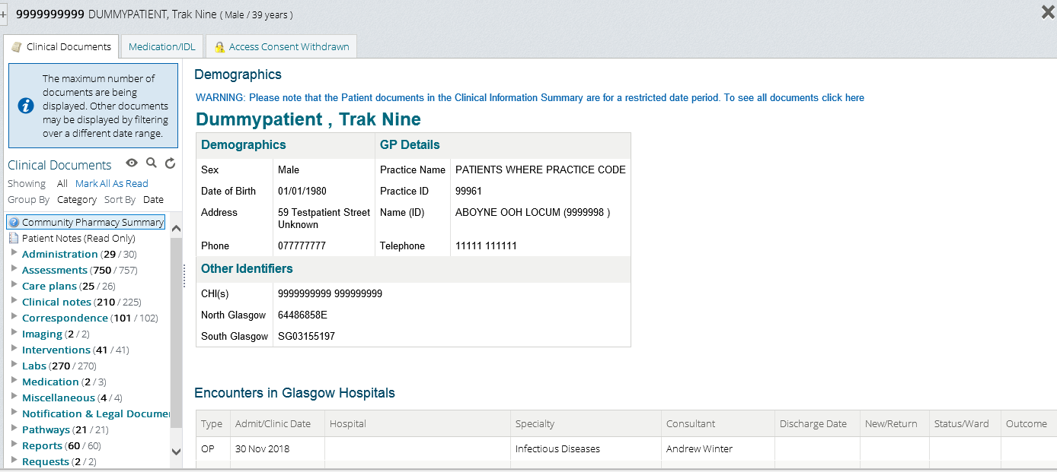

Viewing the patient’s clinical record – Discharge letters etc.
- The CLINICAL DOCUMENTS menu tab displays all the documents available in the patient’s clinical record  - The default view display is sorted by CATEGORY  - Click on a CATEGORY to expand it to view any SUB CATEGORIES and a chronological list of the documents.  - To view a particular document such as an IMMEDIATE DISCHARGE LETTER click on it and the letter will display on the right pane of the screen. A copy of the IMMEDIATE DISCHARGE LETTER can be printed if required from this screen. | 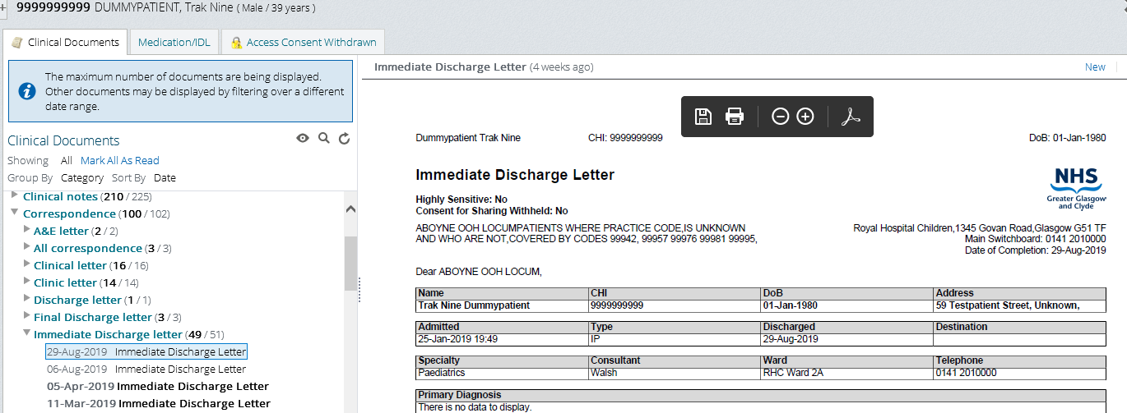

Viewing the Medications
- Click on the MEDICATION/IDL menu tab to view the current medicines review that has been completed for the patient by GGC acute medical and pharmacy staff | 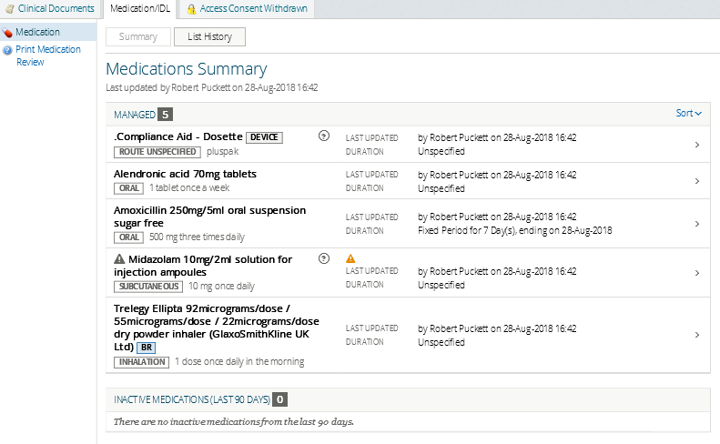
- Click on the LIST HISTORY button to view all medication reviews  - The most recent review is always displayed on the right pane and has a drawing pin icon next to it  - Any other medication reviews will be listed below it on the left-hand pane. Anyone can be selected and will display side by side with the most recent review on the right hand pane. Only 2 at a time can be viewed together.  - Click SUMMARY button to return to the most recent review  - Click PRINT MEDICATION REVIEW to print a pdf document with the details of the most recent review | 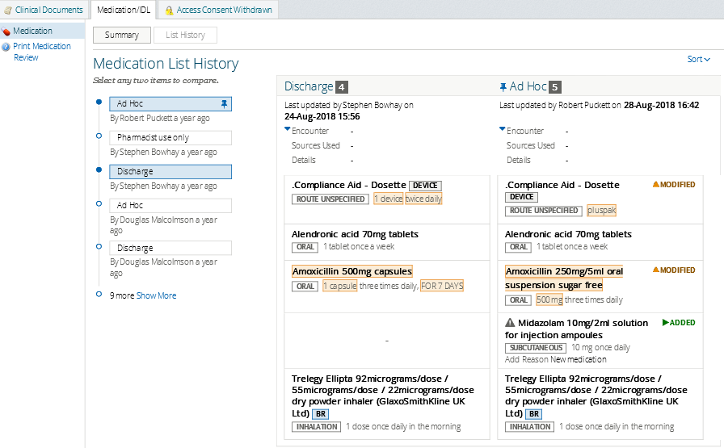

Exit a patient record and return to the patient search screen
- To exit a patient record click on the large grey cross at the top right of the screen. This will return you to the patient search screen  - Clicking the logout button will log you out of the clinical portal system | 