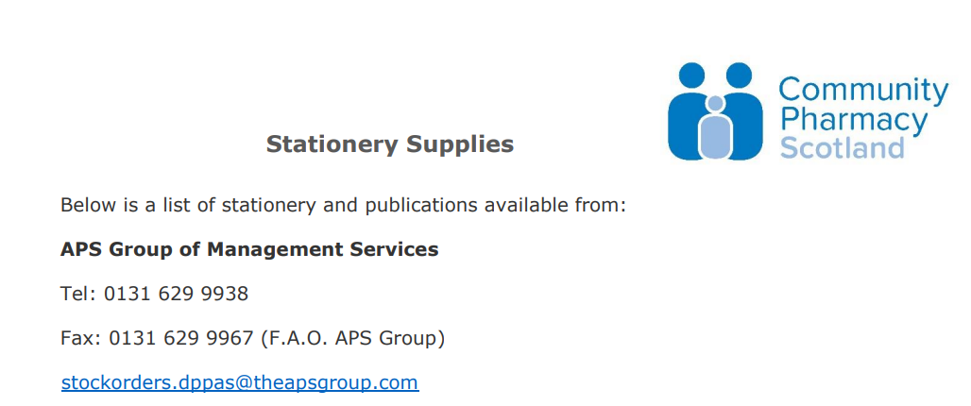

Product Code | Publication | Description | UOM
Item Code: 249470  Customer Code: PPDAS675374 |  | Medicines: Care & Review Service At Your Local Pharmacy | 200 per pack
087309 |  | Methotrexate Patient Booklet | Single
HC1 | HC1 | Claim for Help with Health Costs with Envelope | 100 per box
SG2003 | HC5 | Refund Claim Form | Single
SG2007 | HCS2 | A Quick Guide to Help with Health Costs Booklet | 50 per pack
SG2209 |  | Steroid Record Card | 500 per pack
SG2210 |  | Oral Anticoagulant Therapy Pack | 50 per pack
SG8018 |  | Oral Anticoagulant Therapy Record Book | Single
SG8016 |  | Oral Anticoagulant Therapy Alert Card | 50 per pack
SG2224 | EC92A | Claim for Prescription Charge Exemption Certificate | Single
109575 | HC1 (SC) | HC1(SC) Form & Envelope | 50 per pack
SG2999 | HCS3 | Help with Health Costs Quick Guide A3 Poster | Single
SG3371 | HCS R | Receipt and Refund Pad | Single
Item code: 249469  Customer code: PPDAS675394 |  | Pharmacy First Scotland A5 Booklet | 200 per pack
249716 |  | NHS Pharmacy First Scotland A3 Poster | Single

