SBAR on PCR Guidance

Guidance on how to generate SBARs as part of the patient care provided by Community Pharmacy.

6/7/2017

NHS Grampian

Caroline Gault - ePharmacy Facilitator

This guidance has been taken from the PCR guidance document at <https://nhsnss.org/media/2333/pharmacy-care-record-user-guide.pdf> . If you have any questions about using the SBAR tool, not covered in this guidance, email Caroline Gault at [caroline.gault@nhs.net](mailto:caroline.gault@nhs.net)

**SBAR 10a**

**Overview**

‘Situation, Background, Assessment, Recommendation’ known as an ‘SBAR’ is a communications tool that is used to help frame conversations between healthcare professionals.

*Pharmacists log ins are able to: create, edit and view SBARs. Pharmacy technicians log in can only view SBARs.

The SBAR functions in PCR include:

• Create an SBAR

• Enter recipient, recipient organisation and date action required

• Enter Situation, Background, Assessment and Recommendation text

• Generate a PDF of the SBAR

• Add replies (received back from the recipient)

* Link SBAR to a Care Issue

• Complete the SBAR (when no further replies are expected)

**10b**

**Create an SBAR:**

* Log into PCR and identify the patient that you want to create the SBAR for. – *If the patient does not have a PCR record you should create one*
* There two places where you can create the SBAR:
  + Select the SBAR tab (on the patient home page). (Fig. 10-1)
  + Start a care issue or select a care issue. (Fig.10-2)
* Select the “Create SBAR” link, the “Create an SBAR” page will be displayed (Fig. 10-3)

**Fig. 10-1: Patient home, SBAR Tab**

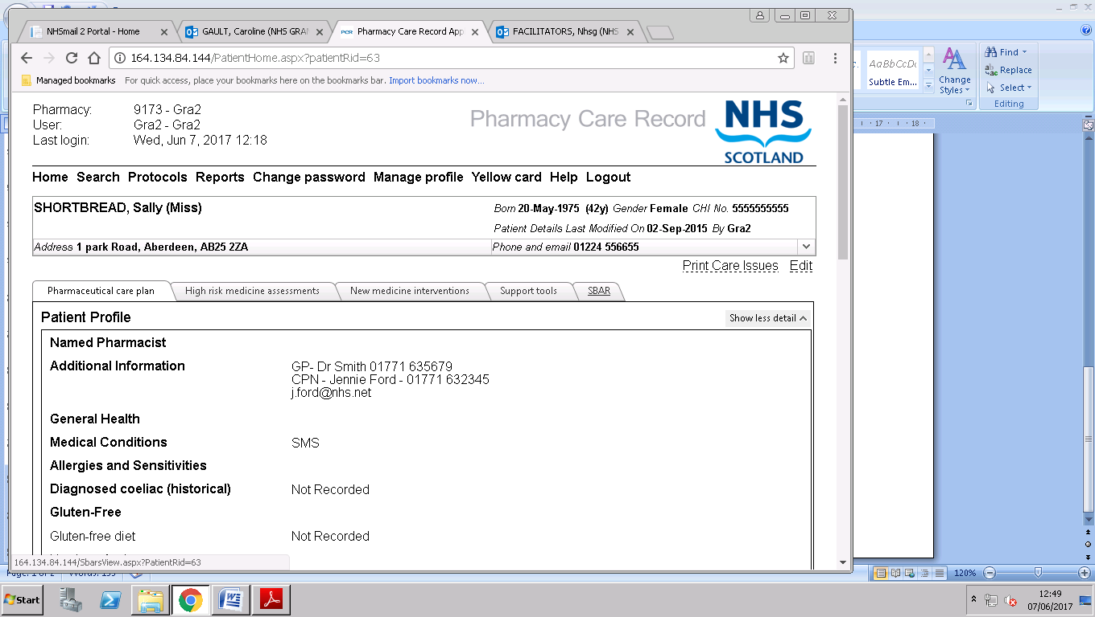

**Fig. 10-2: Care Issue, SBAR Tab**

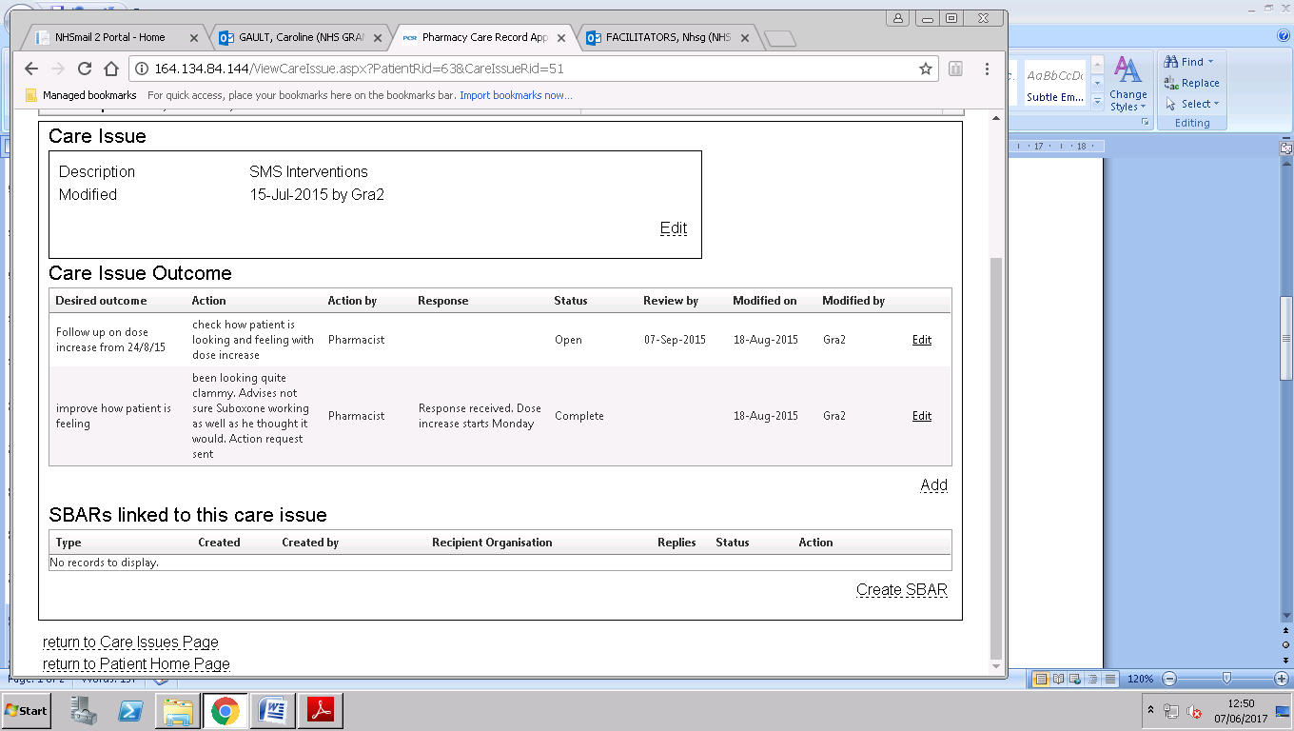

**To define an SBAR type:**

* Select the type of SBAR to create
* Click the Create button, the SBAR page will be displayed (Fig. 10-3)

**Fig. 10-3: SBAR Create window**

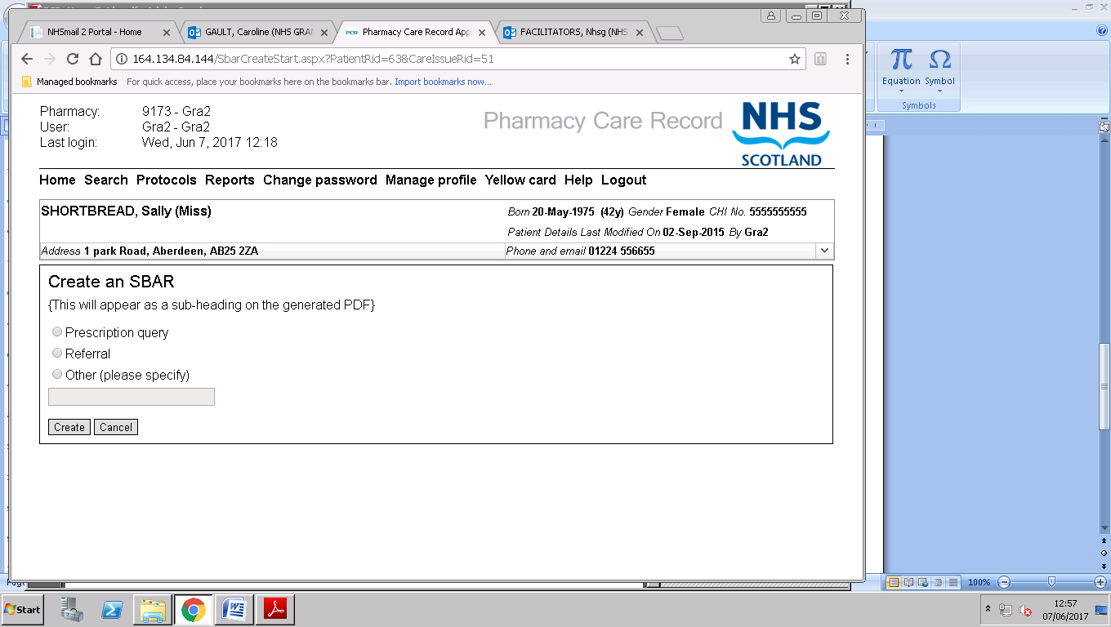

*Note: If an SBAR type ‘****Other’*** *is chosen a short description must also be entered. The description entered will appear at the top of the SBAR when it is generated.*

**10c**

**Filling in SBAR**

The SBAR edit page allows the user to enter the following information.

* Recipient
* Recipient organisation
* Action required? *(Optional)*
* Date action required by *(Optional unless “****Action required?”*** *is selected)*
* Situation
* Background *(Optional)*
* Assessment *(Optional)*
* Recommendation

**Fig.10-4 SBAR Edit Page**

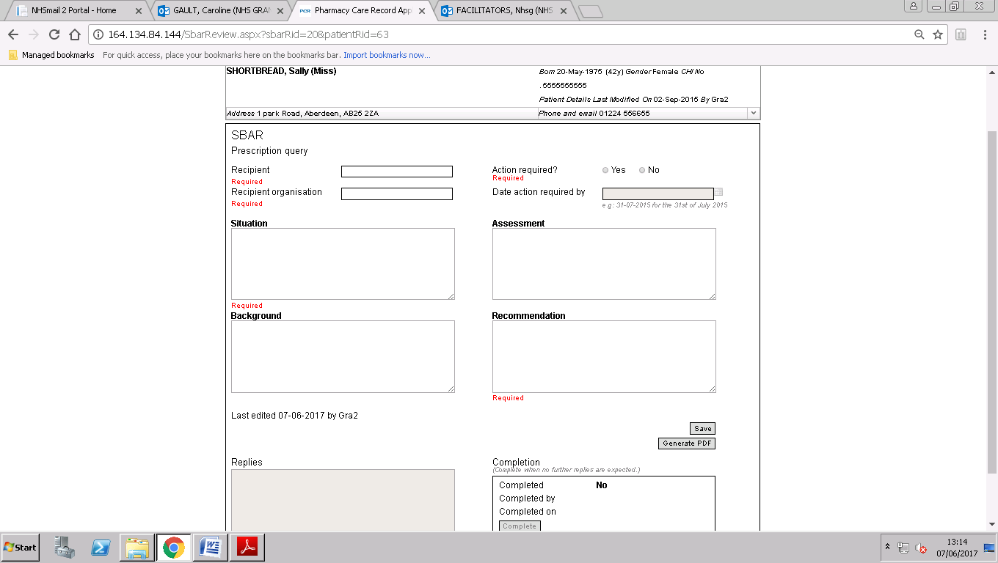

*Note: As a minimum the following fields must have data entered: Recipient; Recipient Organisation; Action required; Situation; Recommendation.*

**To record SBAR data:**

* Enter SBAR text for all sections, or as much as is applicable or known (Fig. 10-4)
* Ensure that the information entered will make sense and can be followed clearly by anyone else reading it
* Click the **Save** button - T*he SBAR will not save unless all the required fields are filled in.*

**10d**

**Retrieving and Actioning SBAR**

SBARs can accessed from:

* Reports page - **All SBARs for Associated Pharmacy** Report (Fig.10-5)
* SBAR tab on the Patient Home page (Fig. 10-6).
* Care Issue page – if associated with a care issue when created

**Fig 10-5 SBAR Report**

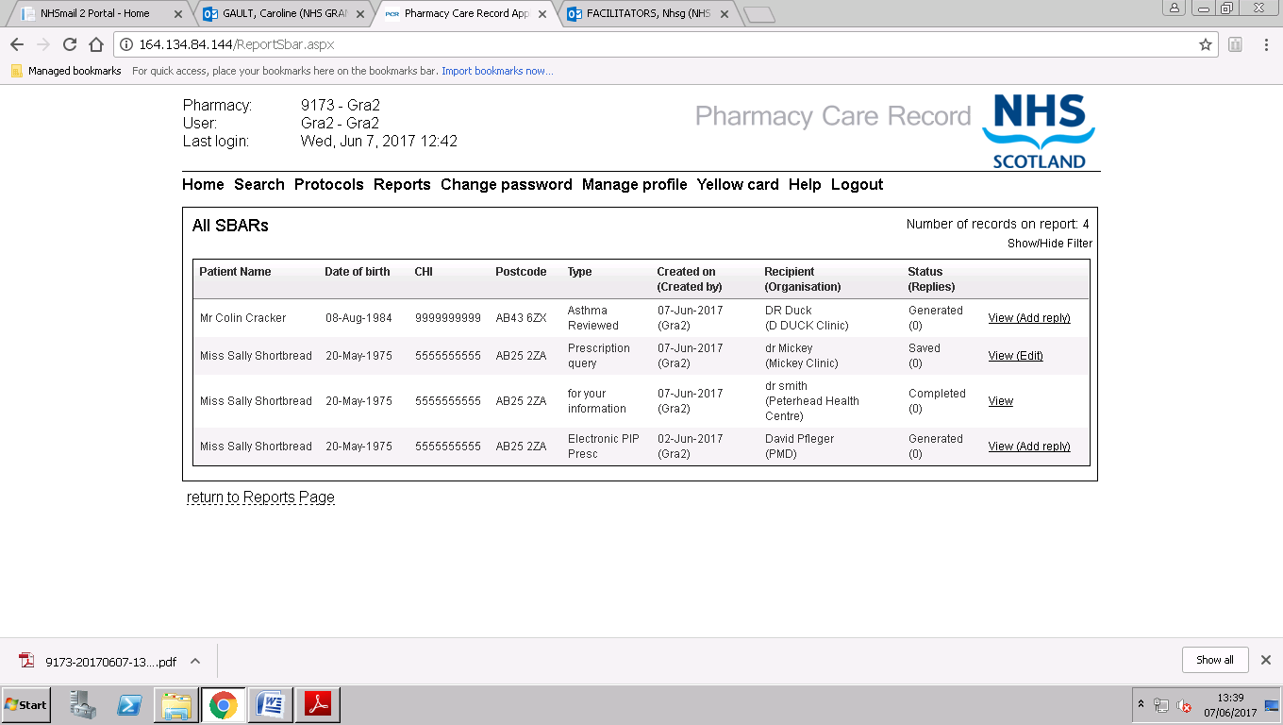

**Fig 10-6 SBAR Tab patient Home page**

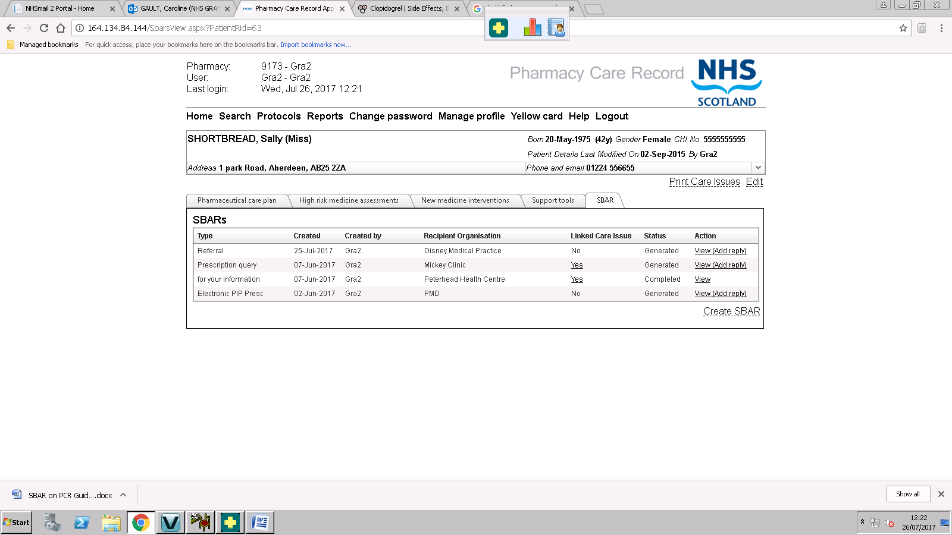

A number of actions can be taken on a SBAR – Edit, generate PDF, add reply, view, complete. These actions are dependent upon the status of the SBAR. Fig. 10- 7

**Fig 10-7 SBAR Statuses and Actions**

|  |  |  |
| --- | --- | --- |
| **Status(Replies)** | Actions available | *Note: once the PDF has been generated no editing can be done.*  *Once SBAR is completed no replies can be added* |
| **Saved** | Edit SBAR, generate PDF, add replies, view, complete |
| **Generated** | View, add replies, complete |
| **Completed** | View |

To Action the SBAR click on the link to the left of the status: View(Edit); View(add reply); View

**10e**

**Generating and Emailing SBARs**

* Open SBAR from **View(Edit)** Link – check for accuracy, edit if necessary
* Click on **Generate PDF button**- this will open your PDF and also save one in your downloads.
* At this point you can right click on the open PDF and print it if you want to send a paper copy to the practice/CPN/dietician etc
* The PDF will be in downloads and named as your Contractor code and date and time generate. E.g.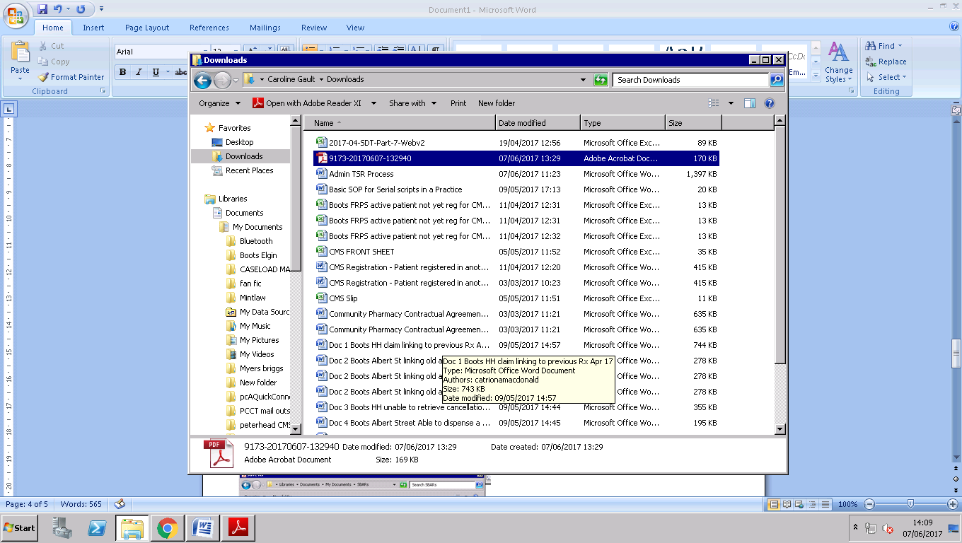
* Go to Downloads and double click to open the PDF
* Click on **File**, Select **Save as** Fig. 10-7

**Fig 10-7 Rename and Save PDF in appropriate folder**

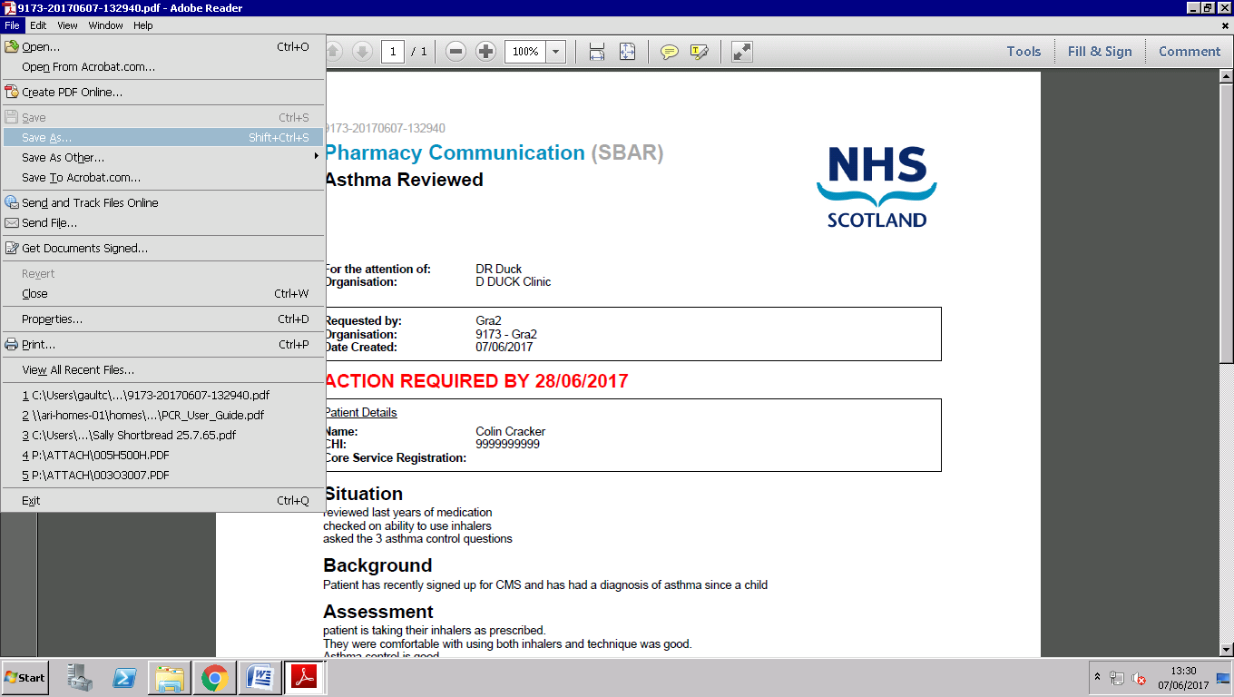

* The **Save As** window will open Rename the file with the Patient’s name and CHI
* Then Select the appropriate folder in **My Documents** folder – suggest that you set up a folder called “SBARs”
* Then Select **Save** Fig. 10-8

**Fig 10-8 Saving SBAR PDF**

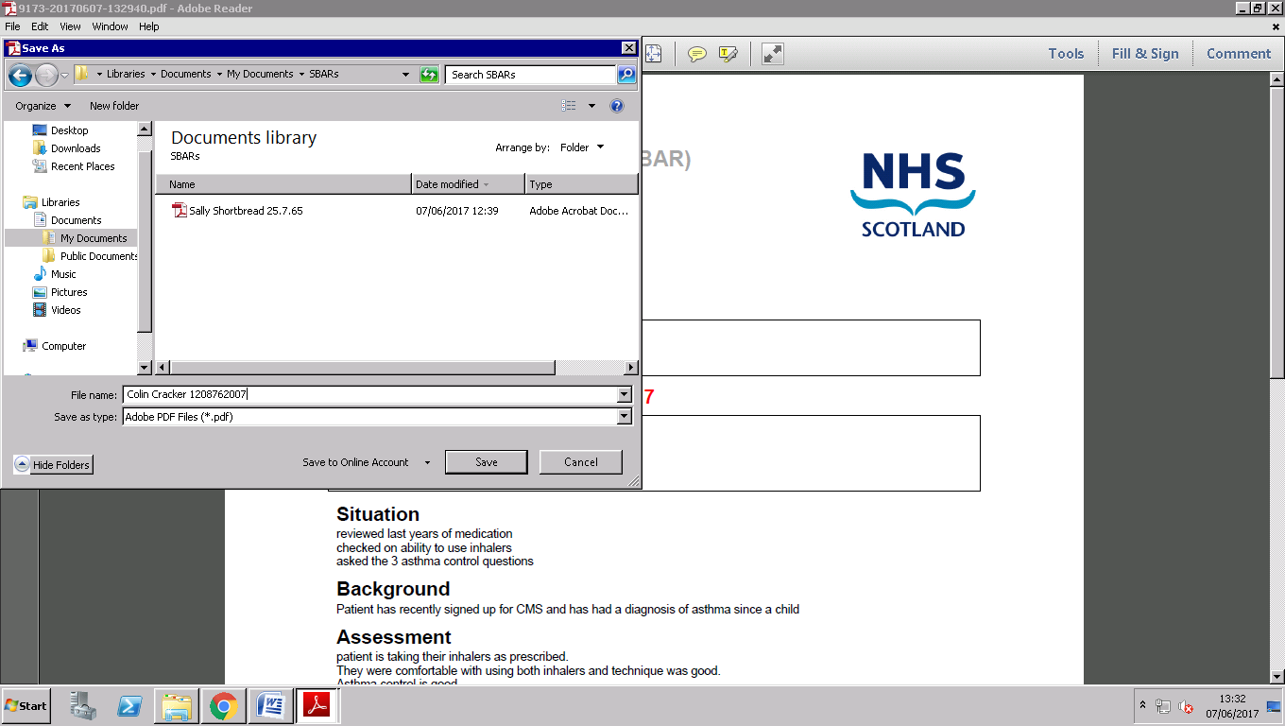

The PDFs can now be attached to emails and emailed to the Clinician/Practice that you want to send the SBAR too. Such as:

* Referral to podiatrist
* Referral to Dietician
* Asthma review for patient’s asthma nurse
* Prescription Query for patient’s GP
* Prescription Query about a Serial script medication for patient’s GP
* Concerns and action needed on SMS patient for their CPN

**10e**

**SBAR Examples:**

