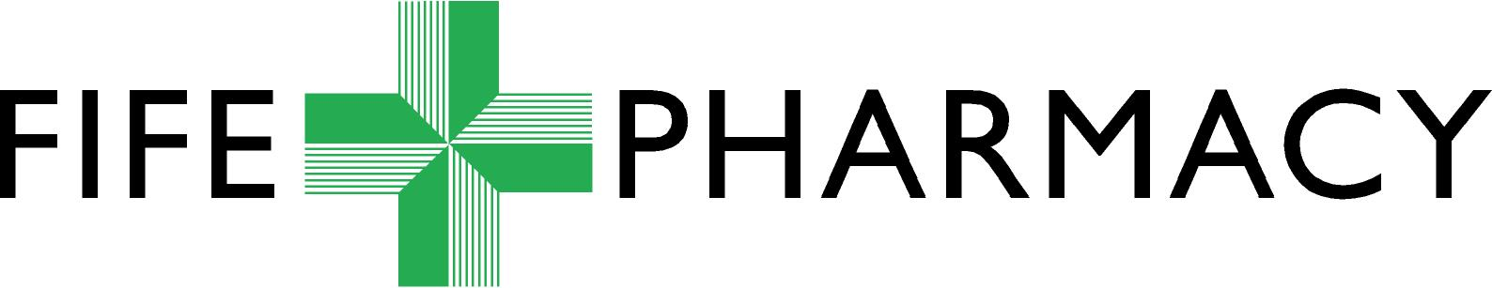

PHARMACY SERVICES

TEACH & TREAT TRAINING SESSION ATTENDED

CLAIM FORM

PAYMENT VIA CONTRACTOR CODE

Pharmacy Name &Address

Contractor Code

Activity
Brief note on what training you received / what topics were covered

Did you meet your planned learning objectives? Yes No Partially

Details of Claim [Only eligible for those that qualified as an IP before 2020]
Date | Times of Session | Item Claimed | Name of Pharmacist Providing Training | Fee
 |  | Attended Training |  | £100.00

Signature of Pharmacist Attending Training
Name of Pharmacist Attending Training
Date

Authorised on behalf of Pharmacy Services
Financial Code

Date

Send this completed form by email to fife.fifepharmacycommpharm@nhs.scot
and please complete this evaluation form from National Education Scotland (NES) or scan the QR code below on a smart phone/tablet.

