

NEO 360

Anti Retro Viral (ARV) Module

User Guide

**Contents**

1. **Accessing the module Page 1**
2. **Homepage Page 1**
3. **Patient list Page 2**
4. **Entering patient details Page 2 - 3**
5. **New Features Page 3 - 4**
6. **Claiming Page 5**
7. **Registering new staff to the access module Page 6 - 7**
8. **Useful contact details Page 7 - 8**
9. **Accessing the module**

* <https://scotland.needleex.co.uk/secure/login>
* Enter Username and Password
* Click Login

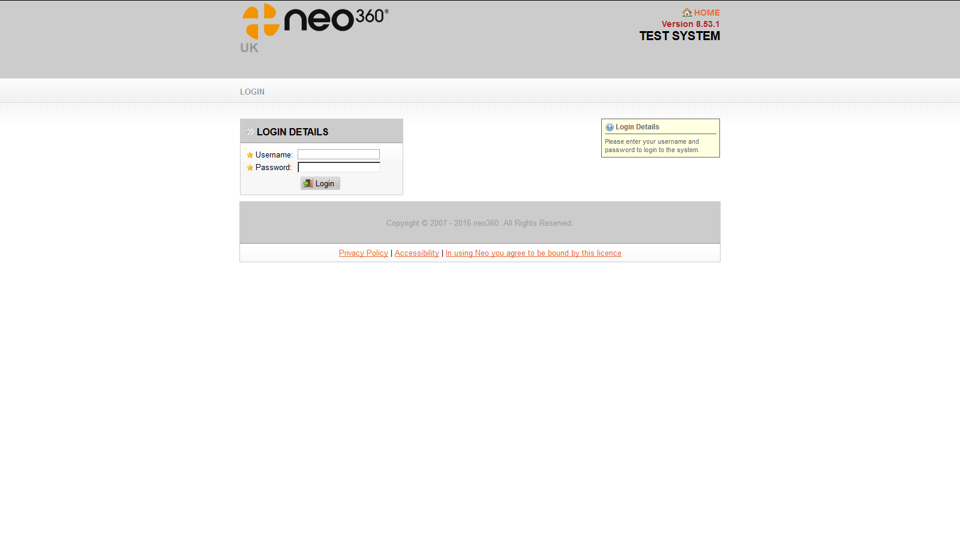

**2. Homepage**

* Gives information on when module was last accessed
* ARV module is at top right hand corner – click to open

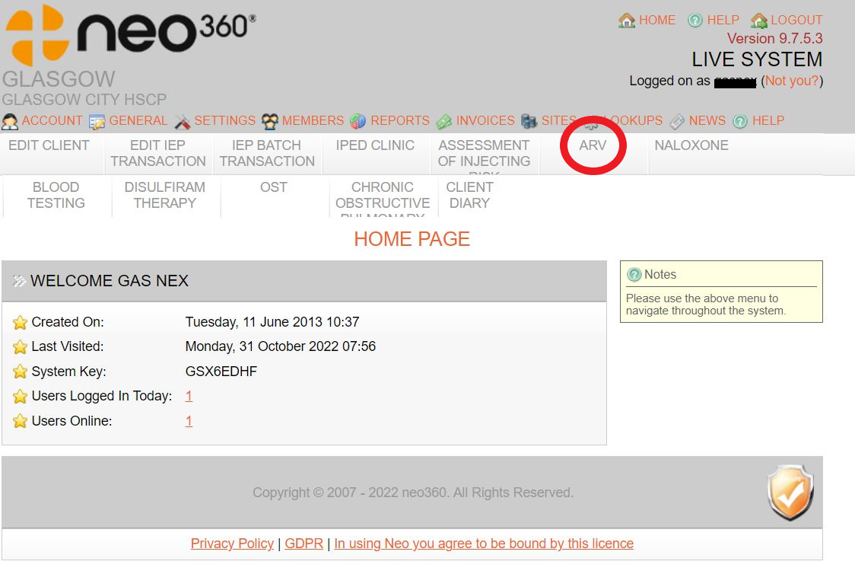

Page 1

1. **Patient list**

* Module will open at Patient List facility
* This will show a list of all patient which the community pharmacy is currently providing ARV services to
* **N.B. Pharmacies shouldn’t add new patients to the system – new patients will be added by the Community Pharmacy Development Team (CPDT) at point of referral – if you are providing care to a patient who is not listed, please contact CPDT immediately;**

All Client Details will already be populated.

Click to scroll between months

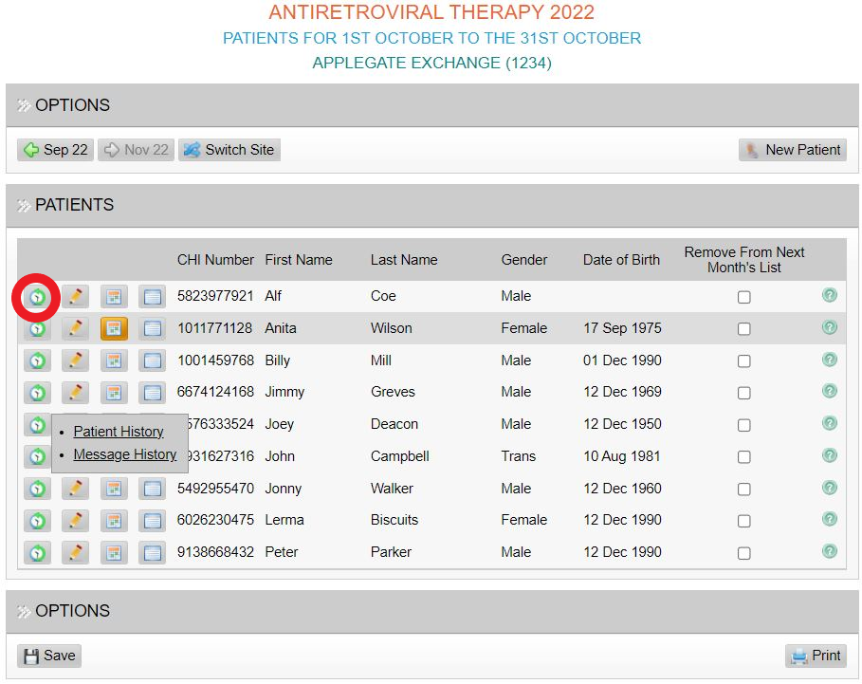

1. **Entering patient details**

Choose calendar option

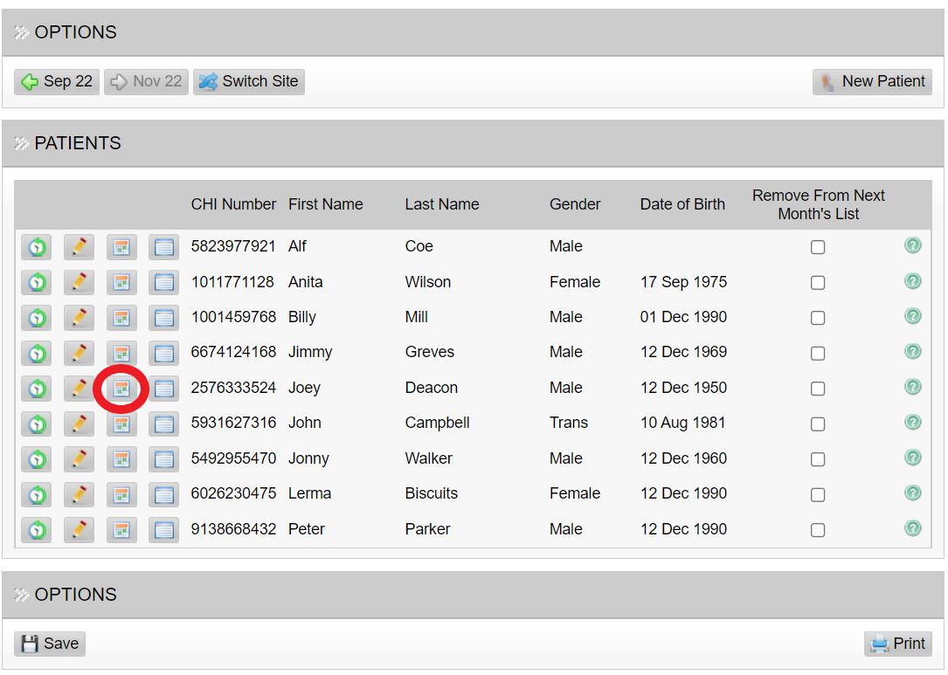

Page 2

* For each day in the month, choose the option which best describes the patient’s status;
* **Supervised** – the patient attended and an ARV dose was administered;
* **Take Home** – by choosing this option you will be asked how many doses were “taken away” – the box will turn orange;
* The calendar will populate depending on the number of take home doses entered;
* **Did Not Attend** – chose this option if the patient did not attend the pharmacy – the box will turn red;
* Where they **Did Not Attend** option is chosen on two consecutive days (or five days in the calendar month) an e-mail alert will be generated to the Brownlee;
* **No Longer in Service** – chose this option if the patient’s treatment has stopped – the box will turn purple;
* Where the **No Longer in Service** option is chosen you will be asked to choose a further option.

**N.B – You only need to choose the “No Longer in Service” option once. Once chosen, this will remove the patient from the system for the next month.**

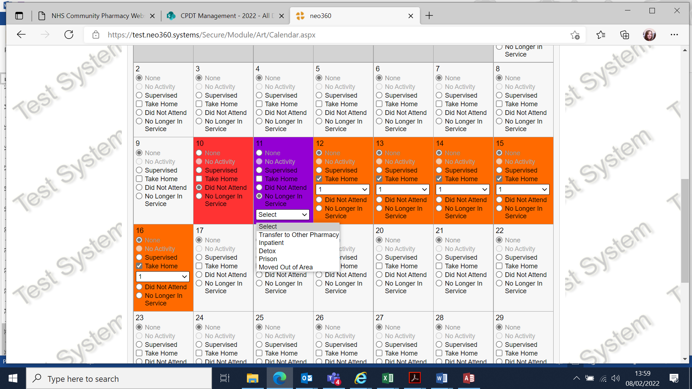

1. **New features**

* A new feature has been added to the ARV module from November 2022 which allows the reporting of 3 missed ARV doses/patient concerns/prescription issues via NEO rather than phoning or emailing the Specialist Hospital Pharmacy or Nursing team**. When this feature is utilised an email will be sent directly to the designated team attached to the patient.**

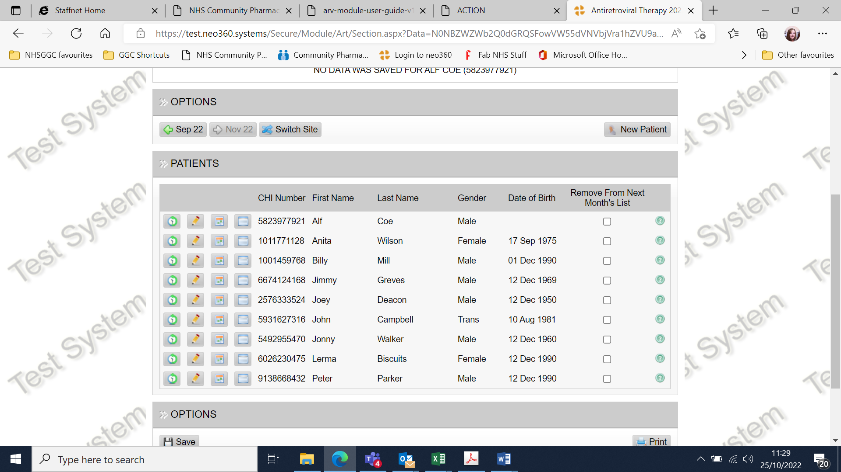

Page 3

* When contact with the Specialist Pharmacy/Nursing team is required the  should be clicked and 3 options will appear. The appropriate subject should be clicked and a free text box will appear allowing additional information to be added to the message.

## Please ensure clinically appropriate language when using this facility.

* **Reporting 3 consecutive missed doses-** Please enter date of last dispensed dose in the free text box and any other information you feel is relevant.
* You can submit multiple message types at a time i.e. Report concern & Prescription issue
* When message complete click “Save and Send”
  + A green band will show at the top of the screen to show that message has been sent successfully to the appropriate ADRS team
  + An audit trail of all messages sent to the team can be found by clicking the  icon
  + You will then be presented with 2 options “Patient history” or “Message history”
  + Click “Message History”
* Message details will appear. If multiple messages have been sent then by clicking “Next” you can scroll through all messages sent and are given date, person submitting and details of each message.

Page 4

1. **Claiming**

* Claims cannot be submitted before the first of the following month
* DO NOT submit claims using the Managerial or IEP log in details, they will be refused, you will have to resubmit and may miss the payment deadline.
* To submit a claim, click the button on the top left to scroll back to the relevant month
* **Please note the counter fraud declaration in red.** The person logged in to submit the claim has responsibility for ensuring that what they are claiming for is accurate. They will be the person we contact if there are any queries regarding a particular claim. DO NOT use someone else’s log in details, even if they have said it is ok to do so
* The submit claim button is underneath the declaration
* Once you click ‘Submit claim’ you will be asked to confirm that the information you are submitting is correct
* If you select ‘yes’ your claim will be submitted and details of the person submitting the claim will be displayed at the bottom
* If you select ‘No’ you will be taken back to the claim screen and amendments can be made
* To be eligible for payment claims must be submitted by the 10th of the following month.
* If you do not click the ‘submit claim’ button, your claim will not be sent and will not be eligible for payment.
* You can go back and review claims that have been submitted and print them out for your records but they cannot be amended
* If you realise an error has been made in your submission and it is before the 10th of the month and the claim is now read only you must contact the Community Pharmacy Development Team via email at: ggc.cpdevteam@nhs.scot for advice. If it is after the 10th of the month, these claims will have been forwarded for payment and you need to contact Michelle Cooper on 0141 201 6041.
* Whoever then signs on to the system will need to carry out their own edit AND check ALL entries are correct. They will then need to resubmit agreeing to the counterfraud declaration. At this point they will become the person responsible for that claim.

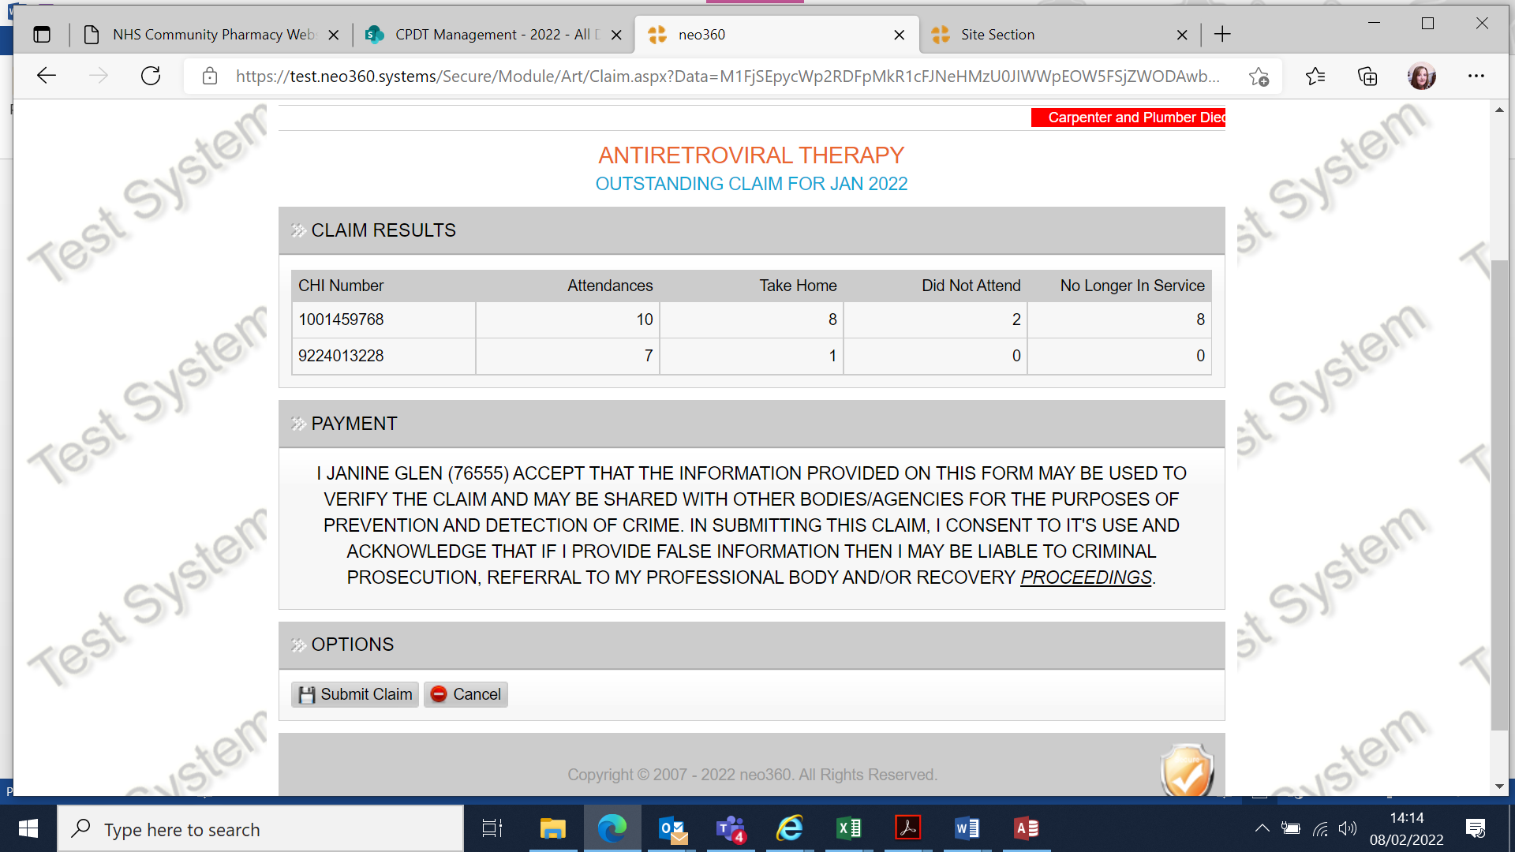

Page 5

1. **Registering new staff to access the module**

For each pharmacy providing an OST service there will be a site manager, this will be the pharmacy manager or regular pharmacist. The site manager will then be responsible for creating individual staff usernames and passwords using the managerial log in.

Only staff with an active GPhC registration number can be registered to access the ORT module.

It is the responsibility of each individual to keep their username and password secure and not share the information with anyone else. Remember the module contains patient identifiable information so must be kept as secure as possible.

* Log in using the managerial log in details
* Staff option is available near the top of the screen, circled below

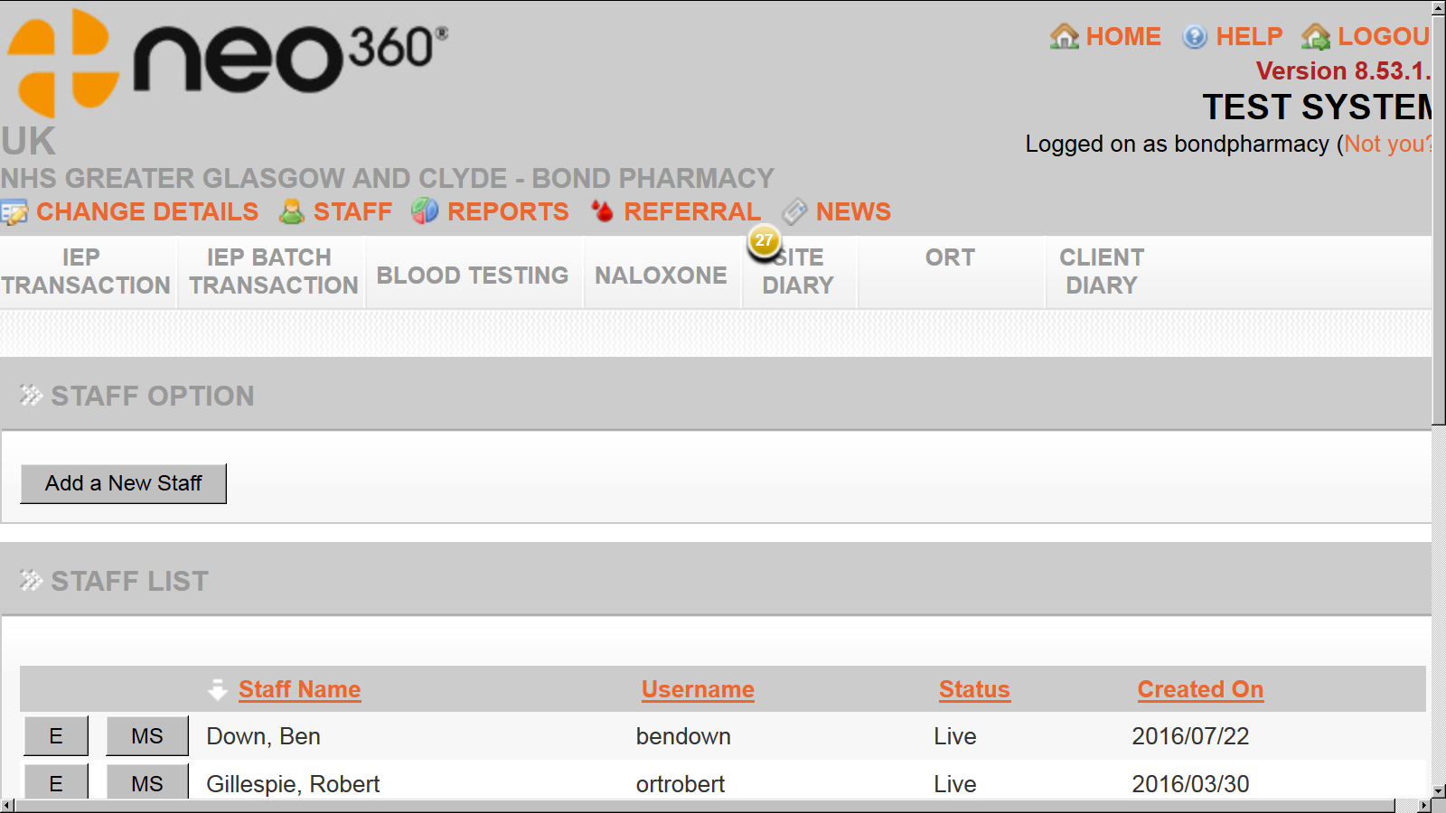

Click here to view, edit or add staff details

To add new staff member details click here

* Enter first name, last name, email address and General Pharmaceutical Council registration number
* An email address may only be used once within the module, for the managerial log in we strongly recommend using the pharmacy clinical mailbox address and for personal log ins, a work or personal email address that only that staff member can access. The email addresses are only used when the staff member has forgotten their password and it needs reset.
* Create a memorable username and password, these must comply with the requirements of NEO which are stated on the right hand side
* Select live, if staff member leaves or is off long term their account should be changed to disabled until such times as it is required again
* Select ARV module
* **Do not select any other modules without contacting the system administrator**
* **Do not grant any other staff member access to staff details, only the site manager should have this access**
* If the staff member will be registered at more than one pharmacy separate user names will need to be created at each location. We would recommend this takes the form of the staff members name and postcode of the site e.g. Mickeymouseg511dh

Page 6

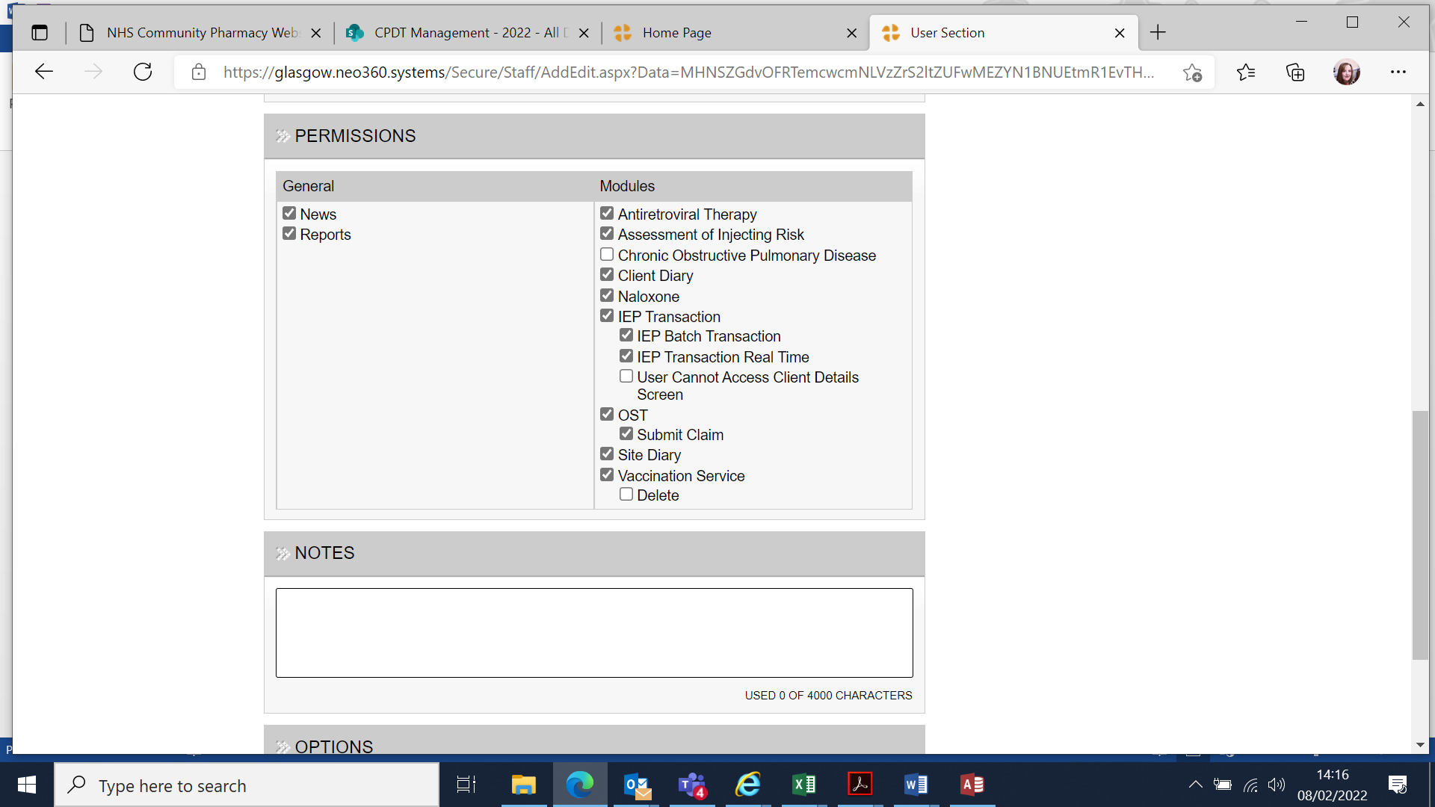

Select this module for each staff member

* Save the changes you have made
* Staff member will now be able to log on and should see ARV module at the top left of the screen. Staff will only see the modules for which they have been granted access so this will vary from person to person

If the site manager leaves they must pass on the site manager username and password to whoever takes over from them. The new site manager should then create a new password for security reasons and check that the email address associated with the managerial log in is the store email address and not a personal email address.

Full details on the NEO360 system can be found in the ‘HELP’ section

1. **Useful contact details**

|  |  |  |
| --- | --- | --- |
| Community Pharmacy Development Team | [ggc.cpdevteam@nhs.scot](mailto:ggc.cpdevteam@nhs.scot) |  |
| Michelle Cooper | Contracts Supervisor | 0141 201 6041 |
| Karen Armstrong | Contracts Administrator | 0141 201 6042 |
| Lauren Keenan | Contracts Officer | 0141 201 6094 |

Page 7

|  |  |
| --- | --- |
| **Version** | 1. **October 2022** |
| **Name/Department of**  **Originator/author:** | HIV/ARV Pharmacy Team/CPD Team |
| **Date ratified:** | February 2022 |
| **Name/Title of responsible**  **Committee/individual:** | Michelle Cooper/Janine Glen |
| **Date issued:** | 1st November 2022 |
| **Review date:** | October 2023 |
| **Target audience:** | NHSGG&C Community Pharmacy |

|  |  |  |
| --- | --- | --- |
| **Version** | **Date** | **Control Reason** |
| 1. | September 22 | Updated to reflect developments made to NEO module for missed doses and areas of concerns. |
| 2. | October 2022 | Changes to ARV module - Changes include:   * Facility to view all patients receiving ARV on front screen; * Facility to report concerns (similar to the function already available on OST module); * Facility to report 3 missed doses (similar to the function already available on the OST module). |
|  |  |  |

Page 8