Dear Colleague,

**GLUTEN FREE FOODS SERVICE**

An interim review of prescribable products available on the gluten free foods service has been undertaken. As a result the following changes have been made:

* Contact and delivery details have been updated where appropriate.

There are four product removals to the November interim update of the formulary list as they have been discontinued by their manufacturer:

|  |  |  |
| --- | --- | --- |
| **Product** | **PIP code** | **Status** |
| Bialimenta Penne 500g | 364-1040 | Removed |
| Bialimenta Spirali 500g | 364-1073 | Removed |
| Bialimenta Acini di pepe 500g | 364-1057 | Removed |
| Bialimenta Formatamisti 6 x 500g | 364-1438 | Removed |

There are six additions to the November interim update of the formulary list as below:

|  |  |  |
| --- | --- | --- |
| **Product** | **PIP code** | **Status** |
| Just Good White Bread (fresh) 380g x 6 | 845-3821 | Added |
| Just White Sandwich Bread (fresh) 600g x 6 | 845-3813 | Added |
| Just Good White Rolls (fresh) (4x65g) x 6 | 845-3839 | Added |
| Finax Flour Mix 900g | 364-1032 | Added |
| Barkat Buckwheat Pasta Penne 250g | 232-3319 | Added |
| Barkat Buckwheat Pasta Spirals 250g | 232-2873 | Added |

Otherwise the gluten free formulary remains the same and a more comprehensive review will be undertaken by end March 2023..

The formulary document detailing the full list of gluten free food products can be downloaded from the NHS Lanarkshire Community Pharmacy website: <https://www.communitypharmacy.scot.nhs.uk/nhs-boards/nhs-lanarkshire/gluten-free-food-gff-service/>

Yours sincerely,

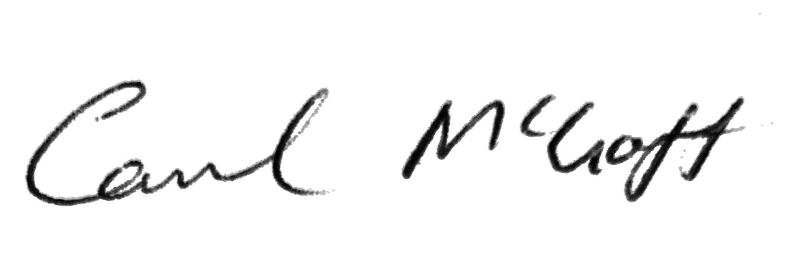

Carol McGoff

Formulary and Clinical Effectiveness Pharmacist, NHS Lanarkshire

November 2022