|  |
| --- |
|  |
| Tube feed management over winter |
|  |

NHS GRAMPIAN – Community Dietitians



|  |
| --- |
|  |
| Spare pump If you have a spare pump, please ensure this is fully charged for use in an emergency. Bolus feedingPlease speak to your dietitian at your next review to find out if it would be safe for you to bolus feed. In the event that cannot use your pump, you may be able to use your 60ml syringe to bolus feed (insert small volumes of feed at a time into your feeding tube, with water flushes before and after) as a temporary measure. Please ensure you flush with a minimum of 30mls of water before and after each bolus feed to avoid the tube blocking. **Nutricia out of hours advice line**  Tel: 0800 093 3672 |

Tel: 0345 099 0200 Email: [gram.communitydietetics@nhs.scot](mailto:gram.communitydietetics@nhs.scot)

|  |
| --- |
|  |
| Dear Patient / Carer,  In light of last year’s storms and wintry weather and ongoing global issues affecting feed stock, we are writing with some advice on managing your tube feeding during adverse weather. |
|  |

# Extra buffer stock

Please ensure you always have an extra **7** days of feed and ancillaries at any time of the year. When stock taking please ensure you tell Homeward whether the total includes your buffer stock or not. If you live in a rural area, you can ask for a **14** day buffer for the winter months. Please speak to your dietitian to arrange.

# Homeward Online Ordering

You can register with Homeward for online ordering which can help you control your supply. Please go to: <https://www.nutricia.co.uk/patients-carers/services/nutricia-homeward-service.html> **Note**: If feed is delivered that you were not expecting, please refuse it at the door. Once it is in your home, we can ask for it to be collected but it will have to be disposed of for safety reasons.

**Gravity feeding sets**

We can provide gravity feeding sets to have as back up to pumps. These sets allow you to run continuous feed without a pump, using gravity, with the rate of feed adjusted by a roller clamp on the giving set. You or your carer(s) would need to be trained in using these sets. Please speak to your dietitian if you feel this would be useful for you. Please see this video for a demonstration of how the sets work: <https://www.nutricia.co.uk/hcp/resource-centre/gravity-feeding-using-a-gravity-giving-set.html>

# Priority Services Registration

# You can register for Priority Services Registration with SSEN. If there is a power cut they should be able to assist with charging your pump.

# <https://www.ssen.co.uk/PriorityServicesRegister/>

# Telephone: 0800 294 3259

# Local information

Information on planning for emergencies can be found here:

<https://www.aberdeenshire.gov.uk/communities-and-events/safety-and-emergencies/>

# Homeward

We are working closely with Nutricia Homeward around your supplies and deliveries. Please continue to let us and /or Homeward know about any concerns so that we can try to deal with them as quickly as possible.

# If you have any questions about your tube feed please don’t hesitate to get in touch.

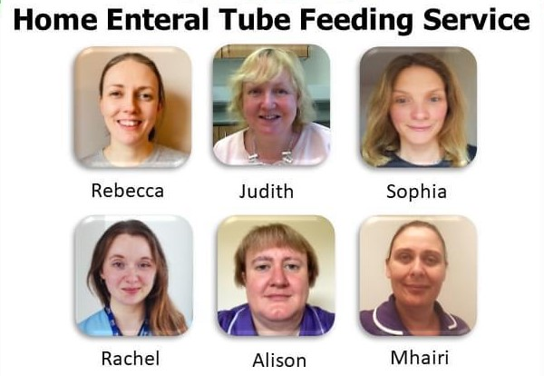Your Home Enteral Feed Team

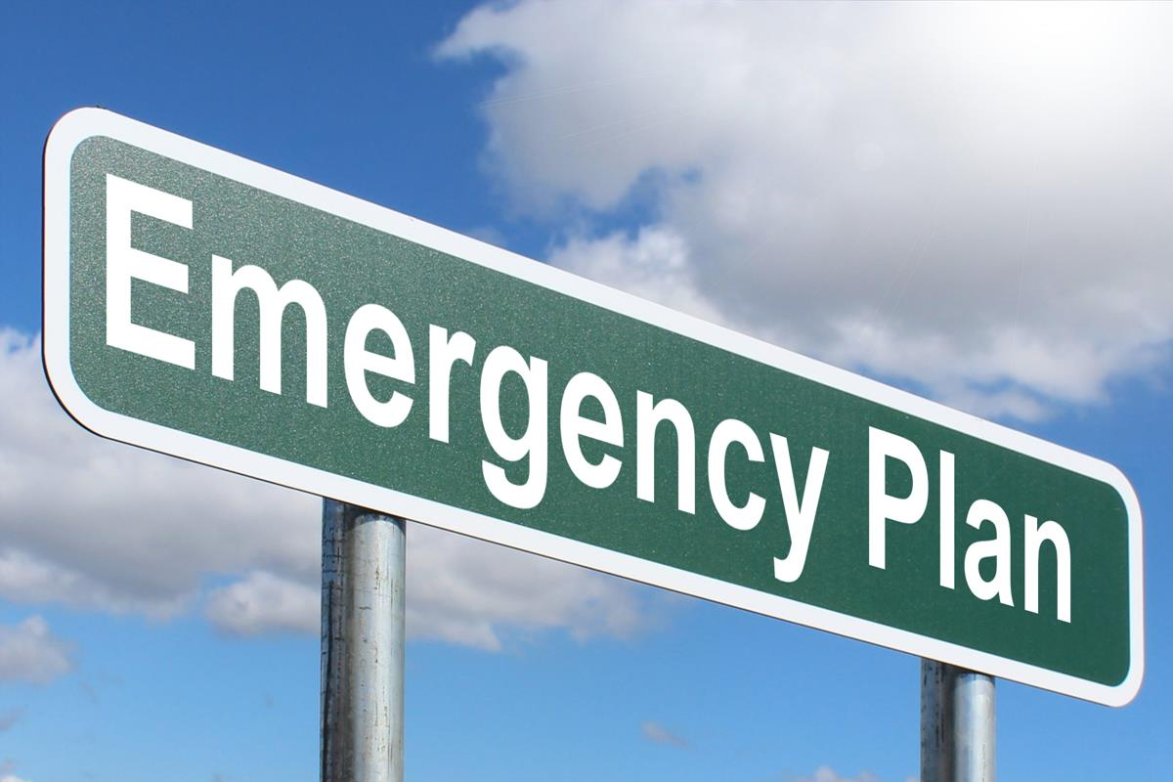

|  |
| --- |
|  |
| Planning for an emergencyCouncil Services During emergencies the council seeks to provide basic services such as food and drink, heating and light at hubs in affected areas e.g. village halls. You should also be able to access charging points at these venues. Next of Kin Please ensure your next of kin are aware how best to support you in adverse weather. If you are concerned you do not have support in place for adverse weather, please speak to your Dietitian. Battery powered radioDuring adverse weather support information is broadcast on local radio. A battery powered radio can help you stay updated. |