**Rota Load Disconnect Brief for Primary Care**

You may have seen correspondence from NHS Grampian regarding imminent potential power outages already. Some of these may be planned with notice provided (Rota Load Disconnect) and others unplanned and with little to no notice (NETS Failure). The latter is most likely in the event of a cyber incident.

The guidance that follows may be helpful to primary care contractors and focuses on Rota Load Disconnect (RLD), although robust Business Continuity Plans (BCP) will ensure resilience also in the event of Net Failure

**Frequently asked questions**

**Q How likely is this to happen**

A NHS Grampian believe this to be “likely”

**Q When will this happen**

A This is unknown but expected during the Winter period 2023

**Q Will any notice be given**

A For RLD less than 24 hours. Net Failure would have no notice

**Q Will my current BCP will cover this.**

A Depends. Some BCPs may concentrate on power being isolated to their site only. RLD will remove power from entire areas. The example below shows Rota Load blocks in Dundee:

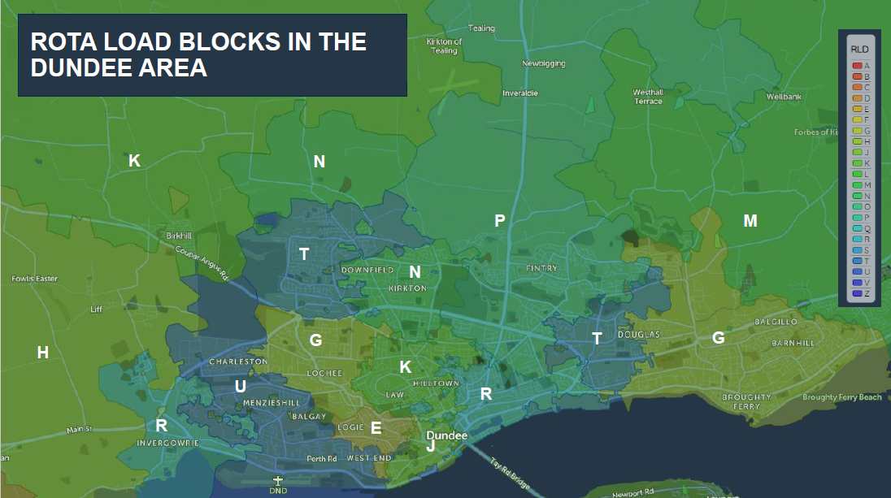

And then how RLD may look:

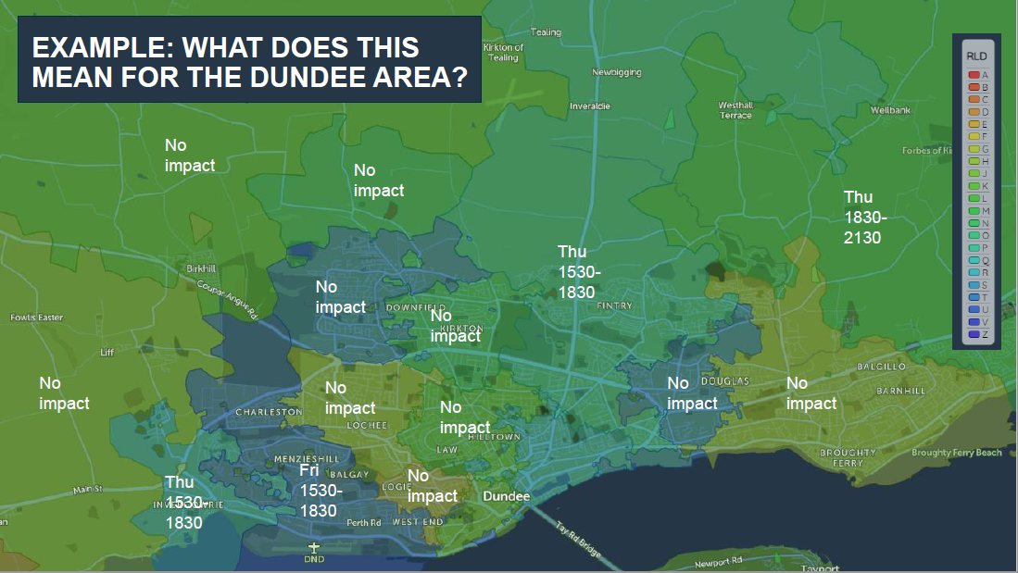

NHS Grampian’s blocks look like this:

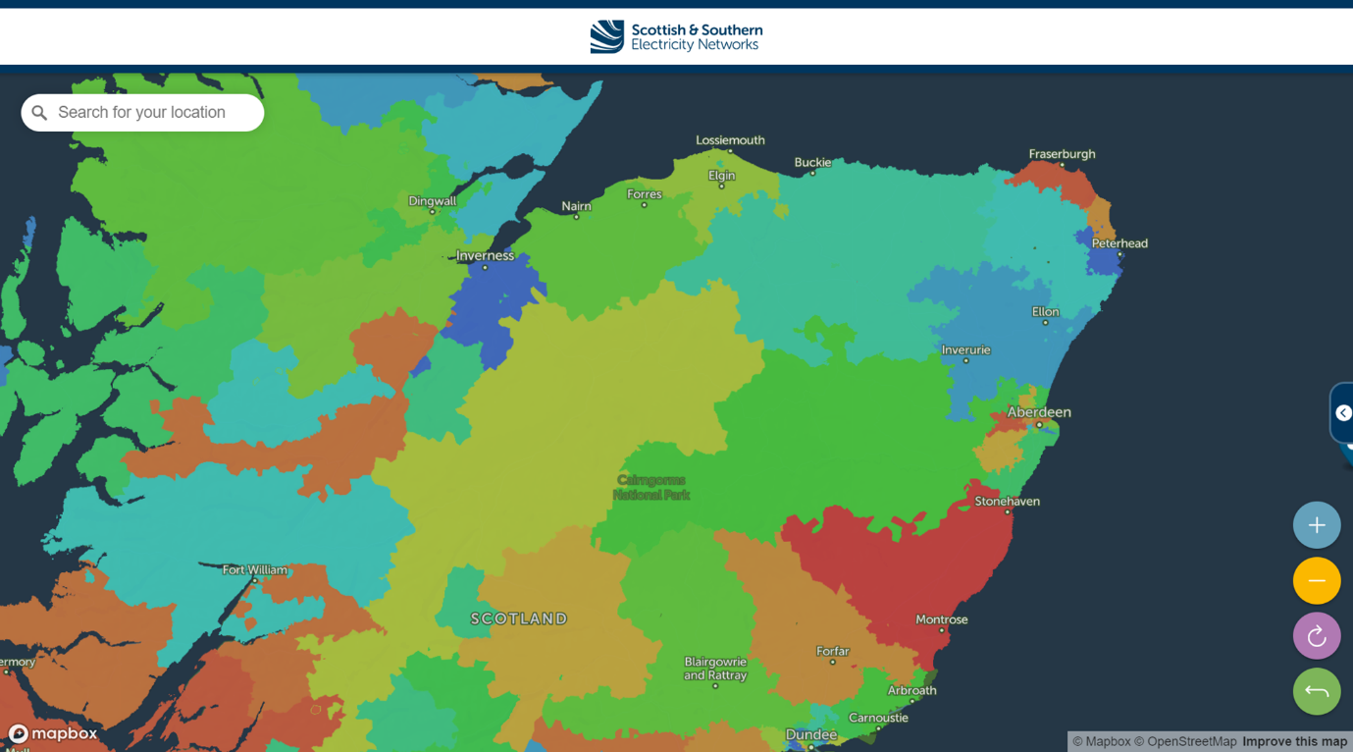

The different colours show different blocks within Grampian and you can see some blocks cover a wide area. Further details can be found at [Find my block letter? Call Free to Solve Electricity Issues (powercut105.com)](https://www.powercut105.com/findmyblock) Letters have been sent to PSR customers directly.

**Q We have a buddy practice. Will that be OK**

A Not necessarily. If your buddy is on the same block as you then they will also have no power as per Dundee example.

**Q What about emergency patients**

A Further information will follow from NHS Grampian on patient pathways.

**Q As GP/Dentist/Pharmacy/Optometrist will I be a protected site**

A No. The only protected health site in Grampian is Aberdeen Royal Infirmary

**Q Is the ARI campus a protected site**

A No. Only the hospital itself

**Q What about other health sites in Grampian**

A NHS Grampian is working on arrangements for service provision

**Q What will happen Out of Hours**

A GMED and GDENS are working up their own contingency plans.

**Q Will ARI operate as normal**

A It is expected there will be some change to accommodate the impact of the outage

**Q Will the mobile phone network be disrupted**

A Yes. There is some resilience in the networks, but masts may be impacted and it is best to assume mobile networks will not function

**Q Will conventional telecoms be disrupted**

A Yes. Digital lines will not function, and older analogue lines use may be limited

**Q Will patients be able to reach me**

A Possibly not. Scottish Government may implement “do not travel” restrictions.

**Q Will public transport operate**

A Again unlikely and there will be disruption to traffic light systems for example

**Q Can I Use a generator**

A Yes if your electricity supply has a suitable interface

**Q What about fuel**

A Likely petrol pumps will not work so if using a generator ensure sufficient supplies. For cars it is suggested to ensure half a tank of fuel. EVs will obviously be unable to be charged in periods of power outage.

**Q Will a priority fuel scheme be announced**

A That requires to be triggered by Scottish Government

**Q If a priority fuel scheme is announced will I be classed as a priority**

A There will only be a limited number of priority users. NHS Grampian will prioritise across all the healthcare system to ensure safe service is maintained. This may mean that not all healthcare staff are classed as priorities under this measure.

**Q If I cannot provide services during this period will I be in breach of contract with NHS Grampian.**

A Providing you can evidence sufficient diligence in your BCP no. If there is insufficient resilience evidence that is a possibility, although unlikely.

**Q Is there help available regarding BCPs**

A Yes. Modules are available on Turas and resources as below

**Business continuity: module 1 : introduction to business continuity in NHS Grampian**

[https://learn.nes.nhs.scot/40029](https://eur01.safelinks.protection.outlook.com/?url=https%3A%2F%2Flearn.nes.nhs.scot%2F40029&data=05%7C01%7Cpeter.maclean%40nhs.scot%7C7d75ed808d4849bc1df008daf54d83b0%7C10efe0bda0304bca809cb5e6745e499a%7C0%7C0%7C638092010823148760%7CUnknown%7CTWFpbGZsb3d8eyJWIjoiMC4wLjAwMDAiLCJQIjoiV2luMzIiLCJBTiI6Ik1haWwiLCJXVCI6Mn0%3D%7C3000%7C%7C%7C&sdata=3DFbwHEe0cVbK8BAjZu%2BNRtFZzKqi9ElqF1PhkAAnGg%3D&reserved=0)

**Business continuity: module 2 : business continuity management**

[https://learn.nes.nhs.scot/60394](https://eur01.safelinks.protection.outlook.com/?url=https%3A%2F%2Flearn.nes.nhs.scot%2F60394&data=05%7C01%7Cpeter.maclean%40nhs.scot%7C7d75ed808d4849bc1df008daf54d83b0%7C10efe0bda0304bca809cb5e6745e499a%7C0%7C0%7C638092010823148760%7CUnknown%7CTWFpbGZsb3d8eyJWIjoiMC4wLjAwMDAiLCJQIjoiV2luMzIiLCJBTiI6Ik1haWwiLCJXVCI6Mn0%3D%7C3000%7C%7C%7C&sdata=EJbm1MJrmif3gFC8XUlY5yILI5exBDo2mIrs07Jaleo%3D&reserved=0)

**Conducting Debriefs**

[https://learn.nes.nhs.scot/60747/civil-contingencies/conducting-debriefs](https://eur01.safelinks.protection.outlook.com/?url=https%3A%2F%2Flearn.nes.nhs.scot%2F60747%2Fcivil-contingencies%2Fconducting-debriefs&data=05%7C01%7Cpeter.maclean%40nhs.scot%7C7d75ed808d4849bc1df008daf54d83b0%7C10efe0bda0304bca809cb5e6745e499a%7C0%7C0%7C638092010823148760%7CUnknown%7CTWFpbGZsb3d8eyJWIjoiMC4wLjAwMDAiLCJQIjoiV2luMzIiLCJBTiI6Ik1haWwiLCJXVCI6Mn0%3D%7C3000%7C%7C%7C&sdata=lrmvHsH6O7mrtEolKYYNV1pIQEKOuuvAClS7ZIOhWYA%3D&reserved=0)

**Q Do you have BCP resources available**

A Yes, See below documentation that may assist. Although designed for NHS Grampian they may be adapted for local use



**Q How will NHS Grampian know our BCP is adequate**

A It is unlikely NHS Grampian will ask to review BCPs. It is likely however that contractors will be asked to confirm their BCPs cover the eventualities listed here.

**Q Is there any information available for my patients**

A Priority Services Register leaflets are available from SSE. Contact [shona.horn@sse.com](mailto:shona.horn@sse.com) with how many you require and address for delivery. If patients are already on a register then they should have been contacted already, but if there has been a new diagnosis or the practice feels it is likely they have been missed you can request accordingly.

**Q Is there anyone I can discuss this with**

A [Tara.mackie@nhs.scot](mailto:Tara.mackie@nhs.scot) or [helen.clark2@nhs.scot](mailto:helen.clark2@nhs.scot) from NHS Grampian’s Civil Contingencies Team may be able to help. Or you can contact the Civil Contingencies Lead in your Health & Social Care Partnership

Aberdeen City [caroline.duguid2@nhs.scot](mailto:caroline.duguid2@nhs.scot)

Aberdeenshire [jason.shirazi@nhs.scot](mailto:jason.shirazi@nhs.scot)

Moray [sonya.duncan@nhs.scot](mailto:sonya.duncan@nhs.scot)

***So what should I do next***

1. Identify which power block your supply is on: You can identify which ‘power block’ your supply is on by looking at the top of your supplier’s bill or using the website <https://www.powercut105.com/>
2. Identify your buddy, and check similar to ensure they are in a different block area
3. Review your BCP and ensure it is sufficiently broad to cover Rota Load Disconnection or Net Failure.
4. Contact those listed above if you have any queries or are uncertain.