

**What is your current role?** Senior Pharmacist Primary Care & Community Pharmacy North Ayrshire HSCP

**How long have you worked in NHS AA?** 4years

**What roles have you previously held?** 15years with a multiple pharmacy covering various roles including Pharmacy Manager. 2years as an NHS General Practice Clinical Pharmacist

**What’s the best bit of your job?** The variety. I meet, work alongside & learn from a variety of colleagues with different skillsets & roles. Patient care is at the heart of everything I do & I enjoy sharing my skills and learnings with others to strengthen patient care in primary care & community pharmacy.

**What do you to relax outside of work?** Spending quality time with my family. I love walking & combine this with my love of talking by having a catch up with family & friends whilst burning calories!

**Meet the team**

**Alyson Stein**



**Friday 20th January 2023.**

**No:3**

Community Pharmacy

Weekly Script

Meet the team:

**Alyson Stein**

Stat of the week:

**NHS Pharmacy First Scotland**

Communications Summary

Success story:

**Gallagher Pharmacy – Greatix award!**

This week’s key messages:

**Exciting opportunity!**

COntents

December 2022 saw ANOTHER record month for NHS Pharmacy First Scotland activity in A&A!

A total of 25,619 items were supplied, 1195 referrals were recorded and a further 3028 advice only consultations were logged.

This is another record number of supplies and advice and we would like to thank ALL community pharmacy teams for making this service accessible to meet the care needs of the citizens of Ayrshire & Arran.

Please share your success stories with the community pharmacy team for inclusion in future editions of

***Weekly Script***

*You could be the next community pharmacy ‘Greatix’ winner!*

Communications Summary

Tuesday 17th: Memo 1 – re: Contractors committee AGM

Tuesday 17th: Memo 2 – Re: Quit your way visits and smokylysers

Wednesday 18th: NHS Circulars 2023 1 & 2023 2

Thursday 19th: Drug Alert – Class 2 – Dioctyl 100mg caps.

Drug alert – Class 4 – Etrivex Shampoo

Friday 20th: Drug alert – Class 3 – Lacidipine 10mg

**Community Pharmacy ‘Greatix’ Award**

**Stat of the week….**



Success story

We are delighted to share that following the good news story from issue 1, Gallagher pharmacy received a ‘Greatix’ award from the board!

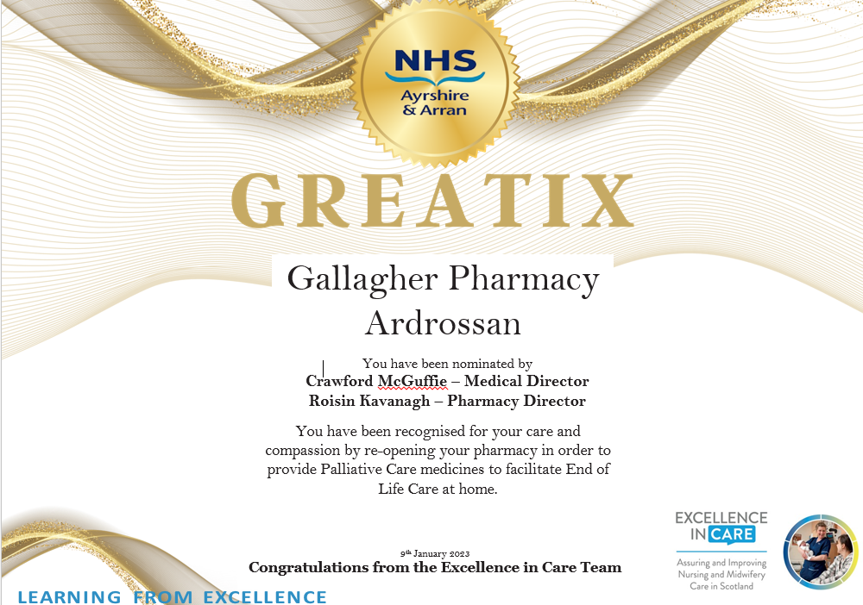

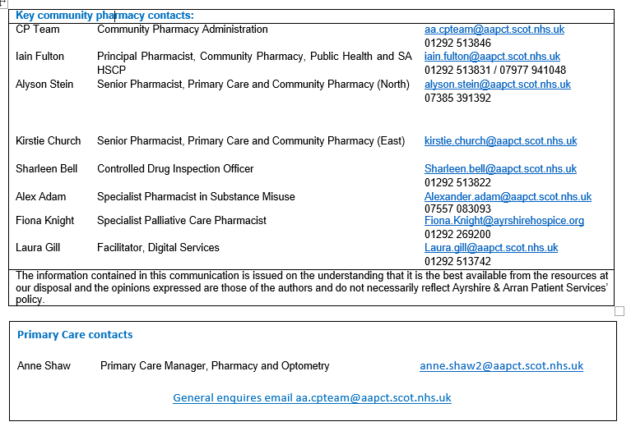

**Key Messages**



**Nominations for Locality Area Pharmacists Representatives**

We are currently looking for nominations for a locality area pharmacist in each of the three local HSCP areas.

The pivotal role of localities in achieving outcomes previously led to the revising of the old Pharmacy Locality Group and Area Pharmaceutical Professional Committee constitutions in order to enable Pharmacy to undertake a key role in the Health and Social Care Partnerships.    We are now looking to recruit locality area pharmacy representative in North, South and East Ayrshire.  The position of Area Pharmacist Representative for each of the three areas also secures membership of the Area Pharmaceutical Professional Committee and allows the locality pharmacy representative to attend the APPC meetings every 8 weeks.

The period of membership of the Area Pharmacist Representative is normally 2 years.

***We are now seeking nominations from Community Pharmacists who are registered with the GPhC and who are working full time or part-time or as a regular locum in Ayrshire, to serve as Pharmacist Representative of the HSCP Area Pharmacy Group in the area that they work in for the next two years.***

If you are interested in these positions and would like more information on the role of the Representative, and also the core meetings that the Representative, or nominated deputy, would also be expected to attend, please contact your locality Senior Pharmacist for Community Pharmacy (South = Iain, North = Alyson, East = Kirstie)

**Nominations should be submitted to** [**Anne.Shaw2@aapct.scot.nhs.uk**](mailto:Anne.Shaw2@aapct.scot.nhs.uk) **by close of business on Friday 10th February 2022.** Where more than one nomination is received, an election will take place as outlined in the constitution.