 |  | GGC CPIP Notebook
No 2: Winter 2021 |  | Supporting Community Pharmacy Independent Prescribers (CPIPs) across GGC to work and learn together.
All about the Ear – Tips for Ear Examinations  Attending a NES CCC Teach & Treat Hub  Hear from Shama, a GGC CPIP who attended the Hub @ Parkhead HC Pharmacy  Best practice ideas:  How do you record your consultations? Could you access them if needed?  Peer Support  Upcoming dates and topics for peer support meetings |  | 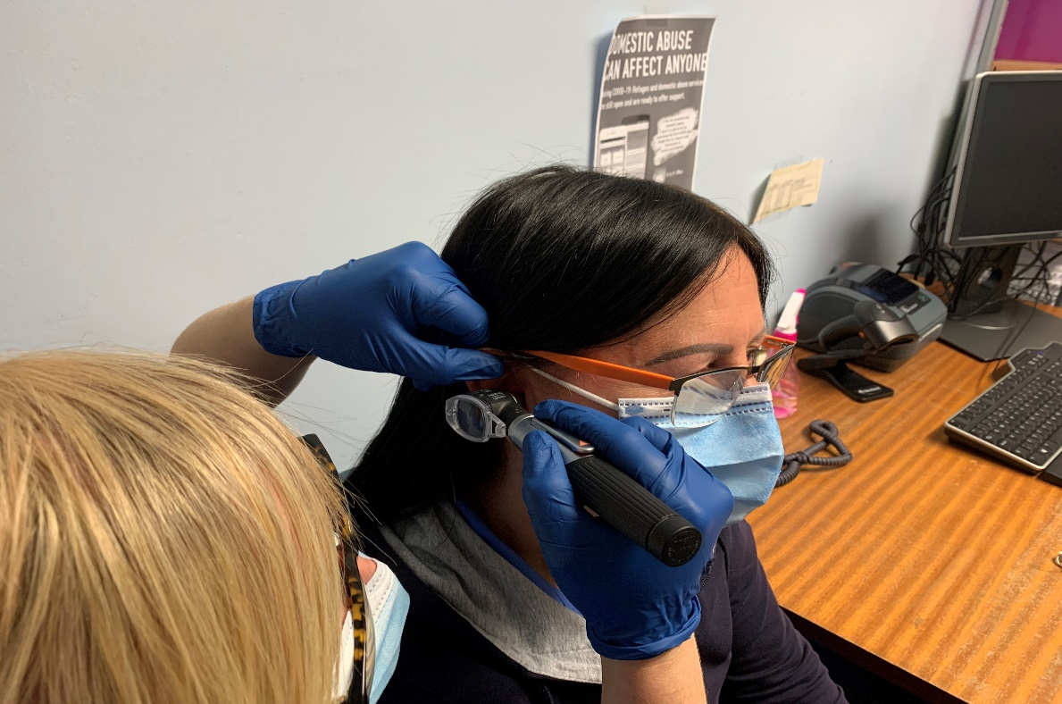

All about the Ears By Maryann Dunnet
Sore ears are a frequent presentation at CPs. It can be quite daunting placing an otoscope into someone’s ear (especially if they are in pain!). Looking at pictures online can be helpful, but it can be difficult to imagine what this can look like in real life. To help with my competence I asked patients who presented with an ear infection Rx if I could look at their ear to improve my awareness of what an infection, perforation or impacted wax actually looks like - this really helped. I also practiced on family members to see what ‘normal’ ears looked like and used some online resources (links below) to help me. Remember to look in the good ear first and to review the patient holistically, checking temperature and general presentation. After watching a NES webinar, I sometimes ask patients to try and ‘pop’ their ears to help decide if it is an inner or outer ear problem. The more I look in ears the more comfortable I feel in doing so. Go on, pick up your otoscope. Have a look at this video.

GGC CPIP Rx Notebook
Attending a Teach & Treat Training Hub  - By Lorna Brown with Shama Arshad  Starting to run a PF+ clinic can be daunting, you may be new to prescribing, you might have run different clinics or you qualified a long time ago but never had a way to use if for your patients before PF+. Getting started can be daunting, you will have completed the NES courses or be in the process of completing them as per PCA(16). There are lots of changes in pharmacy training and there is an increased focus on experiential training at all levels. This type of training is used at all levels and increasingly in post qualification activities. Often at official training an OSCE (Objective Structured Clinical Examination) is used for formal assessment of learning. Within the many experiential training events offered within the pre and post grad pharmacy curriculum, a mini-CEX mini clinical evaluation exercise) is used in the workplace to assess the trainee's ability to identify, action and resolve issues effectively when providing pharmaceutical care for a patient. It enables supervisors to review various skills, attitudes, knowledge and behaviours of the trainee, and is useful for developing pharmacy staff.  If you attend a NES T&T Hub, like the one we have in Glasgow, you will have the opportunity to participate in a mini-CEX and receive feedback in a supportive environment to further develop your skills.  Upcoming CPIP Support Network Sessions  - Week beginning 17th January – Small Group Year 1 prescribing data  - Week beginning 28th February – Skin issues beyond the PGD |  |  |  |  | “I had attended all the NES specified courses but being a recently qualified prescriber and having only recently started to offer PF+, I was keen to attend the hub. I was particularly hoping to consolidate my ear examination skills. Prior experience in this area was based on pictures and role play. There was opportunity to do this with real patients during my session. It was interesting to watch how Maxine conducted her ear examination. She put the patient at ease and was extremely thorough in her examination. When I used her technique, I saw a tiny scratch at the outer rim of the ear drum that I had missed in my more tentative initial examination. Moving the ear around more to view every angle did not hurt the patient, which I was worrying about but definitely improved my assessment.  I would highly recommend my fellow CPIPs to book a visit to a hub because the hands-on experience that you gain from this far supersedes any pictures or role play. Having the support of experienced tutors to guide you is invaluable.”  Shama Arshad, GGC CPIP  If you would like to attend a T&T CCC Hub then check out the self-assessment and application form on the link below:  https://learn.nes.nhs.scot/46668/pharmacy/teach-and-treat-for-common-clinical-conditions  ”  Shama Arshad, GGC CPIP  If you would like to attend a T&T CCC Hub
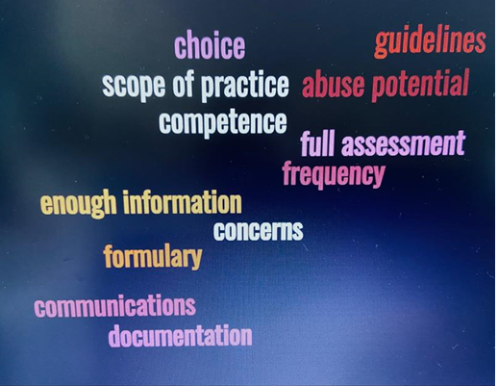
Clinical decision making and prescribing are becoming an increasingly integral to daily Community Pharmacy practice. With the introduction of Pharmacy First and Pharmacy First Plus alongside PGD use, comes an increase in potential for prescribing and judgement errors that can affect both quality of care and patient safety. In order to help CPIPs ensure that they are safeguarded and supported within their role we are highlighting this topic and suggesting ways for pharmacists to reflect on their clinical decision making and prescribing decisions alongside giving guidance on how to document your actions. Should an error or query be identified, you will be required to evidence the investigations/questioning you undertook that resulted in the decision to prescribe (or not prescribe). It is not expected that all decision making will be perfect. However, it is expected that the pharmacists, like other prescribers will be able to justify their decision to others if required.
Documentation
is key
Lorna Brown in conjunction with David Massie
Increased documentation is an additional string required for the CPIPs bow. Documentation can vary depending on many factors including operating system functionality, how your colleagues document and/or how your DMP documented during your PLP. All can affect positively or negatively your documentation process. If you are grappling with the best way to document and communicate – why not consider a visit to your local Teach and Treat Training Hub? Take along an example of your process/paperwork for discussion. Alternatively speak to your peers or colleagues if you work for a multiple, others might have unearthed some smart solutions that could help.
Reviewing your work, will give you the opportunity to reflect on prescribing and identify any areas that are working well and any areas for improvement. It can also enable you to identify any possible reasons for an error occurring and consider methods for avoiding similar errors in future. As a new prescriber it might be an idea to review some of your prescribing or ask someone else to do this for you. Check that you can make sense of what you did and why and if possible that someone else agrees. It could be an idea to do this sooner rather than later so that any potential bad habits or issues are identified early in your prescribing journey and can be rectified.
When making clinical decisions the risk versus benefit must always be considered before making a recommendation or issuing a prescription. Before prescribing, some of the themes in the image above should be considered so that you can justify your decision if required to do so. If you wish to undertake a review of your prescribing and need some support to get started, please contact the CPDT or ask a peer on the WhatsApp - we can help get you started. The sample checklist below could be used or if you have other ideas of how to do it, please let us know and we can share them with the group. Perhaps you could review 5-10 Rx for a fellow CPIP and they could do the same for you?

SAMPLE PRESCRIBING REVIEW CHECKLIST for CPIPs
Prescribing area | Areas to consider when reviewing your or another CPIPs prescribing | Y / N / NA
Right Drug | - Evidence for use in the indication  - Allergies  - Contra-indications/Cautions  - Interactions with co-prescribed medication  - Local and national prescribing guidelines  - Local formulary  - Licensed or unlicensed/off-label use  - Social issues (e.g. carers, inclusion in a monitored dosage system)  - Formulation  - Duplication or omissions in therapy  - Correct use of brand prescribing for safety reasons
Right Dose | - Renal or hepatic function  - Age / weight  - Local and national prescribing guidance (including MHRA)  - Is the dose correct for the indication?  - Has increasing or reducing dosing been done appropriately?  - Most appropriate strength of tablet prescribed for the required dose.
Right Dosage Instructions | - Clear and unambiguous (avoiding “as directed”)  - Up to date (according to current usage/latest letters)  - Include route of administration/area of application/treatment eye or ear  - Are the instructions able to be read and understood by the patient?
Right Follow-up | - Has the necessary monitoring been planned/taken/acted upon e.g. blood tests, BP.  - Has the patient been advised on where to get further supplies if needed?
Right Documentation | - Is the indication for prescribing clear and relevant?  - If prescribing does not follow standard guidance is the reason documented?  - Is the plan for any necessary monitoring or follow up documented?
Right Review | - Where the medication has been used before, has a review been undertaken?  - Have any necessary discussions taken place before continuing medications with risks e.g. NSAIDs
Good prescribing | - Does prescribing show that local guidelines have been referred to e.g. antimicrobial guidelines?  - Is the prescribing plan in the notes and thought process accurate and clear for the next clinician or pharmacist to follow?  - Is the advice that has been given very clear with regards to medication dosage and further advice?
We need your help.
Are you a CPIP working in GGC? Do you have an idea for a webinar topic or an article? We need your help to make this relevant and to support your learning needs.

Please get in touch with lorna.brown8@nhs.scot if you want to get involved.

Consultation Conundrums
What do you do? Female, 37years, presented with right ear itching & left ear discomfort. Medical history – nil, Medication – nil 3-day history. Left ear - inspected outer ear - pinna, lobe - normal, no mastoiditis. Inner ear - compacted wax, possible trauma from use of cotton bud. Right ear - inspected outer ear - pinna, lobe - normal, no mastoiditis. Inner ear - ear canal red & inflamed. Tympanic membrane intact, no exudate.
CPIP 1 - Patient otherwise well. No fever, no nausea, no vomiting, no dizziness, balance unaffected, no hearing loss. Left ear - olive oil drops for 10-14 days to soften ear wax. Avoid use of cotton buds. Right ear - Otomize spray - 1 spray TDS for 7 days. Worsening advice given to seek further medical advice should symptoms worsen or not fully resolve.
GP 1 -. I would give her Otomize to use in the RIGHT red itchy ear and advise simple analgesia for the other ear for a few days, with a worsening statement re exudate
GP 2 - Advise olive oil drops to left ear for 2-3 weeks and issue patient information leaflet on ear wax. Prescribe Otomize spray to use in right ear. Advise that nothing smaller than an elbow should be placed inside an ear canal. (May wish further review depending on extent of trauma).
What do you do? Call from mum, 11-year-old with 3-4 day history of bilateral ear ache. Worse today, increased pain and exudate. Right ear worse than left. Also has sore throat, stuffy nose, green sputum last night now has cough. Not at school as precaution. LFT negative. Mum reports happened previously, and thinks might need ENT referral?
CPIP 2 – Covid recommendations re PCR for cough given. Worsening statement given re no improvement in 3-4 days, guidance on self-care (has paracetamol at home). 5 day course of Amoxicillin given and can attend for assessment at pharmacy or GP practice if PCR negative. Advised if ongoing ear issues TMA with GP to discuss long term management.
GP1 - Given that it's bilateral and beyond 72h and exudate is present, I would prescribe amoxicillin (or alternative if allergic).
GP2 - Advise that given new cough they should arrange a PCR test for COVID and follow national isolation guidance whilst awaiting result. I may issue a course of amoxicillin over the phone or arrange a F2F appointment in the surgery.
Additional information from GP - Re recurrence, I'd want to explore how long since the last episode - not that likely an 11-year-old will need grommets. Probably just needs a short course of antibiotics and nothing else. A review of PMH and follow up if appropriate could be organised with mum to arrange or reassure.
Counselling points to consider – Remember COVID considerations !!

If you have any ideas for clinical conundrums? Please send them to lorna.brown8@nhs.scot

