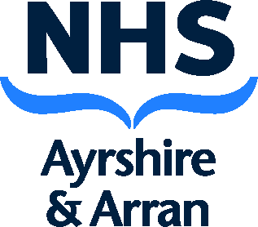

**PRIMARY CARE COMMUNITY PHARMACY**

**LOCAL PHARMACY SERVICE SPECIFICATIONS**

**Community Pharmacy Hospital Discharge Pilot**

**Document Control Sheet**

|  |  |
| --- | --- |
| Title: | Community Pharmacy Hospital Discharge Pilot |
| Document Status: | FINAL |
| Document Type: | Guidance |
| Version Number: | V1.0 |
| Document location: | Joint Pharmacy Drive |
| Author: | Iain Fulton |
| Owner: | Anne Shaw |
| Approved By: |  |
| Date Effective From: |  |
| Review Frequency: | Annually |
| Next Review Date: | Feb 2024 |

**Revision History:**

|  |  |  |  |
| --- | --- | --- | --- |
| Version: | Date: | Summary of Changes: | Responsible Officer: |
|  |  |  |  |
|  |  |  |  |

**Approvals:** this document was formally approved by:

|  |  |  |
| --- | --- | --- |
| Name & Title / Group: | Date: | Version: |
|  |  |  |
|  |  |  |

**Dissemination Arrangements:**

|  |  |  |  |
| --- | --- | --- | --- |
| Intended audience: | Method: | Date: | Version: |
|  |  |  |  |
|  |  |  |  |

**Linked Documentation:**

|  |  |
| --- | --- |
| Document Title: | Document File Path: |
| PGD: CP 022 066 |  |

**NB. This document is uncontrolled when printed.** The contents of this document are subject to change, any paper copy is only valid on the day of printing. To ensure you have the most up to date version of this document please use the link to access the document directly from AthenA or contact the Author.

**Specification for Community Pharmacy Hospital Discharge Pilot**

# Background/Introduction

NHS GGC ran a successful pilot where patients from the North East and North West health and social care partnerships were discharged safely and timely directly from GRI to primary care, with community pharmacies supplying discharge medication and performing medicines reconciliation during patient review.

With this service, NHS Ayrshire & Arran are testing the concept of a supply and pharmaceutical care only model where patients can be discharged from the trauma and orthopedics wards in University Hospitals Crosshouse or Ayr and receive their required medication from their community pharmacy.

This service level agreement forms the basis for the trauma and orthopedic wards in university hospitals Crosshouse and Ayr to safely discharge patients to community pharmacy for medication supply under a PGD.

# Objectives of Service

To allow pharmacy contractors to view the immediate discharge letter (IDL) and provide the required medication in the advised time frame.

To provide better patient flow from acute to primary care.

* By allowing patients to leave hospital when they are medically fit rather than waiting on discharge medication should improve patient experience
* An earlier discharge should help reduce cumulative bed days and therefore waiting times for elective surgery or bed waits from the emergency departments.

# Service Outline

The hospital pharmacy team will contact the community pharmacy by phone in advance of a patients discharge. They will confirm that the pharmacy is able to make the supply and provide basic patient information.

A copy of the immediate discharge letter (IDL) will then be automatically sent to the community pharmacy clinical mailbox AFTER being verified (checked) by one of the hospital pharmacy team.

The community pharmacy will identify the medicines and what quantities to supply by reviewing a copy of the IDL sent to the clinical mailbox of the pharmacy.

Supply will be made using the approved NHS Ayrshire and Arran PGD and processed via the universal claim framework (UCF) LOCAL SERVICE option.

The patient or their representative will then collect the medication from the community pharmacy and will be provided with advice and/or counselling as they would with any other dispensed prescription.

Should a patient request delivery of their discharge medicines this CAN be offered at the discretion of the contractor, however as with all medicine delivered from community pharmacy the responsibility of providing advice on dispensed medicines still lies with the responsible pharmacist and therefore it is suggested that a telephone contact number for the patient is obtained so this can be provided over the phone if required,

Data collection will then be completed by filling in an online form with details specified in appendix A. Completion of this data collection will trigger payment of the administration fee which will be paid in the month after submission of the form.

The link to the form will be sent to each participating pharmacy by e-mail.

Patients should be given a patient experience questionnaire (appendix B) and encouraged to fill this in in the pharmacy before they leave. Alternatively this could be handed in (or given back to a delivery driver) at a later date. These completed forms should be stored in the pharmacy for collection by a member of the Ayrshire & Arran pharmacy team.

1. **Training**

Training will be provided by NHS Ayrshire and Arran primacy and community care team. This training will be in the form of MS Teams sessions as well as written training materials. The senior pharmacists for primary care and community pharmacy will also be contactable for additional queries and/or advice.

# Breach of Contract

Where prima facie evidence of a breach of the terms of this scheme comes to the notice of NHS Ayrshire and Arran the matter will be referred in the first instance to the pharmacy contractor concerned for comment. If appropriate, the pharmacy contractor will be invited to submit proposals for the rectification of the breach. Failure to provide a satisfactory response, or to rectify the breach, will result in the matter being referred to the Chief Executive of the NHS Ayrshire and Arran for consideration by the NHS Board and determination of any further action or sanctions to be taken, including termination of the contract under this scheme and recovery of any payments made in respect of services which have not been provided.

**Appendix A – Microsoft forms feedback**

# The questions asked in the online feedback form are shown below. This should be completed electronically via the link to the form. In the event of internet / IT issues the detail can be captured on paper and uploaded at a later date,

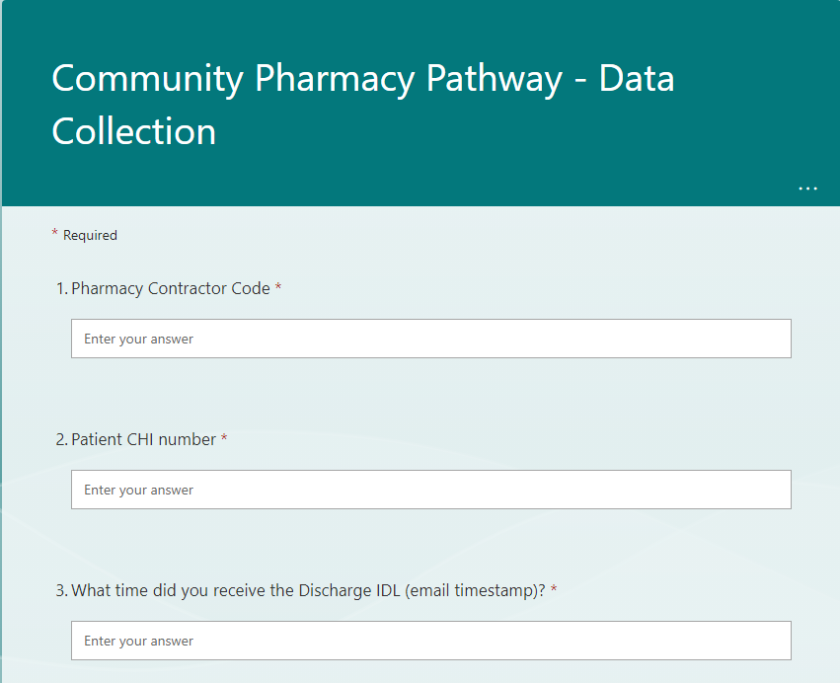

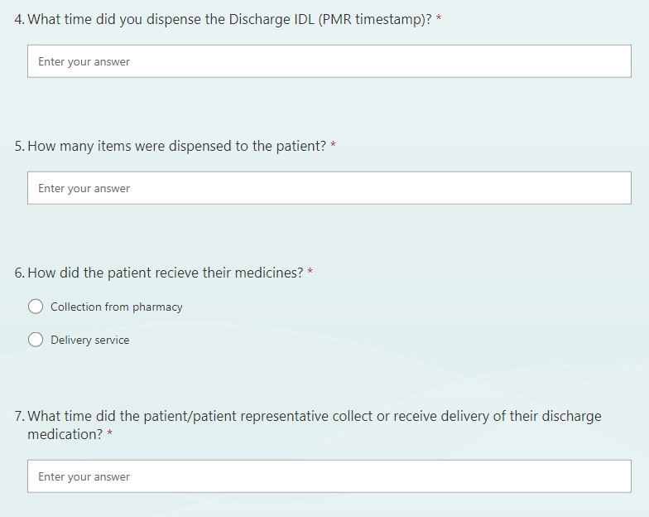

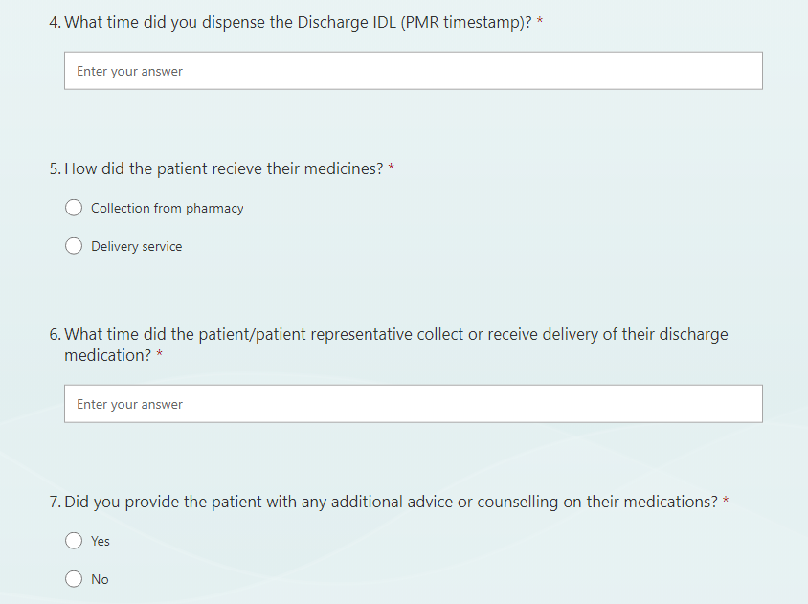

# 

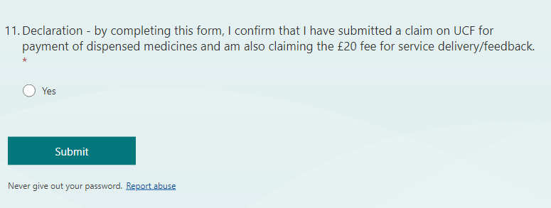

**Appendix B – Patient experience Survey**

**Patient Experience Survey**

**What is the survey about?**

This survey is about your experience as a user of NHS Ayrshire & Arran services

**Why are you being asked to complete this survey?**

The discharge process within Trauma and Orthopaedics in Ayrshire and Arran is currently undergoing a test of change to improve patient flow and experience. Any feedback on your discharge from hospital experience would be very valuable to our service going forward.

**Completing the Survey**

Don’t worry if you make a mistake; simply cross out the mistake and put a tick in the correct box.

Please do not write any personal details including your name and date of birth on the survey.

**Taking part in this survey is voluntary and your answers will be treated in confidence**

**When you have completed this survey, please return it to a member of your community pharmacy team.**

1. **How satisfied were you with the discharge from hospital process?**

**Very satisfied**

**Satisfied**

**Dissatisfied**

**Very dissatisfied**

1. **If you have had an admission to hospital prior to your current admission – how did this discharge experience compare to previous experiences? (If no previous hospital admission, skip to question 3)**

**Better**

**Worse**

**No difference**

1. **Would you be happy to receive your hospital discharge medication from your local community pharmacy again if you were to experience another hospital admission in the future?**

**Yes**

**No**

1. **Do you have any other feedback?**

Was there anything particularly good about the discharge process?

Was there anything that could be improved?

Any other comments