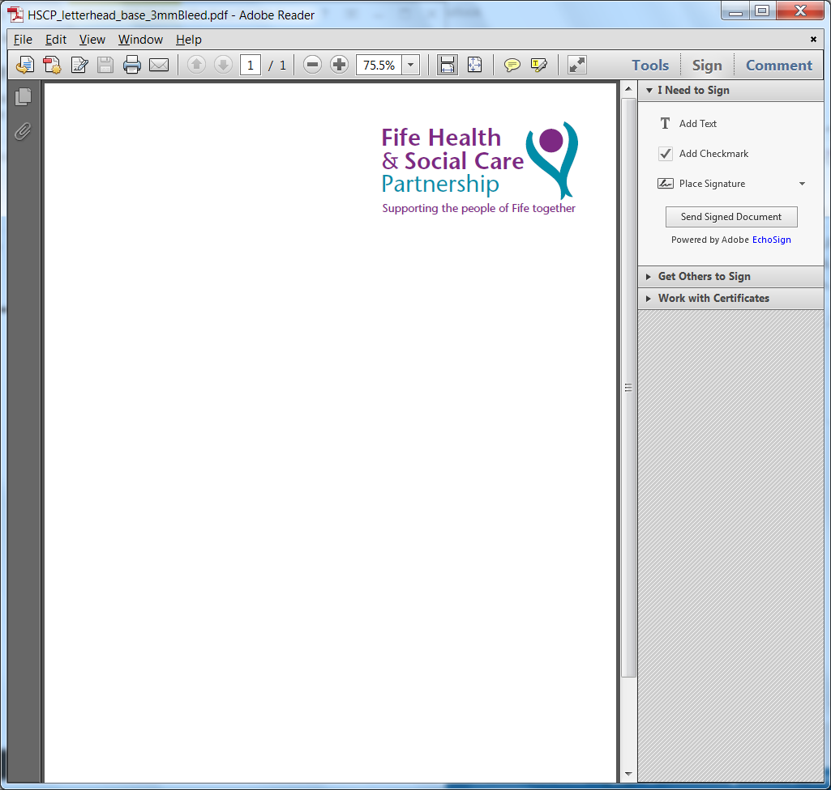 | 

UNPLANNED PHARMACY CLOSURE

Contractor Name and Address
Contractor Code
Date of closure
Type of closure (please X) | Partial |  | Full day
Time of closure | From: To:
Reason for temporary closure
Are you able to provide a ‘closed door’ service where patients can collect previously prepared medication should they need to?
(NB only possible if a pharmacist is present)
Nearest open pharmacy (as confirmed)

Where closure was expected to be longer than 30 minutes the following steps must be taken. By completing this form you are confirming that these steps have been taken ahead of the pharmacy closing:

ACTION | YES / NO / IN PROGRESS / UNSURE
Local GP Surgeries contacted
Local Community Pharmacies contacted
Prescribers of any outstanding ORT doses for the day have been contacted
Instalment patients (including dosette) contacted where necessary
Sign displayed in window to signpost patients to nearest open pharmacy

Name ________________________________________ Position _______________________________

Date ____________________________

Please e-mail this completed form to the Primary Care Department - fife.primarycareadmin@nhs.scot (n.b in emergency situations emails via Smartphone’s can also be used without this template, as long as the same information is communicated) you can also call the team on 01592 226930

