Pharmaceutical services - Additional services - Dispensing and Supply of Urology Products

Urology Supply Service
Managed by Continence Care Service

This document provides learning for use of ELMS2 system for community pharmacy teams

Elms2 Overview
- Urology orders are created by Nursing Teams for Pharmacies to view and dispense
- The system will advise the Pharmacies NHS mailbox of a new order
- Pharmacy can view, fully/part redeem or cancel orders
- Reporting function of orders redeemed or passed for payment

Please note the following
- Each order is known as a voucher to claim payment.

Order Voucher redemption rule
- The voucher can only be redeemed in one transaction and completes the order you have dispensed or item/s you may not have dispensed.
- You cannot go back later and dispense more items to the voucher

The Order Voucher
- Voucher is either fully dispensed, part dispensed or cancelled.
- A dispensing fee is added to the payment of fully dispensed vouchers.
- Inform continence.care@nhslothian.scot.nhs.uk when item out of stock to arrange a new order of an alternative item. Provide client and order details with your communication.
- Once the voucher is redeemed the order will be removed from the order screen.
- You will find history of vouchers at the Personal Budget Administration screen and will be covered at the end of the tutorial.

Contents

1. How to request a login 3
2. How to login the system 3
3 Order search page 4
4 Viewing Orders 5
4.1 How to Dispense a full order 6
4.2 How to update part dispensed an item within Orders 8
4.3 How to cancel an item within an Order 10
5 Personal Budget Administration 12
6 Support Contacts 14

- How to request a login

To request access to the system email elms2@edinburgh.gov.uk with the following details

- Contractor Number
- Contractor Name
- Full Name
- Work email address
- Contact telephone number

- How to login the system

Login https://edinburgh.ethiteconline.com/web/elms2live.wsc/web/main.html

Insert your
- User ID
- Password

You will be asked to change your temporary password; the password must be 8 characters long:
- include 4 alphabetic characters.
- contain at least 2 numbers,
- and one-character i.e. !$£%&

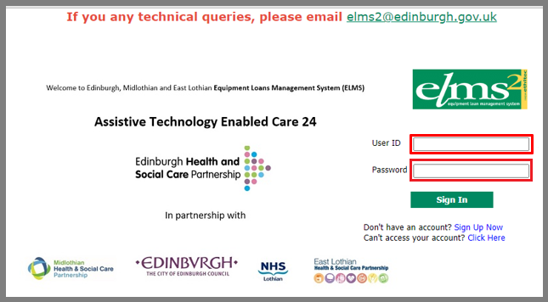

3 Order search page

Here is some information on the order Screen

On the right-hand side of the screen, are 7 icons
- 4 are used (highlighted in red
- 3 not used

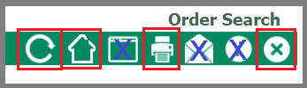
From Left to Right (highlighted in red)
- Refresh your screen
- Home button
- Print
- Log out

In the rest of the screen
- The search function is not used at this time
- Click on change your password, to change your login password

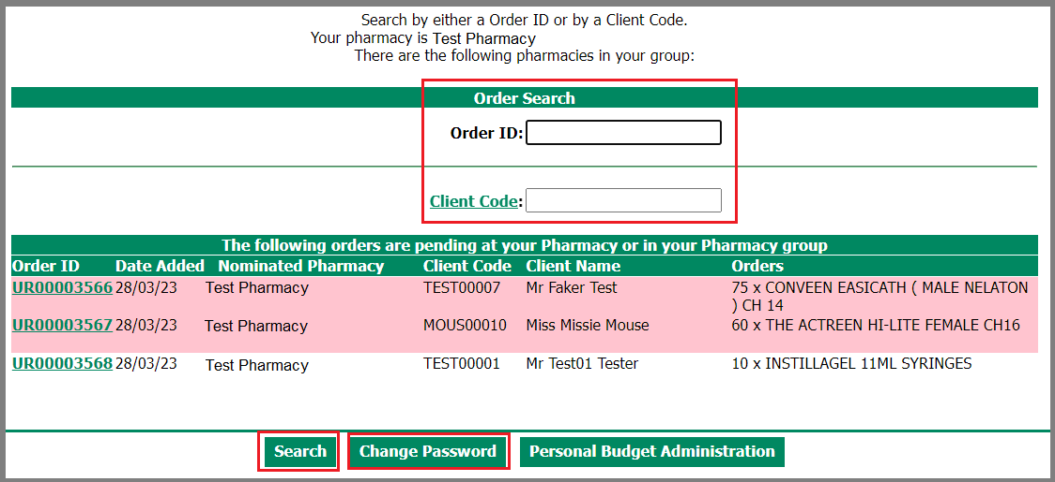

4 Viewing Orders

Urgent orders are marked with a red background and are a priority for the client
Standard orders have a white background and are expected within 5 – 7 days

To view an order
- Click on the Order ID eg UR00003566
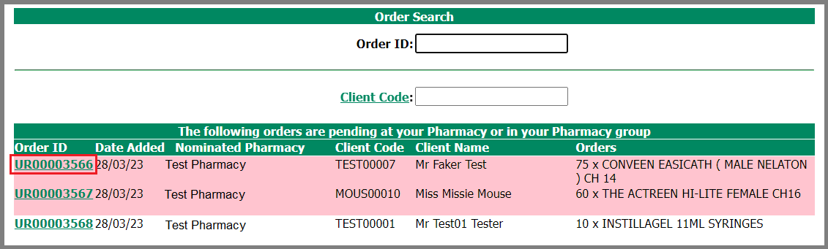

The following page has the information for Pharmacies to dispense the Items

There are 3 areas

- Client Details has the following information
  - Name, Address, DOB, next of kin

- Voucher Details
  - Voucher ID
  - Notes, written by the Nurse for the Pharmacy

- Order Line Notes
  - Date and item information
  - The pack size
  - Required Units Column is shown and is the total of items regardless of pack counts
  - The Req Packs column is shown and is the total number of packs of the item to be dispensed.
  - Redeem section

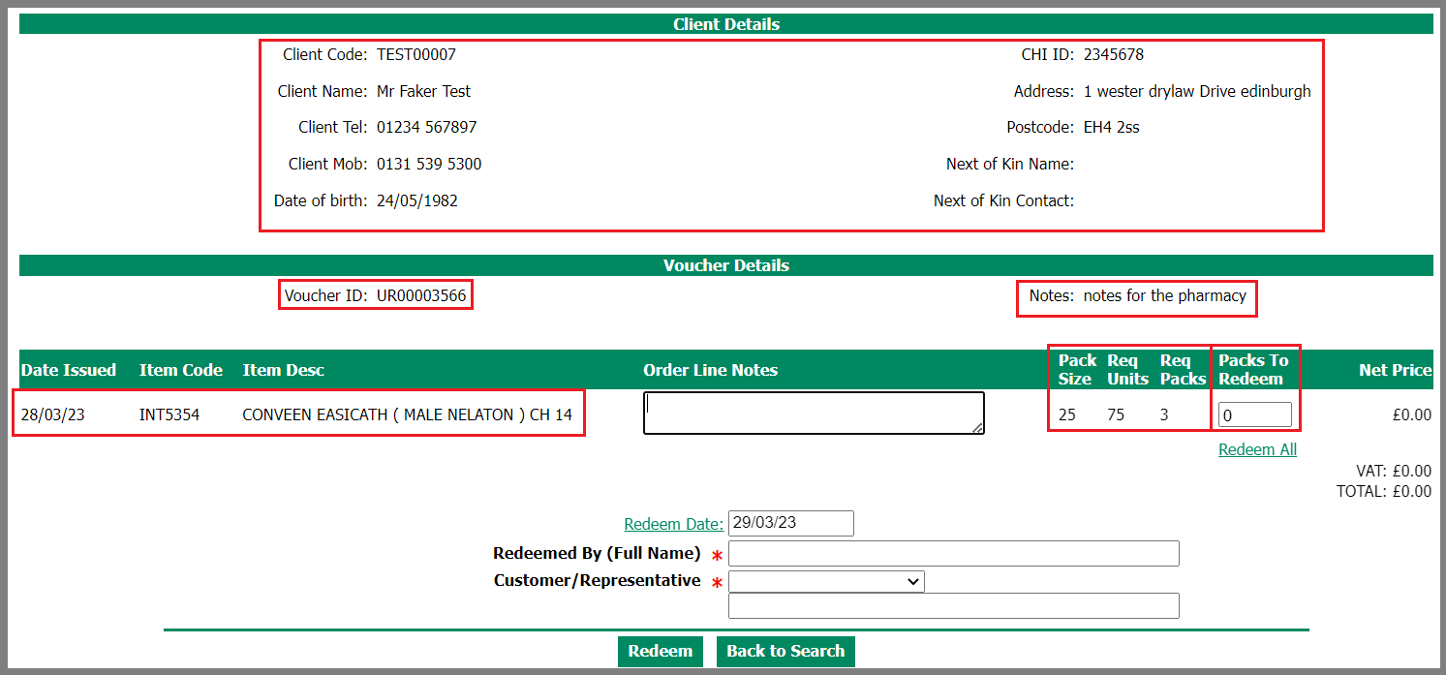

4.1 How to Dispense a full order
Then we can look at how to update part dispensed or cancelled orders

Remember

Voucher redemption rule
- The voucher can only be redeemed in one transaction and completes the order you have dispensed or item/s you may not have dispensed.
- You cannot go back later and dispense more items to the voucher

Notes
The Nursing team may write information pertaining to the prescription, ie client on holiday

Packs to redeem
If all items are to be redeemed - Click on Redeem All

Order Line notes
There is an option to enter informative notes about individual items

Redeemed by (Full Name)
Enter your Name

Customer/ Representative
Click on the down arrow, and choose either Collected or Delivered by Pharmacy

To complete the process, click on Redeem

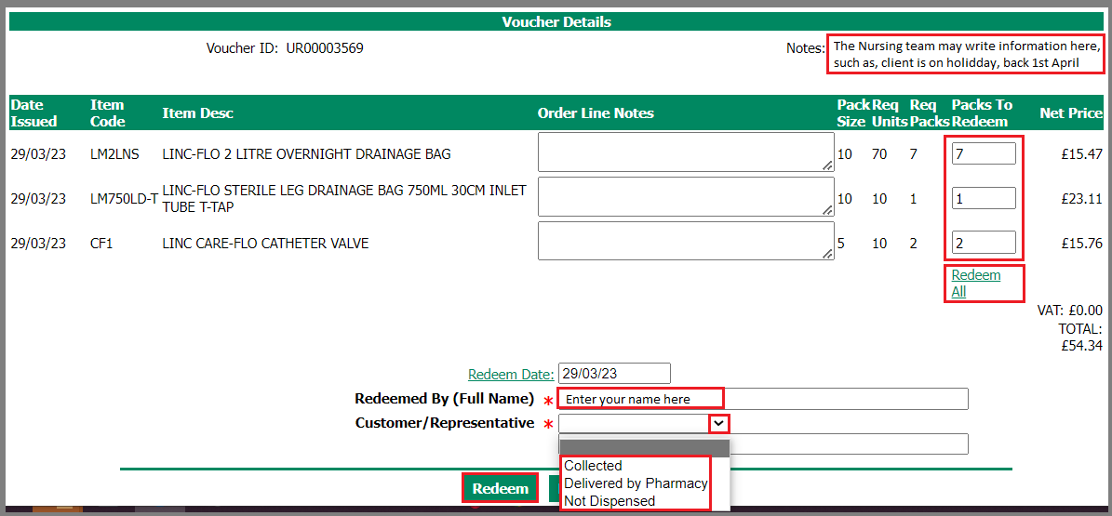

This is the last opportunity to cancel and amend your entry

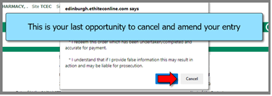
At this point click on OK to finalise the order

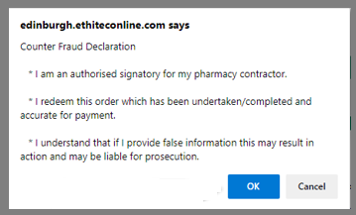

The Voucher Redeemed confirmation screen appears
- All items have been redeemed for payment
- Click on Back to Search screen

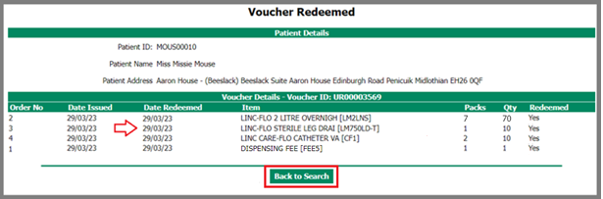

4.2 How to update part dispensed an item within Orders
Let’s look at that same order and instead part dispense not providing item code LM2LNS

In the order Screen
- find the order
- Click onto the Order ID

In the Voucher, you will see the following

Notes
The Nursing team may write information pertaining to the prescription, ie client on holiday

Packs to redeem
Redeem the individual items
If you cannot redeem (dispense) an item, leave item packs to redeem at 0, then write in the order line note

Order Line notes
If you cannot redeem (dispense) the item
- Write in the notes – reason item is not dispensed.
- Inform continence.care@nhslothian.scot.nhs.uk when an alternative item is required. Provide client and order details with your communication.

Redeemed by (Full Name)
Enter your Name

Customer/ Representative
Click on the down arrow, and choose either Collected or Delivered by Pharmacy

To complete the process, click on Redeem
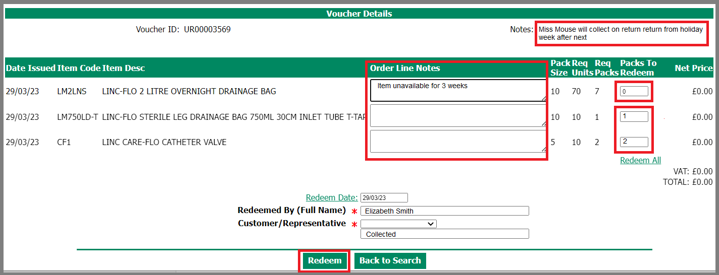
The following pop up will appear
Please read the message and if correct you are not dispensing all items
Click on OK to continue

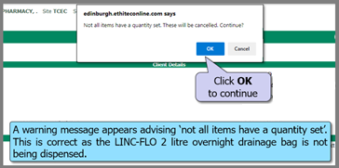
As you are not dispensing all items – this pop up appears.

If correct, click on OK to continue

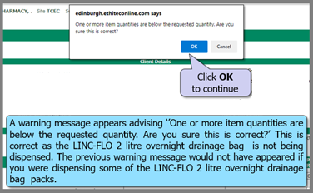

This is the last opportunity to cancel and amend your entry

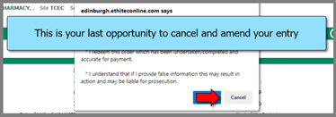

At this point click on OK to finalise the order

The Voucher Redeemed confirmation screen appears
- Item 1 has been cancelled
- Item 2 and 3 have been redeemed for payment
- Click on Back to Search screen

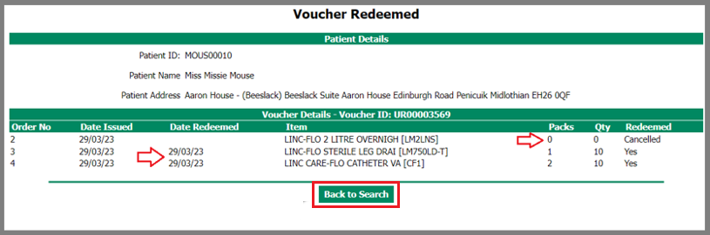

Which takes you back to the Order search screen.
The order UR00003569 is now removed from your list of pending orders

4.3 How to cancel Order

Find the order
- Click on the Order ID

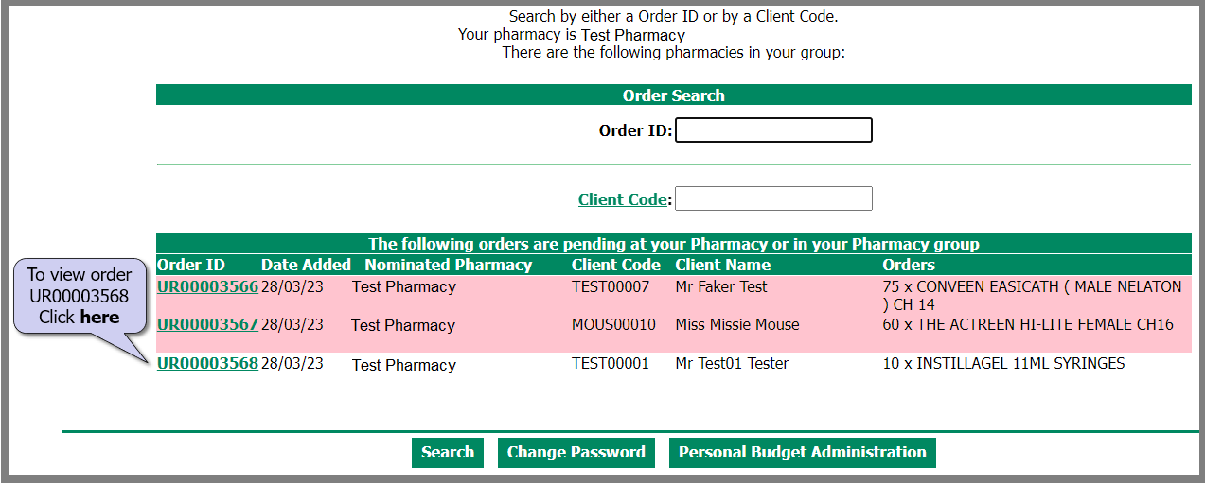

In the Voucher Screen

- Leave all item packs to redeem at 0, then write in the order line note
- Inform continence.care@nhslothian.scot.nhs.uk if an alternative item is required.

Then
Redeemed by (Full Name)
Enter your Name

Customer/ Representative
Click on the down arrow, and choose either Not dispensed

To complete the process, click on Redeem

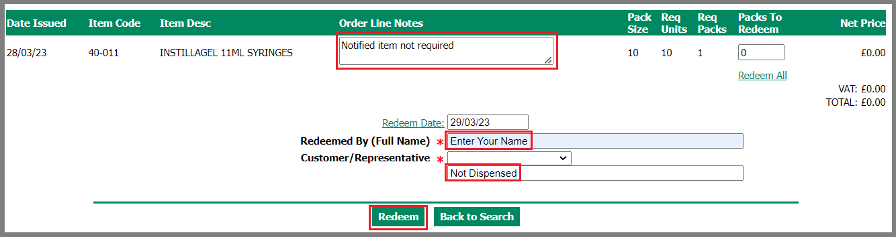

Three pop up messages will appear
Pop up No.1 – informing you that not all items have a quantity
If correct, Click OK to continue
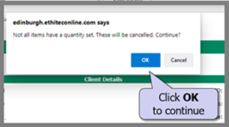

Pop up No. 2
Again the system is confirming that 1 or more items are below the requested quantity
If correct Click OK to continue

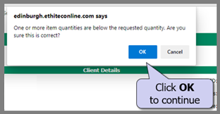

Last pop up
Please read and confirm the Counter Fraud Declaration
To finalise – Click ok

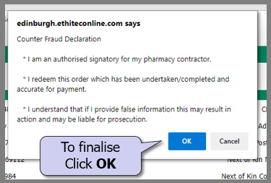

The Voucher Redeemed confirmation screen appears
- All Items have been cancelled

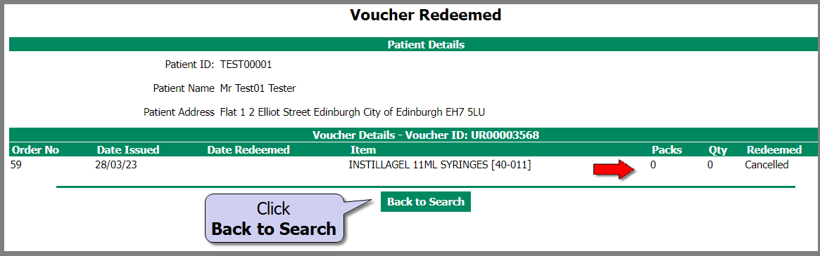

5 Personal Budget Administration

On the front screen, you can access the Personal Budget Administration

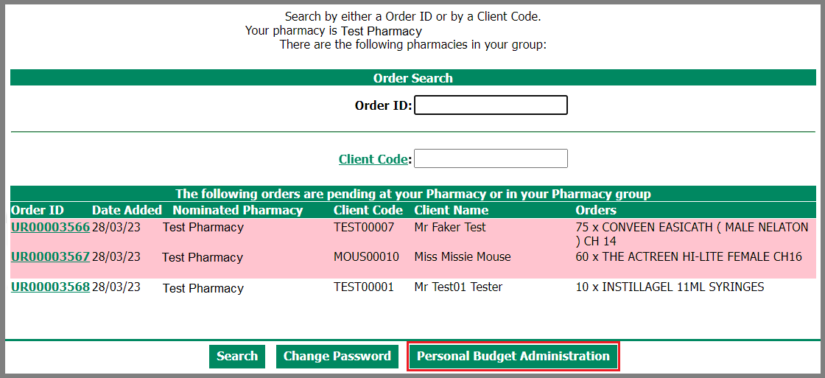

To search for redeemed vouchers
- Click on Redeemed Date Start – a calendar appears, click on the required date
- Enter the end date of your search
- Ensure that the active is Yes
- Click on Search

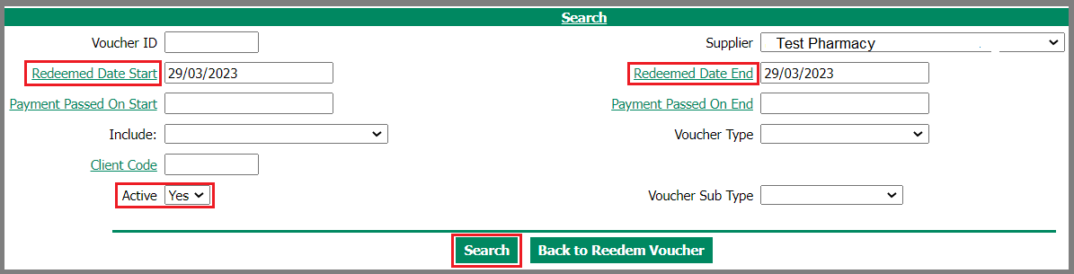

Search results are returned on this screen
To export the list, click on Export List

This will download into a Microsoft Excel file. These files should only be held for as long as necessary, and where longer than 3 months, removal of the client’s name from the export is recommended.
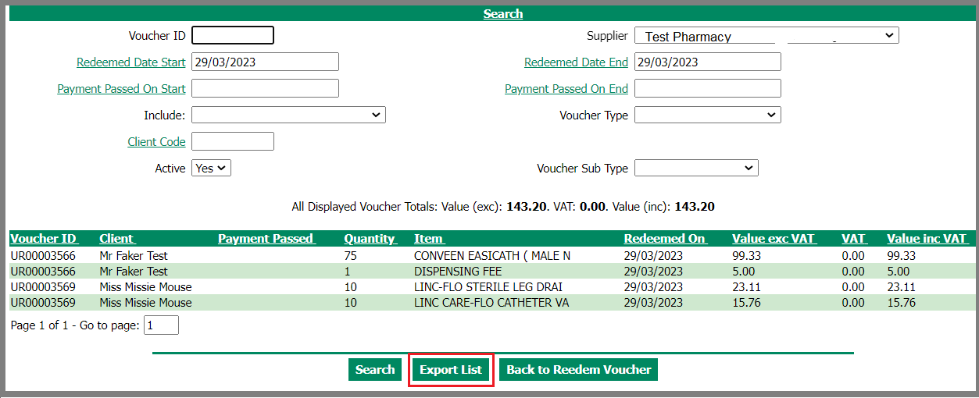
In the screen print below the Payment passed column
- Vouchers will show date payment passed to Primary Services Division Paymaster.

Voucher Information payment information

Vouchers are usually passed for payment 2 working days before deadline on the 14th of each month.

Except in the Month of December when they bring forward the deadline as early as the 4th

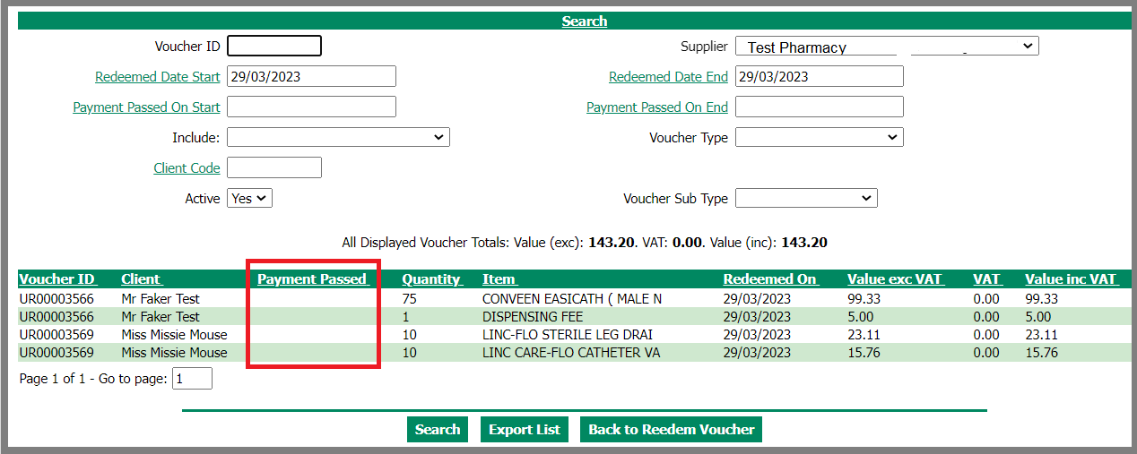

In the Personal Budget Administration Screen

You can also search for a Client
- Click on Client Code

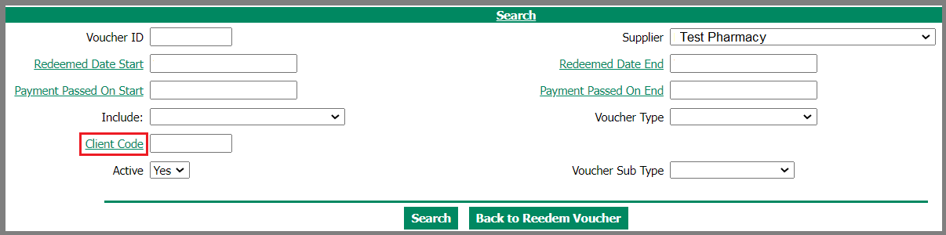

The following page appears
- In the NHS No box, type in the CHI
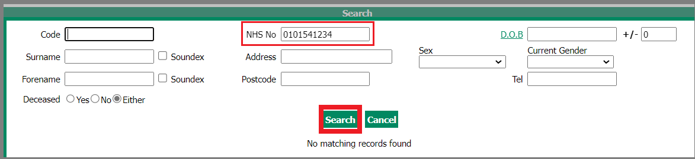

6 Support Contacts

For user access requests or any technical queries using Elms2, please email elms2@edinburgh.gov.uk

For patient order queries, please email continence.care@nhslothian.scot.nhs.uk or telephone
0131 537 4572

Service opening times:
Monday to Friday: 9.00am to 3.00pm
(Closed for lunch between 12.15pm and 1.00pm)

