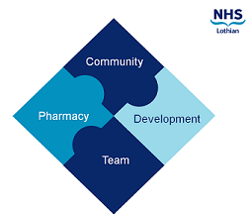
COMMUNITY PHARMACY DEVELOPMENT TEAM WEEKLY UPDATE
Wed 9th August 2023
We hope that you will take some time to read the information below and share with the whole team.
Dawn and Fiona
https://www.communitypharmacy.scot.nhs.uk/nhs-boards/nhs-lothian/

- Signing National & Local PGDs- As outlined in the recent email from PCCT, after a review of NHS Lothians process, it has been agreed that you are no longer required to return a signed copy of the national or local PGDs to the Primary Care Contracts Team. You must however retain a signed copy within your branch for legal and professional purposes.

- New Hayfever PGD- On Monday you will have received an email from PCCT which included the PCA for new Pharmacy First PGDs. These will be added to the NHS Pharmacy First Scotland service for the treatment of seasonal allergic rhinitis (Hayfever). Please note that the PGDs are for information only until they go through local Board governance processes, when signed versions will then be sent out to all contractors. Community pharmacy teams should however ensure they are familiar with the PGDs and complete any necessary training prior to the go live date as detailed in the PCA available here

- Remuneration Package- The Community Pharmacy funding package for 2023/24 has been agreed and the PCA was circulated by PCCT on Monday PCA(P)(2023) 26 Community Pharmacy Funding

- Lothian Prescribing Bulletin (OOS) - The Lothian Prescribing Bulletin (attached) is issued bi-monthly and aims to support prescribing excellence in NHS Lothian

- MSANs 14 & 15 - There have been 2 MSANs released this week for Carbamazepine 100mg and Reboxetine 4mg tablets. Please see attached alerts for more detail.
We hope that you are all keeping well. Please get in touch with us if there is anything you would like to see more information on or if you have any questions.
The Community Pharmacy Development Team
Royal Edinburgh Hospital

