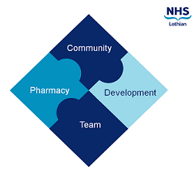

COMMUNITY PHARMACY DEVELOPMENT TEAM WEEKLY UPDATE
Wed 16th August 2023
We hope that you will take some time to read the information below and share with the whole team.
Dawn and Fiona
https://www.communitypharmacy.scot.nhs.uk/nhs-boards/nhs-lothian/

- National DPP webinar- NES/ the Universities and CPS are running a webinar on Wednesday 23rd 7pm-8.15pm about becoming a DPP. Click on the following link for more information and to book a place. Designated Prescribing Practitioner (DPP) Webinar - 23rd August 7pm - 8.15pm — Community Pharmacy Scotland (cps.scot)

- Pause in COVID testing- The recent CMO letter (attached) outlines the planned pausing in COVID testing for Health and Social Care staff. This change should be implemented by 30th August at the latest.

- Appropriate Waste Segregation - Please can you ensure that only patient-returned medicines and sharps are placed in the NHS Lothian provided bins, and that the waste is segregated properly. The segregation chart is attached and is also available on our website here. NHS Lothian facilities who collect your waste require it to comply with regulations so that the national contractor will uplift the waste for processing.

- Workforce survey; NES requesting shared email addresses - NES will be undertaking their annual workforce survey next month and have asked to use the pharmacy shared mailboxes to communicate with contractors. We plan to share the NHS Lothian list with them but if you do not wish your shared mailbox address to be provided to NES please reply to us and let us know by Thursday 24th August.

We hope that you are all keeping well. Please get in touch with us if there is anything you would like to see more information on or if you have any questions.

The Community Pharmacy Development Team
Royal Edinburgh Hospital

