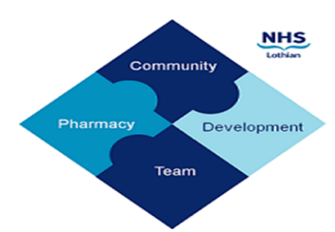
COMMUNITY PHARMACY DEVELOPMENT TEAM WEEKLY UPDATE
Thurs 12th October 2023
We hope that you will take some time to read the information below and share with the whole team.
Dawn, Ellen Jo and Fiona
https://www.communitypharmacy.scot.nhs.uk/nhs-boards/nhs-lothian/
Twitter: @nhslcommpharm

- NES Prescribers Database - Please see below and the attached from NES regarding updating the prescribers database:

You may be aware that NES maintains a list of prescribers in Scotland to help with education development and workforce planning. This data is updated and maintained by the individual account holders through the TURAS Training Management application accessed from the TURAS Dashboard. Keeping your information up to date allows NES to make you aware of the latest opportunities to support your further development.
Please follow the attached guidance and update your record by 30th November 2023. Please ensure the information is an accurate reflection of your prescribing practice in the past 12 months.

To see how NES uses your information, please see our privacy notice . If you have any questions, please contact pharmacy@nes.scot.nhs.uk

- Naloxone Webinar reminder - The second of the national webinars on Naloxone Emergency Supply is on Tuesday 14th November. Details of the service and how to book onto the webinar are all included in the attached PCA

- Out of Stock bulletin - Attached is the latest OOS bulleting from the NHS Lothian team.

We hope that you are all keeping well. Please get in touch with us if there is anything you would like to see more information on or if you have any questions.

The Community Pharmacy Development Team
Royal Edinburgh Hospital

