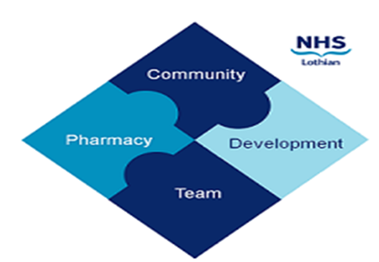

COMMUNITY PHARMACY DEVELOPMENT TEAM WEEKLY UPDATE
Wed 25th October 2023
We hope that you will take some time to read the information below and share with the whole team.
Dawn, Ellen Jo and Fiona
https://www.communitypharmacy.scot.nhs.uk/nhs-boards/nhs-lothian/

- Community Pharmacy Training Event 22nd Nov- A quick reminder about this great opportunity to learn, meet new faces or catch up with some not quite so new ones…. and free food! Have a look at the flyer for more details and register by emailing us at CPDT@nhslothian.scot.nhs.uk
- SSP Extensions - In case you missed them, the attached 2 SSP extensions for Estradot and Jext were sent out from PCCT this week.
Teach and Treat Hubs - Attached is the current list from NES of Teach and Treat Hubs across Scotland to support independent prescribing
- CO monitors from QYW - The Quit Your Way service have visited all pharmacies across Lothian over the past few weeks and provided new replacement CO monitors and sundries. If you have recently taken over a pharmacy contract, PLEASE DO NOT THROW OUT THE CO MONITOR - THIS IS NEW TO THE PHARMACY AND HAS JUST BEEN REPLACED.
- Community Pharmacy Public Health Poster Campaign - Attached is the latest PCA outlining the Public Health poster campaign for 2023/24. The PCA also has details of who to contact for replacement poster holders.
- Ensure Plus Yogurt Style 200ml bottles - This product will be discontinued from Dec 2023. These are 2nd choice ONS on the formulary but typically have low usage (around 50 patients per year). Unfortunately, there isn't an alternative like for like product. Dietitians have been asked to discuss alternative products with their patients as they review them.

We hope that you are all keeping well. Please get in touch with us if there is anything you would like to see more information on or if you have any questions.

The Community Pharmacy Development Team
Royal Edinburgh Hospital

