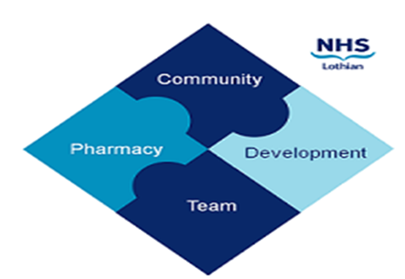

COMMUNITY PHARMACY DEVELOPMENT TEAM WEEKLY UPDATE
Wed 1st November 2023
We hope that you will take some time to read the information below and share with the whole team.
Dawn, Ellen Jo and Fiona
https://www.communitypharmacy.scot.nhs.uk/nhs-boards/nhs-lothian/

- Community Pharmacy Training Event 22nd Nov- A quick reminder about this great opportunity to learn, meet new faces or catch up with some not quite so new ones…. and free food! Have a look at the flyer for more details and register by emailing us at CPDT@nhslothian.scot.nhs.uk

- Pharmacy Delivery Scam - we've been alerted to a scam where fraudulent phone calls are being made to vulnerable patients in Lothian. The calls are from a London phone number and the callers are pretending to represent the local pharmacy and requesting bank or credit card details in order to charge the patients for on-going prescription delivery services. Please alert your delivery patients to this and if you hear of this happening to any of your patients do contact the police on 101.
- CAMHS Info re ADHD Shortages - Currently there are worldwide shortages of ADHD medicines - to keep you in the loop, please see attached information which was sent to all prescribers in Lothian along with letters from Child & Adolescent Mental Health Services (CAMHS) which are being sent out to affected patients, their families, and educators.

- NHS Lothian Intranet - Just a quick reminder that all Lothian community pharmacies should have access NHS Lothian to their intranet including useful pages such as medicines shortages. If your pharmacy is an independent/small multiple and are on the secure 'SWAN' network, you should already be able to access the home page as an example: http://intranet.lothian.scot.nhs.uk/Pages/default.aspx . If you work for a larger multiple and find you are unable to access this, please contact your in-house IT team to ensure the website address has been whitelisted.
We hope that you are all keeping well. Please get in touch with us if there is anything you would like to see more information on or if you have any questions.

The Community Pharmacy Development Team
Royal Edinburgh Hospital

