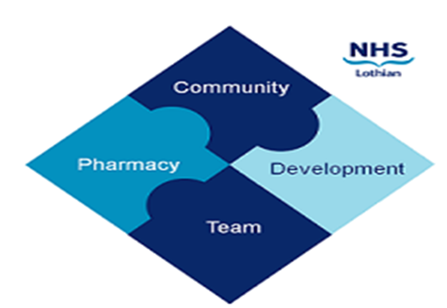

COMMUNITY PHARMACY DEVELOPMENT TEAM WEEKLY UPDATE
Wed 15th November 2023
We hope that you will take some time to read the information below and share with the whole team.
Dawn, Ellen Jo and Fiona
https://www.communitypharmacy.scot.nhs.uk/nhs-boards/nhs-lothian/

- RefHelp Talk - As part of NHS Lothian's Autumn series of RefTalks, there will be a Teams session on Tuesday 28th November 7.30-8.30pm on 'Pregnancy - Hot Topics for Primary Care'. Please see attached flyer for more info on this event.

- Somatuline Name Change - Please note that Somatuline Autogel has now changed its name to Lanreotide Ipsen, so you will start seeing scripts written accordingly. Please see attached patient communication leaflet to help any affected patients manage the change.
- CPDT Team Update - we're sorry to say that our amazing colleague, Dawn Owen (Lead Pharmacist for Community Pharmacy Development) is leaving our team on Wednesday 20th December. Dawn has been instrumental in shaping our Community Pharmacy Development team over the last eight years to support the Lothian community pharmacy network and all the great work you do to deliver NHS services to the public. Due to family commitments, Dawn has decided to take a 'mature gap year', and we're sure you will join us in wishing her all the very best for the future!

We hope that you are all keeping well. Please get in touch with us if there is anything you would like to see more information on or if you have any questions.

The Community Pharmacy Development Team
Royal Edinburgh Hospital

