NHS Highland
Pharmaceutical Care Services Plan 2023/24
Pharmaceutical Services

Compiled by Pharmacy Services

Contents
1 Location and Access of Community Pharmaceutical Services 3
2 Community Dispensing (AMS) Acute Medication Service 4
2.1 Number of Items Dispensed 4
2.2 Polypharmacy 5
2.3 High Risk Medications 8
3 Core Pharmaceutical Services 9
3.1 Pharmacy First Service (includes Pharmacy First Plus) 9
3.2 Public Health Services 12
3.2.1 Emergency Contraception 12
3.3 Smoking Cessation 12
3.4 Medicine, Care & Review (MCR) 13
3.5 Pharmacy Care Records (PCR) 14
4 Additional Pharmaceutical Services 15
4.1 Injecting Equipment Provision 15
4.2 Naloxone Provision 16
4.3 Buprenorphine Supervision 16
4.4 Methadone Supervision 17
4.5 Advice to Care Homes 18
4.6 Care at Home 19
4.7 Clozapine 19
4.8 Vaccination Services 20
4.8.1 Travel Vaccinations 20
4.8.2 Seasonal Flu Vaccinations 21
4.9 Hospital to Community Dispensing 21
4.10 Gluten Free Service 21
4.11 Palliative Care 23
5. Executive Summary 24

Location and Access of Community Pharmaceutical Services
There are 83 community pharmacies and 39 dispensing general practice locations within NHS Highland. The location and drive times extents from these are displayed on the map below. (As of 18th November 2023 two community pharmacies closed permanently)
Figure 1.1 Location and Access of NHS Highland Community Pharmacy Services
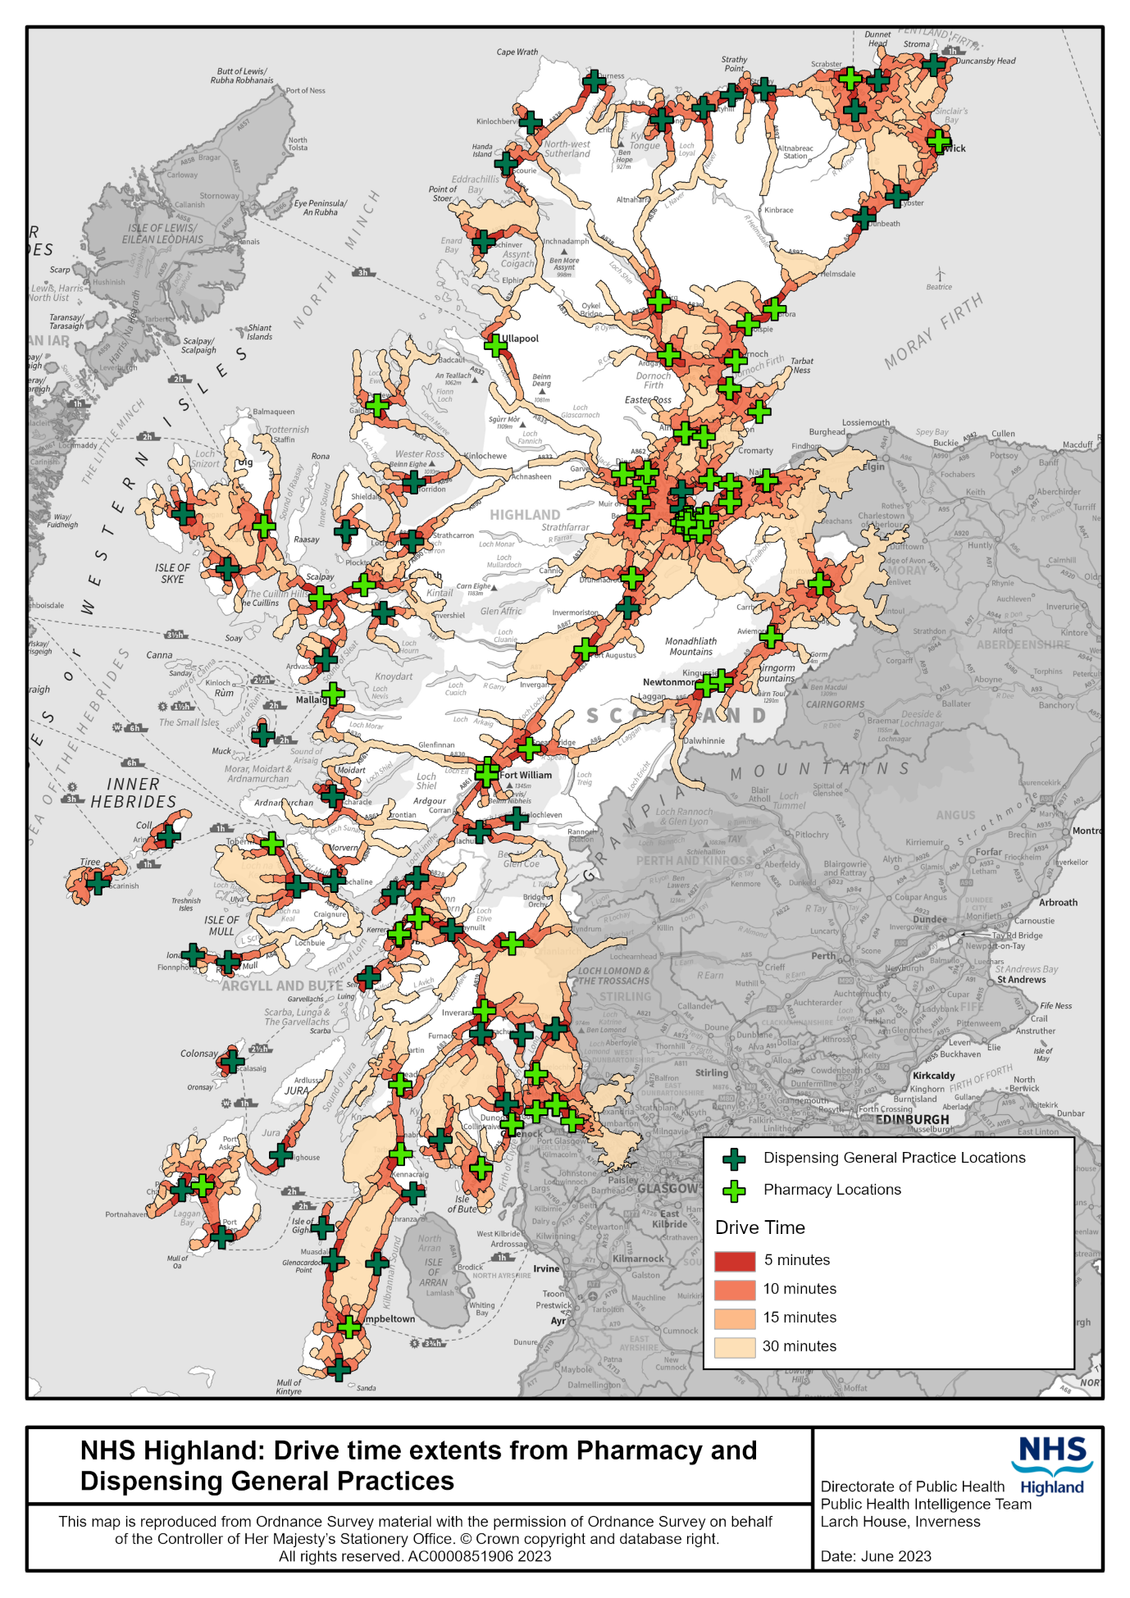
Nearly a third of the population live within a 5-minute drive from a community pharmacy. However, the largest proportion of the population, nearly 40%, live approximately 30-minute drive from a pharmacy with a further 4.6% of the population living in areas with more extended drive times. With the inclusion of dispensing general practice locations, the proportion of the population experiencing drive times greater than 30 minutes is reduced to 0.7%¹.
Table 1.1: Drive Times to Pharmacy Services
Drive Time in Minutes | Percentage Population Within Drive Time of Pharmacy | Percentage Population Within Drive Time of Pharmacy or Dispensing Practice
5 | 30.6 | 33.2
10 | 16.8 | 17.0
15 | 8.9 | 8.6
30 | 39.1 | 40.5
30+ | 4.6 | 0.7
Data source: Community Health Index Population¹
The majority of the population (75.6%) of NHS Highland have access to at least 1 car and nearly a quarter of the population have access to 2 cars².
Figure 1.2: Households in NHS Highland with Car Access Data Source: Scottish Surveys Core Questions. Car Access².

Community Dispensing (AMS) Acute Medication Service

Number of Items Dispensed
In the financial year 2022-23, a total of 5,699,513 items were dispensed from community pharmacies and 972,952 AMS items were dispensed from dispensing general practices. These figures indicate a 4.3% increase in items dispensed from community pharmacies and 8.1% increase in items dispensed from general practice compared with 2015-16 figures. The greatest numbers of items were dispensed in Inverness East, Caithness and Cowal & Bute.
Figure 2.1.1 Number of Items Dispensed by District and Location, 2022-23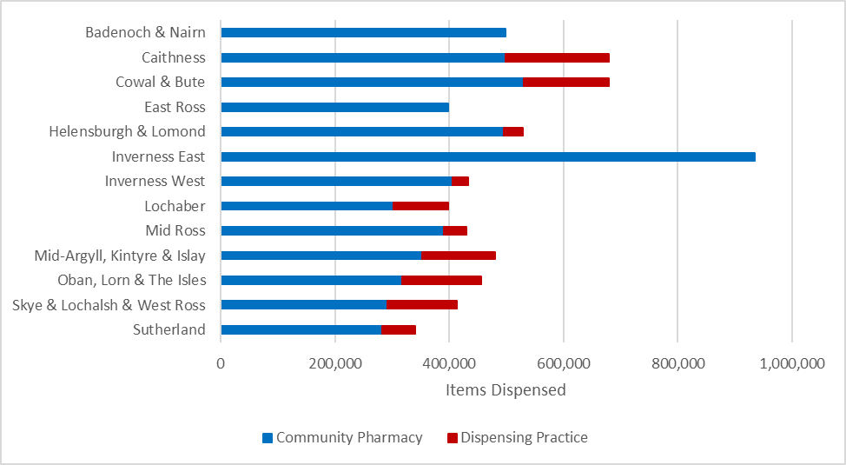
Data Source: PRISMS/PIS³
Table 2.1.1 Number of Items Dispensed by District and Location, 2022-23
District | Number of Items Dispensed
 | Community Pharmacy | Dispensing Practice
Badenoch & Nairn | 498,655 | N/A
Caithness | 498,757 | 181,073
Cowal & Bute | 529,859 | 149,973
East Ross | 397,812 | N/A
Helensburgh & Lomond | 494,992 | 33,686
Inverness East | 935,324 | N/A
Inverness West | 406,501 | 27,025
Lochaber | 301,985 | 96,348
Mid Ross | 391,170 | 38,955
Mid-Argyll, Kintyre & Islay | 352,490 | 128,009
Oban, Lorn & The Isles | 317,158 | 138,520
Skye & Lochalsh & West Ross | 291,259 | 121,891
Sutherland | 283,551 | 57,472
Total | 5,699,513 | 972,952
Data Source: PRISMS/PIS³

Of all items dispensed (where age is known), 83% were dispensed to people aged 45 and over.

Figure 2.1.2 Number of Items Dispensed by Age Group and Location, 2022-23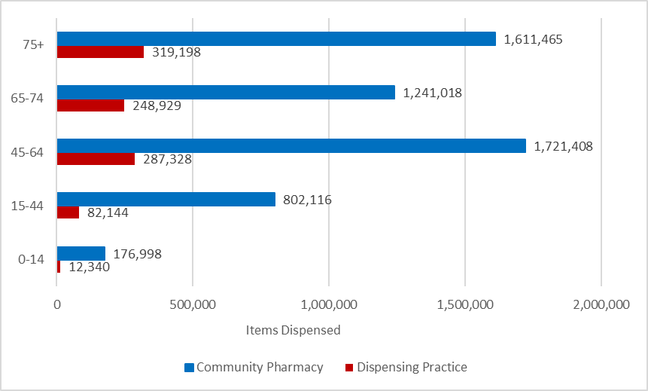
Data Source: PRISMS/PIS³

2.2 Polypharmacy
A total of 122,542 patients aged 50 and over were dispensed at least 1 medication between January and June 2022. Of those, 13% were prescribed medications from 10 or more paragraphs from the British National Formulary (BNF). Just over one third of patients were prescribed medications from between 5 and 9 paragraphs in the BNF.
Figure 2.2.1 Patients Dispensed Medications from Multiple BNF Paragraphs by District, January to June 2022
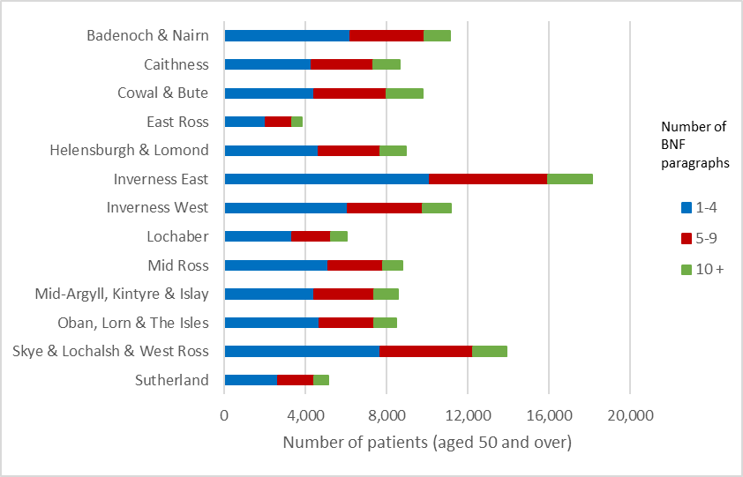Data Source: PRISMS/PIS³, NHS Scotland Polypharmacy Reporting - Six Month Report
Footnote: Reports are restricted to patients aged 50 years and over and restricted to medications from BNF chapters 1 to 10 only.

Table 2.2.1 Patients Dispensed Medications from Multiple BNF Paragraphs by District, January to June 2022
 | Number of BNF Paragraphs
District | 1 to 4 | 5 to 9 | 10+ | Number of patients dispensed at least 1 medication
Badenoch & Nairn | 6,238 | 3,637 | 1,268 | 11,143
Caithness | 4,288 | 3,059 | 1,313 | 8,660
Cowal & Bute | 4,431 | 3,550 | 1,811 | 9,792
East Ross | 2,031 | 1,323 | 491 | 3,845
Helensburgh & Lomond | 4,654 | 3,055 | 1,225 | 8,934
Inverness East | 10,118 | 5,837 | 2,178 | 18,133
Inverness West | 6,104 | 3,680 | 1,369 | 11,153
Lochaber | 3,346 | 1,917 | 763 | 6,026
Mid-Argyll, Kintyre & Islay | 4,417 | 2,981 | 1,163 | 8,561
Mid Ross | 5,133 | 2,693 | 942 | 8,768
Oban, Lorn & The Isles | 4,677 | 2,712 | 1,070 | 8,459
Skye & Lochalsh & West Ross | 7,692 | 4,554 | 1,682 | 13,928
Sutherland | 2,676 | 1,768 | 696 | 5,140
Data Source: PRISMS/PIS^{3,} NHS Scotland Polypharmacy Reporting - Six Month Report

2.3 High Risk Medications
Of all people aged 50 and over who were dispensed at least 1 medication, 66% were dispensed at least 1 high risk medication. High risk medications are defined as those which are most commonly associated with a hospital admission relating to an adverse drug reaction. This group includes Antidepressants, Diuretics, Beta-blockers, NSAIDS, Opioids, oral Anticoagulants, Antipsychotic drugs, ACEI’s, Digoxin, Prednisolone, Ticagrelor, Prasugrel and Clopidogrel³.
Figure 2.3.1 Patients Dispensed High Risk Medications by District, January to June 2022
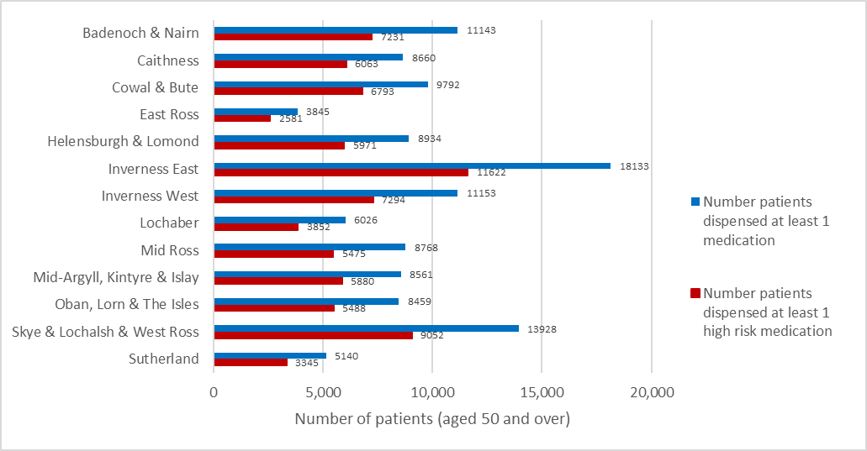Data Source: PRISMS/PIS³, NHS Scotland Polypharmacy Reporting - Six Month Report
Footnote: Reports are restricted to patients aged 50 years and over and restricted to medications from BNF chapters 1 to 10 only.

The Pharmacy Care Record (PCR) includes a High-Risk Medicine Tools component which focuses on the delivery of pharmaceutical care for patients prescribed Lithium, Methotrexate and Warfarin Sodium.

Figure 2.3.2 Dispensing of Items Included in High-Risk Medicine Tools, NHS Highland, 2021-22
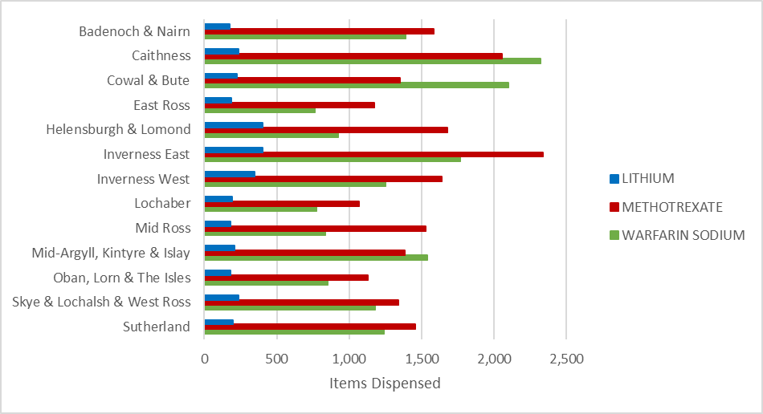Data Source: PRISMS/PIS³
Table 2.3.2 Dispensing of Items Included in High-Risk Medicine Tools 2021-22
District | Lithium | Methotrexate | Warfarin Sodium | Total
Badenoch & Nairn | 175 | 1,584 | 1,389 | 3,148
Caithness | 235 | 2,055 | 2,320 | 4,610
Cowal & Bute | 223 | 1,351 | 2,100 | 3,674
East Ross | 185 | 1,171 | 763 | 2,119
Helensburgh & Lomond | 402 | 1,680 | 923 | 3,005
Inverness East | 405 | 2,335 | 1,767 | 4,507
Inverness West | 350 | 1,637 | 1,252 | 3,239
Lochaber | 195 | 1,070 | 774 | 2,039
Mid-Argyll, Kintyre & Islay | 207 | 1,383 | 1,541 | 3,131
Mid Ross | 183 | 1,526 | 833 | 2,542
Oban, Lorn & The Isles | 184 | 1,128 | 853 | 2,165
Skye & Lochalsh & West Ross | 237 | 1,340 | 1,177 | 2,754
Sutherland | 200 | 1,454 | 1,242 | 2,896
Data Source: PRISMS³
Footnote: Number of items dispensed is the number of times an item appears on a prescription.

Core Pharmaceutical Services
The NHS Highland Pharmaceutical List details the current community pharmacies This includes opening hours, contact details and service provided⁸.

Pharmacy First Service (includes Pharmacy First Plus)
The Pharmacy First (PF) service is part of the Community Pharmacy Core Contract, and so should be available from all Community pharmacies with an NHS contract. All Scottish registered patients can register with the pharmacy of their choice to enable them to consult with a community pharmacist for certain minor conditions from the pharmacy free of charge. The pharmacist advises, treats, or refers the individual according to their need.
The Community Pharmacist Independent Prescriber (CPIP) will provide an enhanced service for patients presenting in the community pharmacy with a common clinical condition(s) which is within the prescribers’ competence to prescribe and manage.
Independent Prescribers
Number of Independent Prescribers – 27 as of June 2023.
Number of Community Pharmacies offering Pharmacy First Plus – 19 across NHS Highland.

Table 3.1.1 Total Number of eDispensed items and Number of PF, UTI & Impetigo Items, GP Referrals & Consultations (March 2023 - snapshot)
 | Items | Pharmacy First |  |  | UTI |  |  | Impetigo
 | Total eDispensed Items | non-PGD eDispensed Items | non-PGD GP Referrals | non-PGD Consultations | UTI eDispensed Items | UTI GP Referrals | UTI Consultations | Impetigo eDispensed Items | Impetigo GP Referrals | Impetigo Consultations
Badenoch & Nairn | 40,024 | 1,028 | 107 | 158 | 19 | 3 | 0 | 8 | 0 | 0
Caithness | 44,102 | 889 | 20 | 107 | 32 | 1 | 0 | 7 | 0 | 0
Cowal & Bute | 42,770 | 658 | 41 | 231 | 22 | 3 | 0 | 3 | 0 | 0
East Ross | 34,273 | 1,811 | 169 | 465 | 37 | 6 | 1 | 10 | 0 | 0
Helensburgh & Lomond | 39,683 | 1,271 | 42 | 184 | 31 | 1 | 0 | 5 | 0 | 0
Inverness East | 76,832 | 3,801 | 208 | 430 | 91 | 19 | 2 | 19 | 1 | 0
Inverness West | 31,622 | 944 | 23 | 522 | 14 | 3 | 0 | 0 | 0 | 0
Lochaber | 24,762 | 462 | 20 | 54 | 18 | 4 | 0 | 5 | 0 | 0
Mid-Argyll, Kintyre & Islay | 29,610 | 619 | 13 | 103 | 11 | 2 | 0 | 5 | 0 | 0
Mid Ross | 34,063 | 864 | 78 | 123 | 26 | 11 | 3 | 3 | 1 | 0
Oban, Lorn & The Isles | 26,223 | 604 | 24 | 43 | 14 | 2 | 2 | 1 | 1 | 0
Skye & Lochalsh & West Ross | 23,158 | 799 | 30 | 98 | 3 | 1 | 0 | 0 | 0 | 0
Sutherland | 24,431 | 648 | 49 | 175 | 10 | 2 | 0 | 2 | 0 | 0
Total | 471,553 | 14,398 | 824 | 2,693 | 328 | 58 | 8 | 68 | 3 | 0

 | Bridging Contraception |  |  | Shingles |  |  | Skin
 | Bridging Contraception eDispensed Items | Bridging Contraception GP Referrals | Bridging Contraception Consultations | Shingles eDispensed Items | Shingles GP Referrals | Shingles Consultations | Skin Infection eDispensed Items | Skin Infection GP Referrals | Skin Infection Consultations
Badenoch & Nairn | 1 | 0 | 0 | 0 | 2 | 0 | 2 | 0 | 0
Caithness | 2 | 0 | 0 | 0 | 0 | 0 | 2 | 0 | 0
Cowal & Bute | 0 | 0 | 0 | 0 | 0 | 0 | 5 | 0 | 1
East Ross | 2 | 0 | 0 | 1 | 0 | 0 | 4 | 1 | 0
Helensburgh & Lomond | 1 | 0 | 0 | 0 | 1 | 0 | 5 | 3 | 0
Inverness East | 13 | 0 | 0 | 6 | 3 | 0 | 14 | 2 | 0
Inverness West | 1 | 0 | 0 | 1 | 0 | 0 | 1 | 0 | 0
Lochaber | 1 | 0 | 0 | 0 | 0 | 0 | 2 | 0 | 0
Mid-Argyll, Kintyre & Islay | 0 | 0 | 0 | 1 | 0 | 0 | 7 | 0 | 0
Mid Ross | 0 | 0 | 0 | 0 | 1 | 0 | 2 | 0 | 0
Oban, Lorn & The Isles | 0 | 0 | 0 | 0 | 0 | 0 | 0 | 0 | 0
Skye & Lochalsh & West Ross | 1 | 0 | 0 | 0 | 0 | 0 | 0 | 0 | 0
Sutherland | 0 | 0 | 0 | 1 | 1 | 0 | 5 | 1 | 0
Total | 22 | 0 | 0 | 10 | 8 | 0 | 49 | 7 | 1

Public Health Services

Emergency Contraception
Across NHS Highland, a total of 3460 emergency hormonal contraception medications (Levonorgestrel and Ulipristal) were dispensed using community pharmacy urgent supply forms between March 2022 and February 2023. The largest number of items (39%) was dispensed in Inverness East. This reflects the general pattern throughout Scotland whereby the majority of emergency hormonal contraception is dispensed in more anonymous city centre locations.
Figure 3.2.1.1 Items of Emergency Contraception Dispensed by District, March 2022-February 2023
Data Source: PRISMS³

3.3 Smoking Cessation
Of all 1767 quit attempts made in NHS Highland in 2021/22, 39% were pharmacy only, 29% were shared-care (care shared between smoking cessation adviser and pharmacy) and 32% were smoking cessation adviser only. Quit rates at 12 weeks ranged from 15.6% pharmacy only, 26% shared-care and 39.5% smoking cessation adviser.
Of all quit attempts in NHS Highland in 2021/22, the highest number were made by people in the most deprived (SIMD quintiles 1 and 2) with 351 and 450 respectively (801 attempts) which is 45.6% of the total quit attempts. The 3-month quit rate in those groups were 24.2% and 25.3% respectively compared to only 11.7% in SIMD quintile 5 (the least deprived). NHS Highland's Local Delivery Plan (LDP) Standard was to achieve 337 successful 12-week quits in the 40% most deprived areas, however, only 246 were achieved.
There was a total of 90 quit attempts amongst pregnant women in NHS Highland in 2021/22 with quit rates 55.6% at 1 month and 37.8% at 12 weeks.

3.4 Medicine, Care & Review (MCR)
A total of 50,650 patients are registered with MCR across NHS Highland (as of January 2023).
Figure 3.4.1 Medicines, Care & Review Registrations by District (as of January 2023)
Data Source: PRISMS³

Pharmacy Care Records (PCR)
There are a total of 77,355 pharmacy care records across NHS Highland (as of May 2023). This has more than doubled since 2016³.
Table 3.5.1 Number of Pharmacy Care Records (as of May 2023)
Data Source: PRISMS³
Figure 3.5.2 Number of Patient Care Issues (as of May 2023)
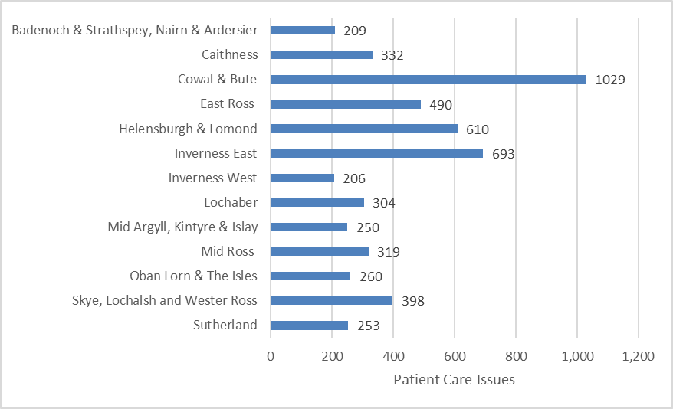
Data Source: PRISMS³
Figure 3.5.3 Number of Complete High Risk Medicine Assessments (as of May 2023)
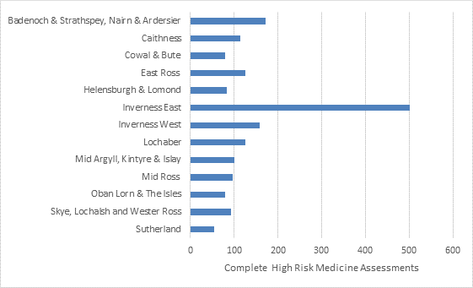
Data Source: PRISMS³

Additional Pharmaceutical Services

Injecting Equipment Provision
Across NHS Highland there were 21 pharmacy outlets and 7 agency outlets which provided an injecting equipment service in 2021/22. The total number of outlets has more than doubled since 2007 and translates as 8 outlets per 1,000 estimated attendances at an IEP outlet. Data provided by 23 out of 28 outlets in NHS Highland, revealed that a total of 48,880 needles and syringes were distributed from all outlet types in 2021/22⁵. 77% of attendances were male and 23% were female.
Data source: Information Services Division

Figure 4.1.1 Locations of NHS Highland Community Pharmacy Services who provide Injection Equipment Provisions (as of June 2023)
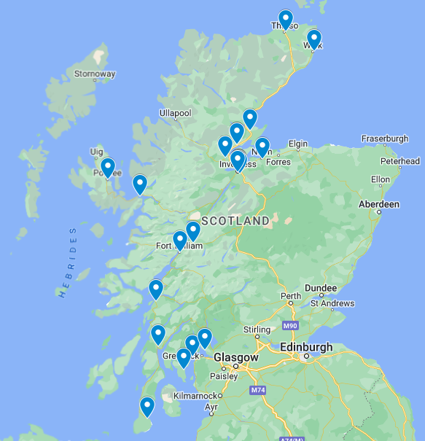
Data Source: Internal Pharmacy Records, Inverness

Naloxone Provision
To contribute to a reduction in drug related deaths within Scotland community pharmacies provide overdose awareness training and naloxone supply to individuals as defined by Scottish Government.
Legally, Drug Treatment Services can hold naloxone for emergency use and train and supply individuals with naloxone.
Non-Drug Treatment services such as hostels, homelessness services and housing support services, can only be issued with naloxone for use in an emergency. Therefore, legally they are not allowed to hold naloxone to distribute to anyone else. i.e they cannot train and supply service users and provide service users with a naloxone kit.

Buprenorphine Supervision
During a 12-month period in 2020/2021, client numbers varied from less than 5 to 32 per month, with the highest number seen in Inverness East. The variation in monthly figures may be due to contractors supplying data for several months at one time as opposed to regular monthly instalments.
Table 4.3.1: Buprenorphine Supervision (2020-21)
District | Number of Supervisions  (2020-2021) | Minimum Number of Clients per Month | Maximum Number of Clients per Month
Badenoch & Nairn | 280 | <5 | 7
Caithness | 930 | <5 | 9
Cowal & Bute | 57 | <5 | 83
East Ross | 1050 | <5 | 11
Helensburgh & Lomond | 571 | <5 | 8
Inverness East | 3492 | 9 | 32
Inverness West | 2543 | 11 | 31
Lochaber | 207 | <5 | <5
Mid Ross | 477 | <5 | 6
Mid-Argyll, Kintyre & Islay | 0 | <5 | <5
Oban, Lorn & The Isles | 0 | <5 | <5
Skye & Lochalsh & Wester Ross | 169 | <5 | <5
Sutherland | 104 | <5 | <5
Data Source: Internal pharmacy records⁶, Inverness

Methadone Supervision
The Community Pharmacy Methadone Prescribing Audit, performed between the 5th and 11th of September 2022, collected data from 84 pharmacies in NHS Highland regarding methadone supervision services. Of the pharmacies audited, 33 dispensed methadone to 220 people within the audit period. The majority (179 people) received methadone within the Highland Alcohol and Drug Partnership (ADP) area⁷.
Table 4.4.1: Number and Proportion of People Prescribed Methadone by Supervision Arrangements
 | Argyll & Bute ADP |  | Highland ADP |  | NHS Highland
Dispensing | Number | % | Number | % | Number | %
Supervised | 15 | 37% | 162 | 91% | 177 | 80%
Unsupervised | 26 | 63% | 17 | 9% | 43 | 20%
Total clients | 41 | 100% | 179 | 100% | 220 | 100%
Data Source: The Community Pharmacy Methadone Prescribing Audit ⁷
The mean daily dose administered was 71.9ml, however this ranged widely from 3ml to 150ml. Overall, 80% of people were administered methadone under supervision, however a higher percentage of people were supervised in Highland ADP (91%) compared with Argyll & Bute ADP (37%). Of all clients, 30% received methadone daily.
Table 4.4.2: Number and Proportion of People Prescribed Methadone by Dispensing Interval
 | Argyll & Bute ADP |  | Highland ADP |  | NHS Highland
Instalments | Number | % | Number | % | Number | %
Daily | 12 | 29% | 66 | 37% | 78 | 35%
2x Weekly | 4 | 10% | 19 | 11% | 23 | 10%
3-4x Weekly | 5 | 12% | 27 | 15% | 32 | 15%
Weekly | 20 | 49% | 67 | 37% | 87 | 40%
Total clients | 41 | 100% | 179 | 100% | 220 | 100%
Data Source: Community Pharmacy Methadone Prescribing Audit ⁷

Advice to Care Homes
Available claims information reveals that 26 pharmacies across NHS Highland hold contracts with 88 care homes (See footnote 2). Not all care homes hold a contract with a pharmacy.
The largest number of care home contracts (23) is held by a small number of pharmacies (3) located in the Inverness district. This reflects the fact that larger pharmacies tend to have more resources and are therefore able to compete more effectively for care home contracts. While it is not unusual for care homes to hold contracts with pharmacies out with their locality, they often utilise local pharmacies for acute requirements. This can lead to disruption in continuity of patient records.
Table 4.5.1: Care Home Contracts (2020/21)
District | Number of Pharmacies with Care Home Contracts | Number of Care Home Contracts
Badenoch & Nairn | 2 | 4
Caithness | 1 | 6
Cowal & Bute | 2 | 6
East Ross | 2 | 4
Helensburgh & Lomond | 1 | 6
Inverness East | 3 | 23
Inverness West | 1 | 15
Lochaber | 3 | 5
Mid Ross | 1 | 3
Mid-Argyll, Kintyre & Islay | 2 | 3
Oban, Lorn & The Isles | 3 | 5
Skye & Lochalsh & West Ross | 2 | 4
Sutherland | 3 | 4
Data Source: Internal pharmacy records, Inverness

Footnotes:
1) There is a possibility that some contractors who do provide care home services may not be represented here as they may not have supplied claim information (from which this data was sourced).

Care at Home
The Care at Home Service supports people to continue to live in their own homes. Support with medicines is one aspect of a range of tasks that Care at Home workers provide to enable people to live at home and retain as much independence as possible.

Clozapine
As part of the wider multi-disciplinary team, community pharmacies can provide clozapine to patients who are identified as community pharmacy dispensing patients.

Figure 4.7.1 Number of Items Dispensed (May 2022-Apr 2023)
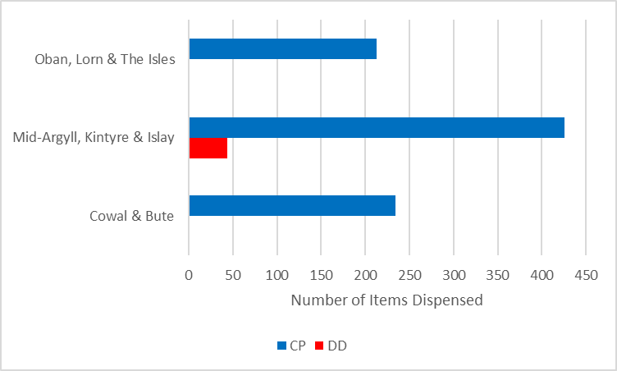
Data Source: PRISMS³
Patient counts less than five in a locality have been suppressed to reduce the risk of disclosure.

Vaccination Services

Travel Vaccinations
The Community Pharmacy Services department, working in conjunction with the NHS Highland Vaccines and Immunisations Pharmacist have developed a one-stop travel health service from community pharmacy whereby people would be able to get all of their travel advice, medication and immunisations in the one place, including those vaccines that are available privately or on prescription from the NHS free of charge, and were previously available from the patient’s GP practice under the old NHS GP contract.
Community pharmacies who participate in this service agree to provide an initial consultation to determine the person’s travel requirements. They then provide any of the following vaccinations free of charge using NHS Highland Patient Group Directions (PGDs):
- Revaxis (Diphtheria, Tetanus and Polio)
- Hepatitis A
- Typhoid
- Hepatitis A/Typhoid
- Cholera

If the person required malaria prophylaxis or a further vaccine that is not available on the NHS then they can purchase this or be vaccinated for a private fee by the community pharmacist can access this via the private service.

In rare cases, where the person’s clinical circumstances mean that they are outside the inclusion criteria of the PGDs then they can be referred to the Board’s public health service.
Some community pharmacies also provide a covid vaccination service in line with national campaigns.

4.8.2 Seasonal Flu Vaccinations
The aim of this is to increase access to immunisation for eligible staff groups involved in direct patient care in order to contribute to the achievement of Board immunisation targets. Eligible people within the population or at-risk cohorts who meet the criteria can also access this service by participating community pharmacies.

Hospital to Community Dispensing
The aim of this service is to provide patients with access to medicines prescribed from the hospital service along with any associated pharmaceutical care support from a participating local community pharmacy.

Gluten Free Service
The Food List (Formulary) is a list of prescribable gluten-free products that can be ordered by patients in the North of Scotland. It gives a wide, but not exhaustive, list of available gluten-free products. The pharmacy is also responsible for providing an annual review, supply and advice.
Figure 4.10.1 Number of Items Dispensed, April 2022 – March 2023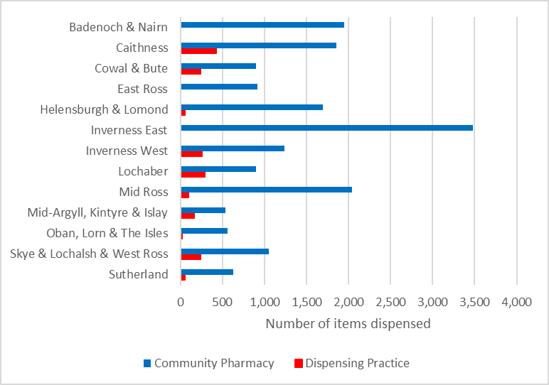
Figure 4.10.2 Formulary Compliance % (Items Dispensed), April 2022 – March 2023
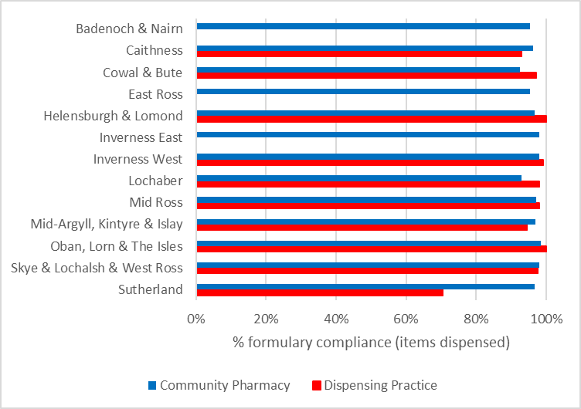
Data Source: PRISMS³
Note: There are no dispensing practices in Badenoch & Nairn, East Ross, and Inverness East.

Palliative Care
Within NHS Highland all community pharmacies participate to provide additional palliative care support to patients – more info here. The network pharmacies service includes:
- The provision of advice and support on palliative care medications to GP’s , Community Nurses and other pharmacists
- The provision of advice and support to patients and their carers, signposting to additional services
Of the 83 community pharmacies, 54 pharmacies are palliative care medicines stockholding pharmacies, retaining a small stock of specific medications that may be required for palliative & end of life care.
Figure 4.21.1 Locations of NHS Highland Community Pharmacy Services Palliative Care Stockholders (as of June 2023)
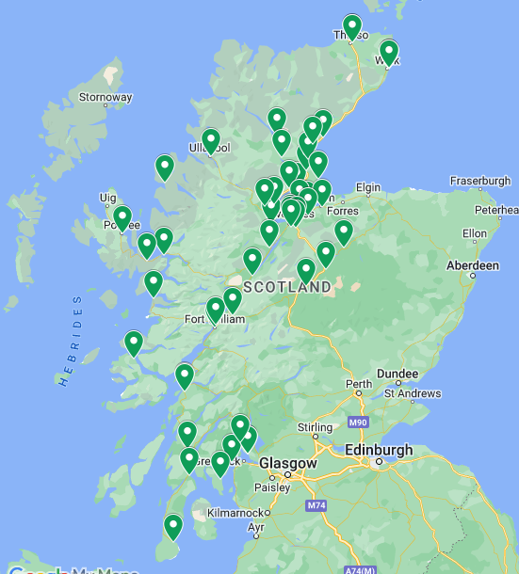
Data Source: Internal Pharmacy Records, Inverness

5. Executive Summary
The publication of NHS Highland (Pharmaceutical Services) (Scotland) Amendment regulations 2011 requires NHS Boards to publish an annual Pharmaceutical Care Service Plan (PCSP). This 2023/24 PCSP update is published according to these regulations in accordance with the Scottish Government circular PCA (P) 7 (2011).
The report gives a brief overview of the population of NHS Highland and provides a diagrammatic description of the current pharmaceutical services existing within NHS Highland. Data from a range of sources are utilised to establish any unmet need for each of the core Community Pharmacy Contract services. Additional services currently provided in NHS Highland are also examined. The extent to which that need is met is examined through assessment of any existing gaps in the provision of the core pharmaceutical services within the Community Pharmacy contract.
There are currently 83 contracted community pharmacies in Highland, (59 in the north and 24 in Argyll & Bute). Of those community pharmacies, 21 are independent pharmacies and 38 are multiple in the north of Highland, 12 are independent community pharmacies and 12 multiple within A & B. NHS Highland currently have 39 Dispensing Practices. All are well distributed across the region and meet the access needs of the vast majority of the population, with no large gaps being identified. However, in view of the recent community pharmacy closures (18th November 2023), the unmet need for additional community pharmacy provision may be required to be considered. New community pharmacy applications are continuing to be considered by the Pharmacy Practices Committee (PPC).
Ongoing additional service provision is being developed across community pharmacy with the introduction of both national and locally negotiated services, and the introduction of Pharmacy First Plus being created with an ever-increasing number of community pharmacists upskilling to independent prescribing.

References
1) Community Health Index Population. April 2016. Held by NHS Highland Health Intelligence Team.
2) Scottish Surveys Core Questions 2014. SSCQ 2014 Supplementary Tables, Car Access. Available from: https://www.gov.scot/publications/scottish-surveys-core-questions-2014/pages/5/
3) Prescribing Information System for Scotland
4) Information Services Division. NHS Smoking Cessation Service Statistics (Scotland) for Financial Year 2019/20 Available online: NHS smoking cessation service statistics (Scotland) - April 2019 to March 2020 - NHS smoking cessation service statistics (Scotland) annual - Publications - Public Health Scotland
5) Information Services Division. Injecting Equipment Provision in Scotland 2021/22. Published 18th October 2022. Available online: Injecting equipment provision in Scotland - 2021 to 2022 - Injecting equipment provision in Scotland - Publications - Public Health Scotland
6) Internal Pharmacy Records, Inverness
7) NHS Highland Community Pharmacy Methadone Prescribing Audit 2022, September 2022.
8) Pharmaceutical List 2023

Correct as of November 2023

