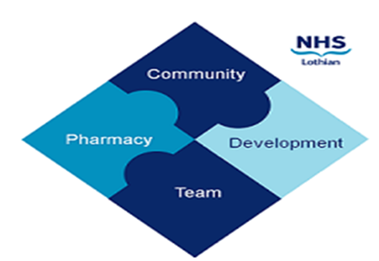

COMMUNITY PHARMACY DEVELOPMENT TEAM WEEKLY UPDATE
Wed 29th November 2023
We hope that you will take some time to read the information below and share with the whole team.
Dawn, Ellen Jo and Fiona
https://www.communitypharmacy.scot.nhs.uk/nhs-boards/nhs-lothian/

- Carbomer Eye Gel Recall - Please ensure all your staff (including Reliefs and Locums) are aware of the safety alert and related product recall of certain batches of AaCarb eye gel, Aacomer eye gel, and Puroptics eye gel, which were sent out to all pharmacy mailboxes by PCCT on Monday.
- Medicine Delivery Scam - We are continuing to receive reports, most recently from Edinburgh-based pharmacies now, about fraudulent phone calls being made to vulnerable patients. The calls are from a London phone number and the callers are pretending to represent the local pharmacy and requesting bank or credit card details in order to charge the patients for on-going prescription delivery services. Please alert your delivery patients to this and if you hear of this happening to any of your patients, contact the police on 101.
- Independent Prescriber Application Process - Just a little reminder that any notes of interest for a NES funded IP course for 2024 needs to be submitted by Friday 1st December. If you haven’t already expressed your interest, please see our email to your mailbox earlier today for more details.
- Public Health Posters and Holders - Just a quick reminder that you can order extra posters and poster holders from our supplier the APS Group at stockorders.DPPAS@theapsgroup.com.
- Service Now Portal - This is the new(-ish) NHS IT portal which should be used by community pharmacy teams to report issues or make requests regarding NHS Mail Outlook, for instance new account requests, linkings to pharmacy mailboxes, password resets etc. The login page and the Service Now user guide can be found on our NHS community pharmacy webpage:
https://www.communitypharmacy.scot.nhs.uk/nhs-boards/nhs-lothian/nhs-email-accounts-outlook-365/

We hope that you are all keeping well. Please get in touch with us if there is anything you would like to see more information on or if you have any questions.

The Community Pharmacy Development Team
Royal Edinburgh Hospital

