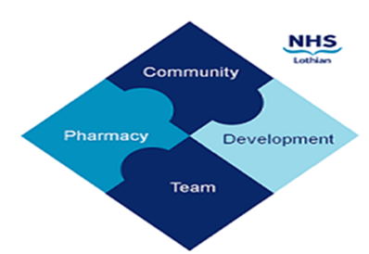

COMMUNITY PHARMACY DEVELOPMENT TEAM WEEKLY UPDATE
Wed 13th December 2023
We hope that you will take some time to read the information below and share with the whole team.
Dawn, Ellen Jo and Fiona
https://www.communitypharmacy.scot.nhs.uk/nhs-boards/nhs-lothian/

- Systemic Anti-Cancer Therapy - This is a quick reminder that any contractors signed up to deliver the enzalutamide SACT service must purchase the medicine through the formal UK supply chain, via the wholesaler Alliance as outlined in the SLA available here

• Eligible for antiviral treatment – Patients who test positive for covid who are at risk should contact 0300 790 6769 to determine if they are eligible for antiviral treatment. This number and the details for other health boards can be found on the NHS inform website. Please see attached circular for more information.

• Vitamin D Supplements for Care Home Residents - Please see attached information regarding the recommendation for care home residents to receive a vitamin D supplement. This is for your awareness in case you see an increase in requests from any care homes that you dispense medicines for.

• Sexual and Reproductive Health at the Pharmacy - Survey
Please share your experiences, practice and views on delivery of sexual and reproductive healthcare (SRH) at the pharmacy to help shape future research and development in Scotland! The survey takes under 10 minutes to complete, but you need to be logged into Office365 using your NHS account to access it. It can be completed on a phone or tablet as long as you have your login details. Please feel free to share with other pharmacists. https://forms.office.com/e/zM9Z5vtaq3

• National Patient Safety Alert – Diabetes
Please see attached safety alert relating to a potential inappropriate dosing of insulin when switching insulin degludec as a result of a shortage of Tresiba®

• Medicines Defects – Tramadol
Please see attached safety alert relating to certain batches of tramadol that the PIL does not include the most up to date safety information for drug interaction of antidepressants with Tramadol, sleep-related breathing disorders, adrenal insufficiency, hiccups, and serotonin syndrome, and the need to seek medical advice if they occur.

• PCFS/ CPS joint statement
Please see attached comms from Practitioner & Counter Fraud Services (P&CFS) and Community Pharmacy Scotland (CPS) agreeing that there is a need to provide a statement to all contractors.

We hope that you are all keeping well. Please get in touch with us if there is anything you would like to see more information on or if you have any questions.

The Community Pharmacy Development Team
Royal Edinburgh Hospital

