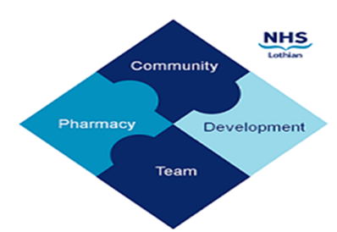

COMMUNITY PHARMACY DEVELOPMENT TEAM WEEKLY UPDATE
Wed 27th December 2023
We hope that you will take some time to read the information below and share with the whole team.
Ellen Jo and Fiona
https://www.communitypharmacy.scot.nhs.uk/nhs-boards/nhs-lothian/

- Community Pharmacy NHS PGDs – There are currently review dates on some of the NHS PGDs in your NHS Boards. Please note that review dates are not expiry dates on the PGD; they are a note of the time window in which the review will take place. If the PGD is past its review date, the content will remain valid until such time as the PGD review is complete and the new issue published.

PGDs with expiry dates will have these specifically stated.

The national PGDs for Aciclovir and Flucloxacillin for use under NHS Pharmacy First Scotland, and Desogestrel for use under Public Health Service are currently under review – updated versions will be issued in 2024.

- Pharmacy First Optometry Circular – This Circular provides updated guidance aimed at community optometry, community pharmacy teams and an updated referral form for the assessment and treatment of minor eye conditions. We have updated the Optometry referral form on our website:
NHS Community Pharmacy Website (scot.nhs.uk)

- Guaranteed Minimum Payments for the procurement of medicines – This circular advises community pharmacy contractors and Health Boards of a corrective payment in order to deliver contractual requirements for the financial year 2023/24

🎄🎁We hope you all have a great festive break, and all the very best for 2024! 🎉⛄

The Community Pharmacy Development Team
Royal Edinburgh Hospital

