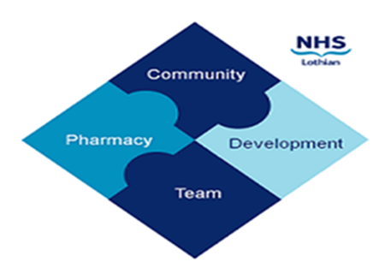

COMMUNITY PHARMACY DEVELOPMENT TEAM WEEKLY UPDATE
Wed 3rd January 2024 (yes, really)
We hope that you will take some time to read the information below and share with the whole team.
Ellen Jo and Fiona
https://www.communitypharmacy.scot.nhs.uk/nhs-boards/nhs-lothian/

- Nitazenes – these powerful synthetic opioids are increasingly occurring in Scotland’s drug supply so we have been asked to promote awareness of nitazenes due to their increased risk of very sudden overdose in users.

Please have conversations where appropriate with relevant patients, promote ‘take home naloxone’, and use the resources and posters (produced by the Scottish Drug Forum in conjunction with other health organisations) for educating patients and pharmacy staff as part of their #StopTheDeaths campaign:
https://www.stopthedeaths.com/resources-1

There is also now a recent webinar on YouTube titled ‘On Alert: New Opioids and Benzos in Scotland’s Drug Supply’ :
https://www.youtube.com/watch?v=eSDNPaW4qQ4

- Tariff Clawback Changes – the new PCA(P)(2023)46 has come out regarding amendments to the Drug Tariff Part 11 Discount Clawback Scale. The PCA was sent out to all shared mailboxes by PCCT last Friday.

- Environmental Pilot – Do you have an interest in sustainability and the environment? Metered dose inhalers (MDIs) contribute an estimated 3% of the carbon footprint of NHS Scotland! The Primary Care Respiratory team are looking to recruit 5 or 6 pharmacies to encourage patients to return their expired or used inhalers for appropriate disposal. The respiratory team can provide dispensing bag stickers for highlighting to patients. RPS are also looking to write a piece on a pharmacy who is interested in sustainability. If you are interested in supporting a greener environment please contact Katie.Johnston@nhslothian.scot.nhs.uk

• Secondary Care Pressures – Community Pharmacies are reminded to make use of appropriate PGDs e.g. Unscheduled Care and Pharmacy First / Plus, to support the pressures currently faced by secondary care.

We hope that you are all keeping well. Please get in touch with us if there is anything you would like to see more information on or if you have any questions.

The Community Pharmacy Development Team
Royal Edinburgh Hospital

