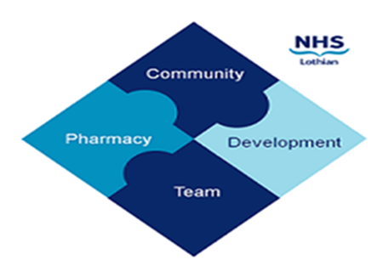

COMMUNITY PHARMACY DEVELOPMENT TEAM WEEKLY UPDATE
Wed 10th January 2024
We hope that you will take some time to read the information below and share with the whole team.
Ellen Jo and Fiona
https://www.communitypharmacy.scot.nhs.uk/nhs-boards/nhs-lothian/

- GLP-1s – GLP-1 medicines continue to be in short supply – please see the attached National Patient Safety Alert for updated info and recommended action by prescribers.

- Nutramigen Recall – please ensure that all staff including Reliefs and Locums are aware and take action where necessary over the recall of Nutramigen LGG Stage 1 & 2 baby formula due to possible bacterial contamination. We have attached the Food Standard Scotland alert sent out last week for your easy reference.

- M:CR Top Tips – Over Christmas, NHS Fife produced a handy list of tips and reminders to help pharmacies manage M:CR and serial scripts – please see attached (thanks NHS Fife for letting us borrow this!)

- Service Now – did you know you can change the pharmacy location displayed on your NHS Mail Outlook account yourself? Just log into the Service Now portal and follow page 12 of the Service Now user guide – details are on our website:

https://www.communitypharmacy.scot.nhs.uk/nhs-boards/nhs-lothian/nhs-email-accounts-outlook-365/

- Cozaar 100mg Tablets – Hopefully you’ve all seen the recent Drug Alert regarding certain batches of Cozaar 100mg PIL missing the text about avoiding grapefruit juice when taking this medicine. Please see the attached for affected batches and ensure the missing information is conveyed to patients where required.

- NES Ears Webinar – NES will be hosting an interactive learning event which will be a facilitated discussion where attendees will work through one of the latest Community Pharmacy Learning Together e-learning resources on Ear Conditions. This will be happening on Wednesday 17th January 7-8.30pm. To book your place, please go to your TURAS account via this link:

https://learn.nes.nhs.scot/72700/pharmacy-courses-and-events/management-of-ear-conditions-in-community-pharmacy

We hope that you are all keeping well. Please get in touch with us if there is anything you would like to see more information on or if you have any questions.

The Community Pharmacy Development Team
Royal Edinburgh Hospital

