** Condom Order Form**

**Please complete the order form below fully to avoid a delay in your order**

**being processed.**

|  |  |  |
| --- | --- | --- |
| **CDS Centre:** |  | |
| **Name:** |  | |
| **Address:** |  | |
| **Post Code:** |  | |
| **Phone:** |  | **Date:** |
| **Condoms:** |  | **Number of Packets Required** |
| A Standard Box  (Contains 72 packs of various condoms) |  |
| Extra |  |
| Sensitive |  |
| Latex Free |  |
| Variety |  |
| Large |  |
| Lubricant |  |
| Flavoured |  |
| Natural |  |
| Internal Condom { Prev Female Condom} |  |
| Trim |  |
| Black |  |
| Single Packs- Contains 3 Condoms |  |
| **Resources:** | C Cards (bundles of 50) |  |
| Leaflets (bundles of 50) |  |
| Pre-Paid Envelopes |  |
| YP/YP+ Clinic cards ( bundles of 25) | **OUT of STOCK** |

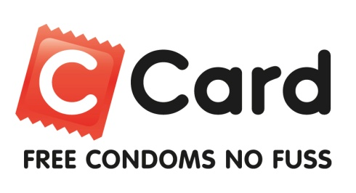**Completed forms should be emailed to Carol.Rattray@lanarkshire.scot.nhs.uk**