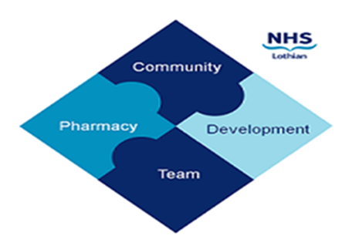

COMMUNITY PHARMACY DEVELOPMENT TEAM WEEKLY UPDATE
Wed 24th January 2024
We hope that you will take some time to read the information below and share with the whole team.
Ellen Jo and Fiona
https://www.communitypharmacy.scot.nhs.uk/nhs-boards/nhs-lothian/

- GLP-1 Shortages – we want to highlight that if you are unable to supply a particular medicine to a patient, current guidance in the recent MSAN and National Patient Safety Alert (see attached) is to refer the patient back to the prescriber for an alternative. Pharmacies should not dispense alternatives (e.g. lower strength at a higher equivalent dose) themselves since this places extra strain on the supply system for patients already on these other alternatives.

- NHS Mail – a quick reminder that NHS Lothian IT security policy states that any emails containing sensitive information or patient details e.g. scripts should only be sent to a pharmacy’s NHS Mail Outlook shared mailbox ending in nhs.scot. No other email addresses should be used, even corporate ones. If your pharmacy is having problems accessing the shared mailbox (e.g. linking not working, accounts locked etc.) please see guidance on our website on how to log a call via the IT portal Service Now (see below) or contact us for further advice:
https://www.communitypharmacy.scot.nhs.uk/nhs-boards/nhs-lothian/nhs-email-accounts-outlook-365/
- SWAN2 – NHS Scotland is now rolling out to all community pharmacies a new and improved SWAN connection to the NHS network provided by BT. Once your pharmacy has been identified to be upgraded to the new network, you will be contacted by the ePharmacy Helpdesk who will be sending out new equipment prior to the engineer’s visit. Any queries, please contact the ePharmacy Helpdesk on 0131 275 6600.

We hope that you are all keeping well. Please get in touch with us if there is anything you would like to see more information on or if you have any questions.

The Community Pharmacy Development Team
Royal Edinburgh Hospital

