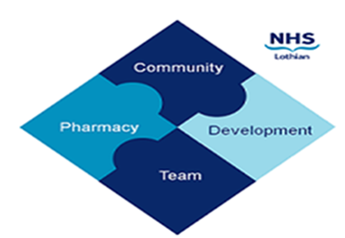
COMMUNITY PHARMACY DEVELOPMENT TEAM WEEKLY UPDATE
Wed 14th February 2024
We hope that you will take some time to read the information below and share with the whole team.
Ellen Jo and Fiona
https://www.communitypharmacy.scot.nhs.uk/nhs-boards/nhs-lothian/

- Have you dispensed haloperidol recently? There have been three separate incidences where patients have been incorrectly administered haloperidol via syringe, resulting in patients receiving x10 the prescribed dose. All three cases involved patients administering 5mls of haloperidol via a 5ml syringe, for a 0.5ml dose.

What can Community Pharmacy teams do to support?
We know it is not always possible to give the correct syringe size - in this instance a 1ml syringe would be best practice. When dispensing haloperidol and/or other liquid preparations to patients please ensure you counsel the patient on their dose, dose changes if applicable, dispense the most appropriate syringe and where possible, show the patient where on the syringe they should be drawing the liquid up to.

- CPDT Webinars - Pharmacy First - We are very excited to be running our first training events of the year on ‘The Changing World of Pharmacy First’. Suitable for all pharmacy team members, this session will include latest PGDs, Referral Pathways, Pharmacy First Plus, and NHS England’s new Pharmacy First service. If you are interested, please reply to this email with the names of the staff members coming, which pharmacy you are based (if applicable), the best email address to use for sending the link to the Teams events, and which session you’d like to attend - Tue 5 March (7.30-8.30pm) or Thur 7 March (1-2pm).

- Men B Paracetamol PGD - Just a reminder that paracetamol for the prevention of post-vaccination fever childhood MenB vaccination should be supplied under this specific PGD. Please remember that the paracetamol dose within the PGD differs from paracetamol sold over the counter. A copy of the PGD can be found on our website.

- Latest MSANs - Please ensure you’ve seen the MSANs sent earlier this week by PCCT out to all pharmacy mailboxes regarding Methadone 5mg Tablets and Ramipril 1.25mg. Please also see the attached Public Health Alert for Pertussis.

- SWAN Upgrade - NHS NSS is now in the middle of migrating all community pharmacies’ current NHS connection to the new NHS connection which is supplied by BT. Please find attached a letter explaining what is involved; NSS has also put an article on the website that goes into more detail of what you can expect when the engineer visits your pharmacy.

We hope that you are all keeping well. Please get in touch with us if there is anything you would like to see more information on or if you have any questions.

The Community Pharmacy Development Team
Royal Edinburgh Hospital

