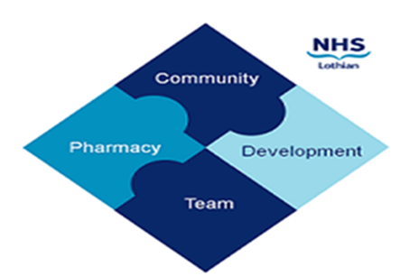

COMMUNITY PHARMACY DEVELOPMENT TEAM WEEKLY UPDATE
Wed 7th February 2024
We hope that you will take some time to read the information below and share with the whole team.
Ellen Jo and Fiona
https://www.communitypharmacy.scot.nhs.uk/nhs-boards/nhs-lothian/

Unscheduled Care PGDs – A reminder of these important points to all contractors:
Regarding the National PGD for the Urgent Supply of Repeat Medicines and Appliances, all contractors must ensure all their Pharmacists including Permanent, Locums and Reliefs have completed the PGD Individual Authorisation Forms from the pack from each PGD update and sent it to relevant department of the Health Board(s) they are working.
Contractors: you must ensure that at least one pharmacist has named your premises on the form, or payment cannot be made for a supply under the PGD. Pharmacists must have submitted forms by the appropriate deadline or payment for supplies made will be stopped (unless the PGD is signed and sent for authorisation immediately before a supply is made).
Individual pharmacists are reminded that they must sign the most recent version of the PGD, which from now on will be an annual requirement. If you do not sign and email/post each time the PGD is issued and continue to use the UCF forms for supply under this PGD, you will be acting illegally. Use your GPhC number on the Authorisation form and on UCF forms.

- CPS Shortage Flowchart – Community Pharmacy Scotland have published a couple of handy flowcharts as a reminder of the process to be followed by community pharmacies when faced with shortages, as well as a streamlined Shortage Reporter form. For more info, see: https://www.cps.scot/drugtariff/shortages-information

- Pharmacy Useful NHS Contacts – our Community Pharmacy Champions and our team have put together a quick reference list (just two pages) of useful NHS contacts which you can print off and pin up in your dispensary. It includes info on who to call or email at NHS if you have any queries regarding controlled drugs, endorsing, palliative care, sexual health, unscheduled care, waste, stock orders etc. Hope you find this useful!

- CPD Team Vacancy – our team is now recruiting a Lead Pharmacist for Community Pharmacy Development continue the important and interesting work we do to support and develop the network of Lothian community pharmacies and the great NHS services you deliver to the public. For more details, please see: https://apply.jobs.scot.nhs.uk/Job/JobDetail?JobId=178335

We hope that you are all keeping well. Please get in touch with us if there is anything you would like to see more information on or if you have any questions.

The Community Pharmacy Development Team
Royal Edinburgh Hospital

