**User Guide to carry out a Medicines Reconciliation (Meds Rec) in a Community Pharmacy**

*This process is designed to be carried out by either the Pharmacist or Pharmacy Tech with access to clinical portal.*

*(Please note in this example page some of the information from the IDL will not match with the info on the Meds Rec Form as the IDL used are from the test patients.)*

1. Using your PMR system and the information given from the Hospital via a phone call, complete the patient name and CHI/DOB section on the Meds Rec Template.
2. Complete the current medication list on pharmacy PMR system by entering the relevant drugs, strength and directions from your PMR records on to the form.

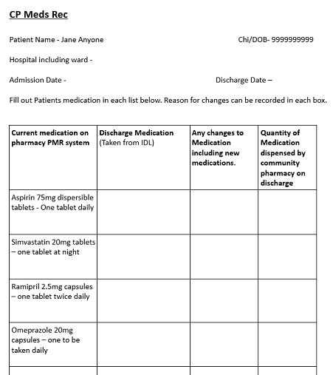

1. Access clinical portal via the link below using your username and password.

[**https://www.ggc-portal.scot.nhs.uk/concerto/Login.htm**](https://www.ggc-portal.scot.nhs.uk/concerto/Login.htm)



1. To Search for a patient, select the search tab on the left-hand column then select patients. Enter the patient ID as the patient CHI number, select reason for search as Discharge Prescription then press the blue search button.

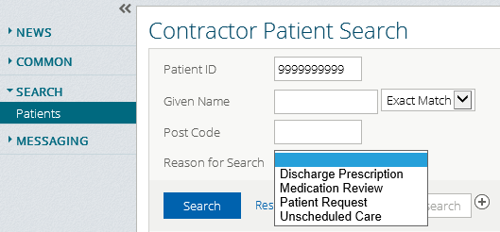

1. This will now bring up the patient below the search information, as highlighted in the screenshot below. Click on the patient to select them.

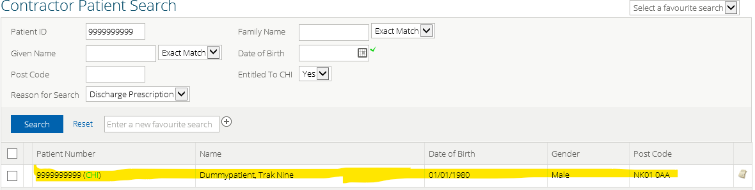

1. The patient’s clinical record will now appear as shown below.

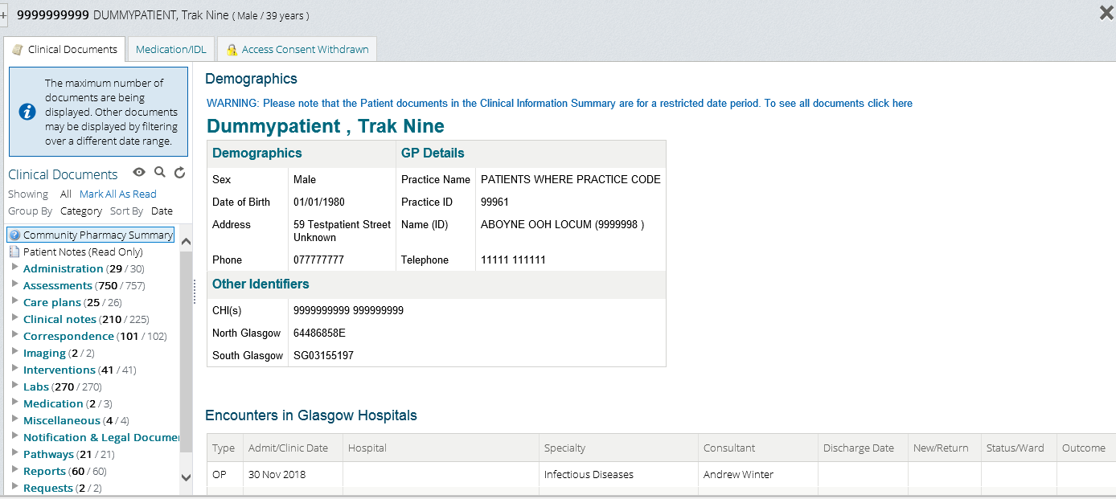

1. To view the IDL in the clinical documents tab select Correspondence, then Immediate Discharge Letter

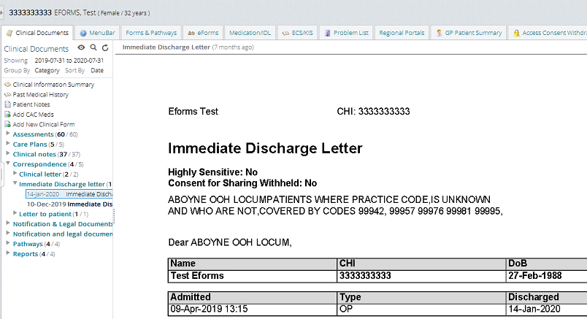

1. Complete the Hospital ward, admission date and discharge date on the Meds Rec Template from the IDL

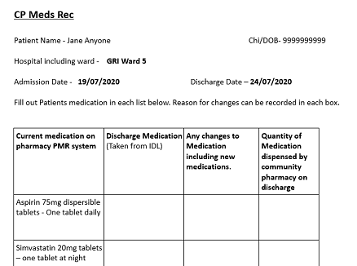

1. Use the information from the IDL to complete the discharge medication section on the Meds Rec Template. The column for any changes to medication can be used to highlight the medication changes or notes about the patient’s medication.

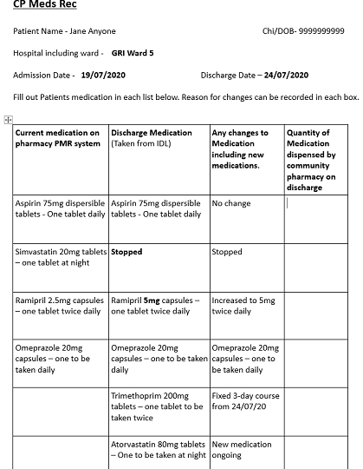

Note with the Orion Clinical Portal – HEPMA Integrations

There are some differences between the integrated HEPMA data and those IDL’s generated manually.

1) The HEPMA data is pulled directly from the HEPMA system so dosing instructions will include exact times of administration. These times of administration are to instruct HEPMA users and correspond with secondary care drug round times. They should not be interpreted as strict guidance on labelling or for primary care unless specified by the Secondary Care Pharmacy Team (e.g. Parkinson’s medicines).

Sample dosing instructions:

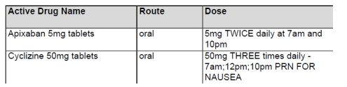

Apixaban, in this instance, can continue to simply be labelled as “Take ONE tablet MORNING and NIGHT”. It need not be labelled as “Take ONE tablet at 7AM and ONE tablet at 10PM”

2) At import, HEPMA data overwrites all existing/historical medicines. Such medicines will then be placed in the ‘Stopped Drugs’ list and marked as ‘Superseded by HEPMA medications’. This does not necessarily mean the medication has been stopped. If it appears in the ‘Active Medicines’ list it can be continued as recommended.

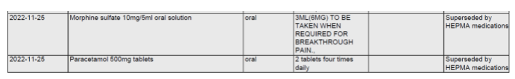

1. Quantity of medication dispensed by Community Pharmacy column is used to note down the quantity of medication that you are going to supply the patient. Using the dispensing information from your PMR it should be possible to see what medication the patient should have at home. Normally only new and changed medication is supplied at discharge.

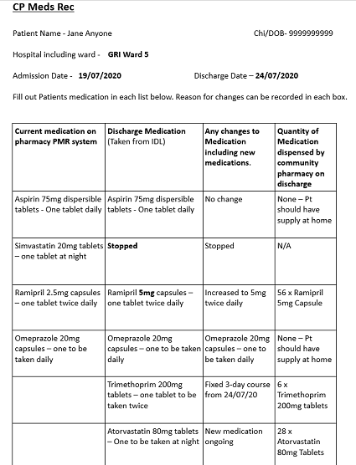

1. Using the PCR create an SBAR for the patient. Note you may need to create the patient on the PCR.

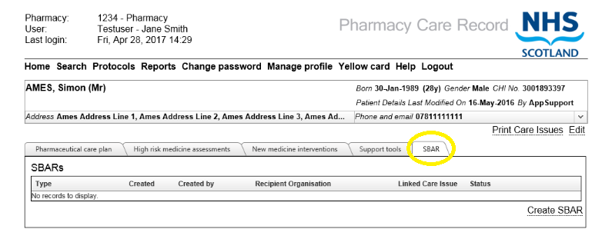

1. Complete the SBAR - example below - and email a copy to the locality Prescribing Support Team *(email addresses for locality Prescribing Support Teams in Appendix 1)*. The information on the SBAR is taken form the IDL and completed Meds Rec Template.

**This step must be completed within 24hrs of the patients’ discharge from hospital to ensure the records are updated in the patients’ GP Practice and the correct drug information is available on the patients’ Emergency Care Summary**.

Also include the information that the Community Pharmacy will complete a new medicines review with the patient within 5 days; within the SBAR. (More information in point 14 below).

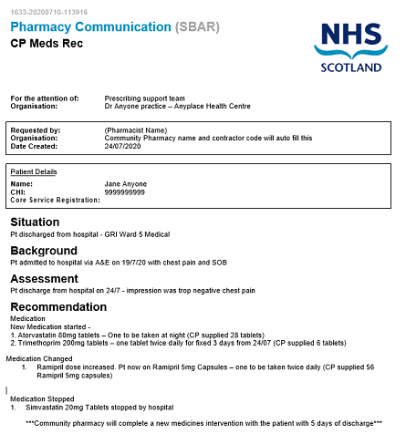

1. Using the UCF framework on your own PMR system select local service and complete a UCF claim for the quantities of each medication supplied. The drug cost will be reimbursed via the UCF payment systems.
2. Within 5 days of the patients’ discharge from hospital, contact the patient and complete a new medicines intervention with the patient. Please note this can be done either face to face, by phone call or via NHS Near Me if available.

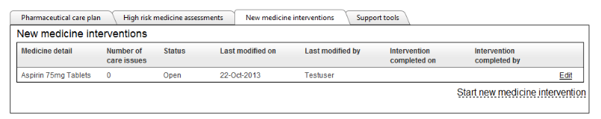

Any care issues that cannot be resolved by the pharmacy as part of the normal new medicine intervention process can be escalated to either the Prescribing Support Teams in the practice or the patients’ GP as clinically appropriate.

1. Update the GGC Electronic Claiming Workbook (ECW) with the patient’s CHI number and date of discharge. This is submitted monthly to CPDT to claim service fee per patient (£35).

**Additional Information on How to Resolve Discrepancies during the Meds Rec Process**

Discrepancies can occur during the CP meds rec for a number of reasons. These may include, but are not limited to, acute medication dispensed at another pharmacy so not on your PMR system, incomplete meds rec at the hospital admission and transcription errors on the IDL.

The medication/IDL tab on the clinical portal system can be used to help the Community Pharmacy Team attempt to resolve meds rec discrepancies.

To access the medication/IDL tab on clinical portal, log into clinical portal and select the patient as described in the Meds Rec guide. The medication/IDL tab can then be selected from the top menu bar.

*Please note the screenshots below are taken from the test patients and may differ slightly for your patient.*

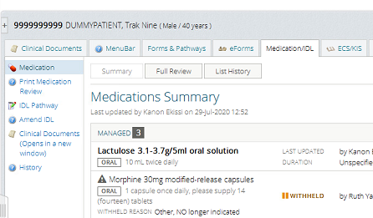

Select the list history option to view the history of the patients Medication/IDL.

Once in the List History option, select the Admission Review to view against the discharge review.

*(Note - on a live patient the discharge review will be at the top of the list with the pin icon as this will have just been completed by the Hospital Team.)*

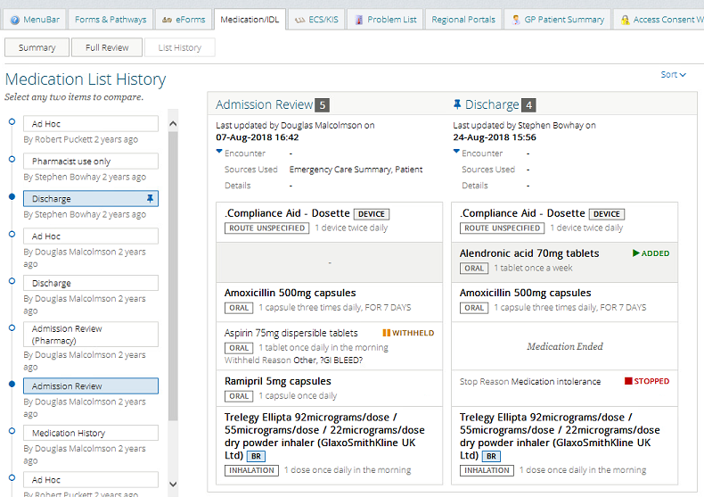

Clicking on any of the drugs in the right-hand window will open a Compare Medications information window as seen below

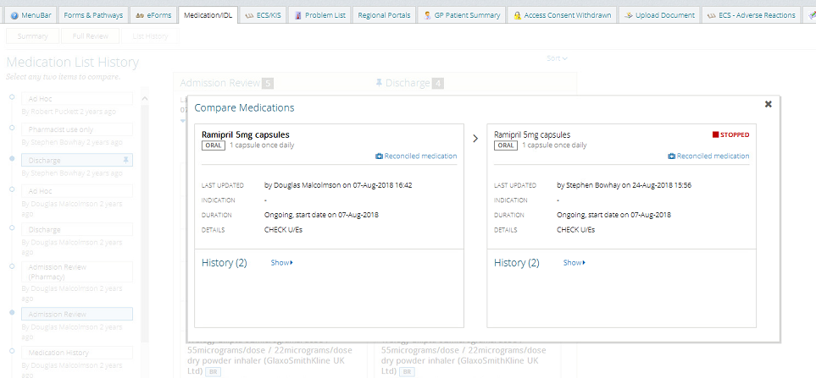

Selecting Show will give further information on the drug history, this may include reason for stopping any medication.  *(The example below shows stopped – medication intolerance)*

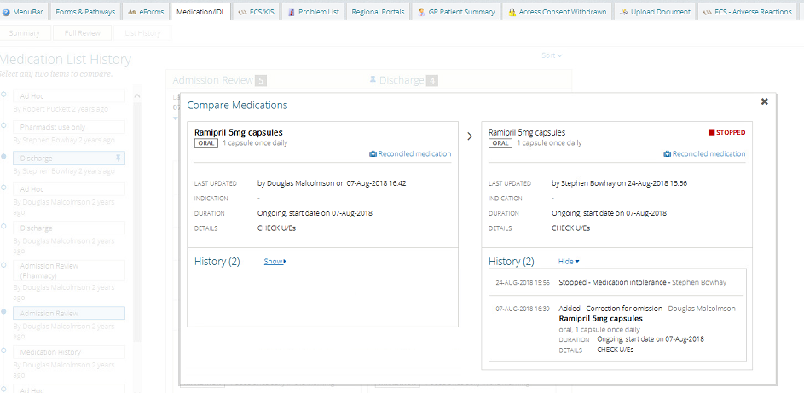

In some patients an admission review may not be present. In this instance the additional drug information may be found by clicking on the > symbol for the medication in the Medications Summary window.

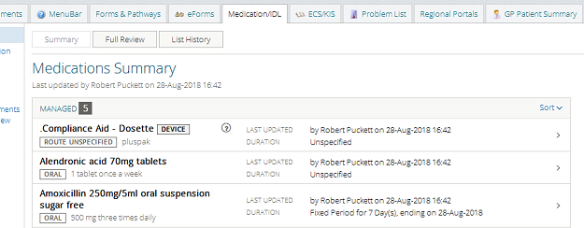

For other issues such as non-clinical operational issues, please contact either of the Community Pharmacy Champions on the information below:

|  |  |
| --- | --- |
| **Glasgow North East Champions**  Hannah McConnell  E:hannah.mcphail@nhs.scot  Ruth Robertson  E: [Ruth.Robertson4@nhs.scot](mailto:Ruth.Robertson4@nhs.scot) | **Glasgow North West Champions**  Garry Scott  E: [garry.scott@nhs.scot](mailto:garry.scott@nhs.scot)  T: 0141 959 1478  Stuart Dinnie  E: [stuart.dinnie@nhs.scot](mailto:stuart.dinnie@nhs.scot)  T: 0141 639 7191 |
| **East Dunbartonshire Champion**  Iona Leitch  E: [Iona.Leitch2@nhs.scot](mailto:Iona.Leitch2@nhs.scot) |  |

For any issue related to the ECW please contact the CPD Team by email [ggc.cpdevteam@nhs.scot](mailto:ggc.cpdevteam@nhs.scot)

**Appendix 1**

Email addresses for Community Pharmacy Teams to send completed SBAR into Primary Care Pharmacy Teams:

Glasgow North East: [PharmacyHubNE@ggc.scot.nhs.uk](mailto:PharmacyHubNE@ggc.scot.nhs.uk)

Glasgow North West: [ggc.nwpcpharmacy@ggc.scot.nhs.uk](mailto:ggc.nwpcpharmacy@ggc.scot.nhs.uk)

East Dunbartonshire: [ggc.eastdunbartonshirechpprescribing@nhs.scot](mailto:ggc.eastdunbartonshirechpprescribing@nhs.scot)