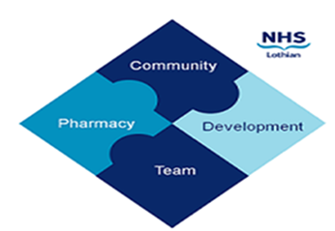
COMMUNITY PHARMACY DEVELOPMENT TEAM WEEKLY UPDATE
Wed 21st February 2024
We hope that you will take some time to read the information below and share with the whole team.
Ellen Jo and Fiona
https://www.communitypharmacy.scot.nhs.uk/nhs-boards/nhs-lothian/

- Codeine Linctus - just in case you hadn’t already seen this in the news, codeine linctus is in the process of being reclassified by the MHRA from a ‘Pharmacy’ medicine to a ‘Prescription Only Medicine’ though this may take a little time:

https://www.rpharms.com/about-us/news/details/rps-welcomes-reclassification-of-codeine-linctus

Codeine linctus to be reclassified to a prescription-only medicine because of risk of abuse and addiction - GOV.UK (www.gov.uk)

Due to increased reports of codeine linctus thefts from community pharmacy, please be vigilant and keep stock securely. And keep an eye on the RPS, CPS and MHRA website for further updates on the situation!

- Smoking Cessation – we have now published an updated quick user guide specific to the steps required to create and update smoking cessation records on PCR. Please see: https://www.communitypharmacy.scot.nhs.uk/nhs-boards/nhs-lothian/stop-smoking/

- Missing OOH Scripts – just a quick reminder that, if your pharmacy is open at the weekend and a patient has arrived expecting an urgent script to have been emailed by LUCS to your clinical mailbox but it hasn’t arrived, you can call the Prof-2-Prof line to chase it up. (This number is stored in your Unscheduled Care folder)

We hope that you are all keeping well. Please get in touch with us if there is anything you would like to see more information on or if you have any questions.

The Community Pharmacy Development Team
Royal Edinburgh Hospital

