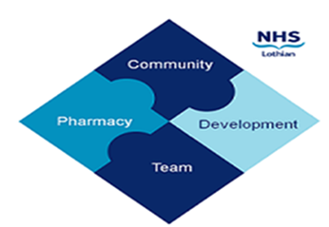

COMMUNITY PHARMACY DEVELOPMENT TEAM WEEKLY UPDATE
Wed 6th March 2024
We hope that you will take some time to read the information below and share with the whole team.
Ellen Jo and Fiona
https://www.communitypharmacy.scot.nhs.uk/nhs-boards/nhs-lothian/

- Enzalutamide SLA - Do you supply Enzalutamide (Xtandi) via the SACT SLA (Systemic Anti-Cancer Treatment)? If so, to ensure you are adhering to the SLAs ordering process please complete and return the attached audit form to us at CPDT@nhs.scot . This audit form should take less than 5 minutes to complete and needs to be returned by the 20th March.

- CPDT Webinar - THANK YOU to everyone who attended “The Changing World of Pharmacy First” webinar last night. We had a great attendance with lots of information shared and lessons learnt. It’s not too late to book onto the final delivery, which will be on Thursday 7th March 1-2pm. If you would like to attend, lease reply to us with a note of your name, pharmacy (if applicable), and the best email for us to send the Teams link to. If you have any feedback or future topics you wish to learn about please let CPDT know.

- NES Webinar - NES will be hosting a “Summer Health” Webinar on the 27th March 7.00-8.15pm. This interactive webinar will help support community pharmacy teams with the management of common clinical conditions which are often experienced over the summer months e.g. hayfever, insect bites, sunburn. This webinar will also outline the Pharmacy First Scotland relevant PGDs relating to summer health and provide an opportunity to discuss and ask questions. Please see TURAS Learn to register your interest.

- Metoject is changing - Please ensure you are familiar with the changes coming to the Metoject devices since patients may seek your advice on using these devices. Please see attached communication for more information.

- Out-of-Stock Bulletin - Please see the attached latest edition of the Lothian Out-of-Stocks bulletin. Don’t forget to have a look at our new Shortages page on the Community Pharmacy Lothian webpage.

- February Payment 2024 – NHS NSS Practitioner Services Division has confirmed the good news that all community pharmacy contractors will have been paid in February 2024 using their actual December 2023 data rather than estimates.
We hope that you are all keeping well. Please get in touch with us if there is anything you would like to see more information on or if you have any questions.

The Community Pharmacy Development Team
Royal Edinburgh Hospital

