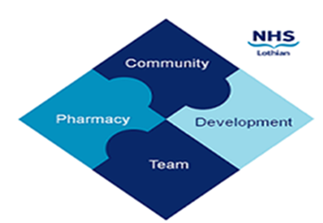

COMMUNITY PHARMACY DEVELOPMENT TEAM WEEKLY UPDATE
Thursday 29th February 2024
We hope that you will take some time to read the information below and share with the whole team.
Ellen Jo and Fiona
https://www.communitypharmacy.scot.nhs.uk/nhs-boards/nhs-lothian/

Community Pharmacy Scotland Ask Me Anything

Colleagues at Community Pharmacy Scotland are holding an Ask Me Anything event in March which will cover UCF for Pharmacy First Plus recording and a general Pharmacy First update. These are being run on Wednesday 6th March and Thursday 14th March. More information and a link to register can be found here.

Salbutamol Shortage

Please see attached memo regarding Salbutamol 2.5mg solution for nebulisation supply disruption. Action for Community Pharmacy teams;
· Please check quantity patient has at home.
· Please only issue a maximum of 4 weeks supply of salbutamol nebs against any prescription until stock returns to normal.

NES Foundation Training Year (FTY) Recruitment for the 2025/26

As part of the preparations for the recruitment process for the summer 2025 intake of FTY trainee pharmacists (previously pre-registration pharmacist training), NES are now seeking expressions of interest from Training Providers who would like to participate in the process. Please note from 2025/26 all FTY posts in Scotland must recruit via this national process administered by NES due to GPhC accreditation requirements. Please see the CPS website for more information - Action required: NES Foundation year 2025/26 — Community Pharmacy Scotland (cps.scot)

Various peer review & support sessions are also available via NES:

· TURAS online peer review sessions that may be appropriate for pharmacists taking on the DPP role.
Supervised learning events workshop | Turas | Learn (nhs.scot) with sessions planned for 17 April and then more in August, September and November to tie in with trainee pharmacists starting their FTY.

· Supervisor peer review and support session | Turas | Learn (nhs.scot) with sessions planned for 25 March to tie in with those who started being a DPP for the January & March IP courses and others planned throughout the year.

· NES will also arrange another DPP Drop-in Session | Turas | Learn (nhs.scot) for mid-May to support those being asked to be a DPP for the RGU September 24 course. These will be advertised on Mailchimp in April & May.

Medicines Defects, Recalls & MSANs
Please see attachments regarding medicines defeats involving Concerta XL 36mg, Concerta XL 18mg and recall on Adakveo 10mg/ml.

Please find attached a level 3 MSAN and two level 2 MSANs for the noted products below. Please distribute them to your networks.

- MSAN(2024)02 - Epilim® (sodium valproate) syrup 200mg/5ml
- MSAN(2024)03 - Midazolam (Epistatus®) 5mg/0.5ml oromucosal solution pre-filled oral syringes
- MSAN(2024)04 - Salbutamol 2.5mg/2.5ml and 5mg/2.5ml nebuliser liquid unit dose vials

We hope that you are all keeping well. Please get in touch with us if there is anything you would like to see more information on or if you have any questions.

The Community Pharmacy Development Team
Royal Edinburgh Hospital

