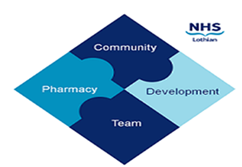

COMMUNITY PHARMACY DEVELOPMENT TEAM WEEKLY UPDATE
Wed 20th March 2024
We hope that you will take some time to read the information below and share with the whole team.
Ellen Jo and Fiona
https://www.communitypharmacy.scot.nhs.uk/nhs-boards/nhs-lothian/

- Pharmacy First Plus on UCF – CPS, Scottish Government and the NHS have been looking at using the UCF option on pharmacies’ PMR systems to capture Pharmacy First Plus activity by Pharmacist Independent Prescribers. This project is now being delayed – an update will be sent out when available.

- Jext 300mcg/0.3ml Pens – These will be out-of-stock until w/c 25th March 2024 – please see attached MSAN for further supporting information.

- MSANs for GLP-1s – Please see attached for a reminder about ongoing supply issues for several GLP-1 RAs and supporting guidance.

- MCR Serial Script Claims – A wee reminder to all pharmacies to send your electronic claims ideally on the day you hand medicines over to a serial script patient, so that this data can promptly update the Emergency Care Summary system used by hospitals and other healthcare providers, including GP systems. Claims submitted later means the patient collection date is inaccurate and can be misconstrued as non-compliance!

- PCR Errors – The NHS Lothian Quit Your Way team has asked us to highlight the most common errors when entering smoking cessation data on the PCR system:

- The patient’s own telephone number should be recorded, not the pharmacy’s telephone number – the latter stops the record being uploaded onto the national database

- Please check ensure the patient’s mobile number has 11 digits, not 10 digits – or the patients who have an outstanding three month follow up at week 15 can’t be contacted

- Service Now – did you know you can use the NHS’s Service Now IT portal to change the details showing on your NHS Mail account e.g. your pharmacy location? See our helpful NHS Mail section on our NHS website here:

https://www.communitypharmacy.scot.nhs.uk/nhs-boards/nhs-lothian/nhs-email-accounts-outlook-365/
We hope that you are all keeping well. Please get in touch with us if there is anything you would like to see more information on or if you have any questions.

The Community Pharmacy Development Team
Royal Edinburgh Hospital

