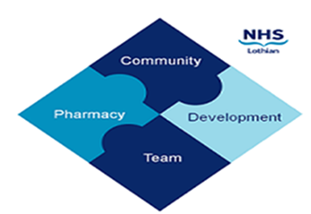

COMMUNITY PHARMACY DEVELOPMENT TEAM WEEKLY UPDATE
Wed 27th March 2024
We hope that you will take some time to read the information below and share with the whole team.
Ellen Jo and Fiona
https://www.communitypharmacy.scot.nhs.uk/nhs-boards/nhs-lothian/

- Salbutamol Leaflet – The Scottish Respiratory Pharmacy specialist interest group have created a really helpful short leaflet to support patients' understanding of their treatment in plain, easy-to-understand terms, including supporting patients’ understanding of not over-relying on salbutamol. Please consider printing out these leaflets to hand to relevant patients: Asthma: New Practice Leaflet | Community Pharmacy Scotland (cps.scot)

- NRT 1.5mg lozenges – We have heard that Niquitin Minis 1.5mg lozenges are being discontinued.

- Pharmacy First Updated PGDs – The PGDs for the treatment of Shingles and Skin Infections via Pharmacy First have been updated – look out for these in your pharmacy shared mailboxes. The updated TURAS courses can be accessed here:
https://learn.nes.nhs.scot/43887/pharmacy/cpd-resources/shingles-for-pharmacy-first-scotland

https://learn.nes.nhs.scot/43886/pharmacy/cpd-resources/skin-infections-for-nhs-pharmacy-first-scotland

Just a reminder that although you must sign the PGD and retain your copy as per professional and legal requirements, there is no need to send it to NHS Lothian. This includes both national and local NHS Lothian PGDs.

- Nystatin - We have been made aware that one manufacturer of nystatin has changed the administration device from a 1ml pipette to a 5ml oral syringe. Please make sure that any patients/representatives are counselled appropriately on the new device and are aware of the correct dose. Prescriptions will now need to state:
One ml dose to be used FOUR times a day after food NOT One measured dose to be used FOUR times a day after food
Please be vigilant and amend the dosage instructions where required as above for all new or recurrent prescriptions.
We hope that you are all keeping well. Please get in touch with us if there is anything you would like to see more information on or if you have any questions.

The Community Pharmacy Development Team
Royal Edinburgh Hospital

