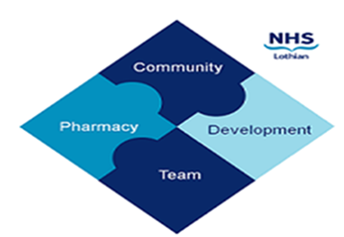

COMMUNITY PHARMACY DEVELOPMENT TEAM WEEKLY UPDATE
Wed 3rd April 2024
We hope that you will take some time to read the information below and share with the whole team.
Ellen Jo and Fiona
https://www.communitypharmacy.scot.nhs.uk/nhs-boards/nhs-lothian/

- PCR Changes – To make it easier for community pharmacy teams to put through smoking cessation attempt info, the smoking cessation part of the PCR system is being updated on the evening of 8th April 2024.

The PCR user guide and a summary of the latest changes will be posted on the NSS website around the same time: https://www.nss.nhs.scot/pharmacy-services/pharmacy-care-record-pcr/guidance-on-the-pharmacy-care-record-pcr/

- SSP for Isosorbide Mononitrate – Please see the attached PCA for details of the recently issued Serious Shortage Protocol for isosorbide mononitrate (Monomil XL) 60mg modified release tablets. This includes recommended alternatives for dispensing and additional advice.

- MSANs – In case you haven’t seen these, please see attached for MSANs regarding the discontinuation of Insulatard InnoLet and Levemir InnoLet for injection 3ml pre-filled disposable devices.

- Digital Prescribing & Dispensing Pathways (Paperless Prescribing) – The winter newsletter for the ongoing national Digital Prescribing and Dispensing Pathways (DPDP) programme (i.e. paperless prescribing across Scotland) is now available via this link:
https://sway.cloud.microsoft/ttCs1ic1zmUIwd2U?ref=email
We hope that you are all keeping well. Please get in touch with us if there is anything you would like to see more information on or if you have any questions.

The Community Pharmacy Development Team
Royal Edinburgh Hospital

