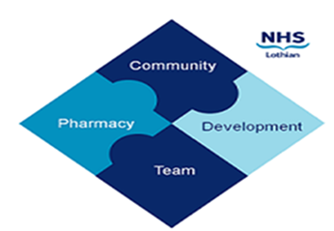

COMMUNITY PHARMACY DEVELOPMENT TEAM WEEKLY UPDATE
Wed 10th April 2024
We hope that you will take some time to read the information below and share with the whole team.
Ellen Jo and Fiona
https://www.communitypharmacy.scot.nhs.uk/nhs-boards/nhs-lothian/

- O365/NHS Mail – Please find attached three docs which eHealth have now released to explain and support the latest security and IT topics, including using personal non-NHS devices for things like Teams. Intune Company Portal app appears to be the new way for non-NHS staff to be able to log into NHS Lothian email accounts from a mobile device. There's also a useful matrix which shows you what you can/can't access depending on what device/operating system you are using. Any problems/advice needed, please call eHealth on 0131 536 5050.

- MSANs – In case you haven’t seen these, please see attached for MSANs regarding guanfacine 2mg and 3mg M/R tablets, and diazepam rectal solution tubes.

- CD Forms – A reminder to all pharmacies to use the CDRF (CP) CD Requisition Form when requesting the transfer of CDs from another pharmacy. These forms must then be submitted to NHS NSS Practitioner Services for inspection. You can order forms here:
https://www.nss.nhs.scot/pharmacy-services/pharmacy-prescriptions/order-prescription-stationery/

More details on the process can be found in the Guide to Good Practice here:
https://www.communitypharmacy.scot.nhs.uk/nhs-boards/nhs-lothian/controlled-drugs-governance-team/
- RPS Event - Shortages – RPS are running a Shortages online workshop on 16th and 25th April where they are keen to hear your views on shortages to help inform the work they are undertaking in this area. Please see attached flyer for further details and how to register.

- CPDT Team Changes – Our IM&T Facilitator, Fiona Anderson, will sadly be leaving our team this week after four years, and moving to a different area of NHS Lothian pharmacy to focus on prescribing efficiencies – we wish her luck! For all NHS Mail Outlook queries, please check our community pharmacy website for help and advice:
https://www.communitypharmacy.scot.nhs.uk/nhs-boards/nhs-lothian/nhs-email-accounts-outlook-365/

Remember, you can use the Service Now portal to log a variety of requests including new accounts, password resets, mailbox linkings etc. Details are on our website!

- We also welcome our new team member, Wendy Carswell, who takes over as Pharmacist Coordinator for Community Pharmacy and Primary Care – she brings many years’ experience of primary care and community pharmacy in England and Scotland. Welcome Wendy!
We hope that you are all keeping well. Please get in touch with us if there is anything you would like to see more information on or if you have any questions.

The Community Pharmacy Development Team
Royal Edinburgh Hospital

