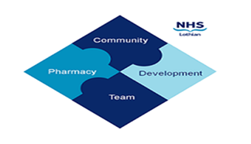

COMMUNITY PHARMACY DEVELOPMENT TEAM WEEKLY UPDATE
Wed 17th April 2024
We hope that you will take some time to read the information below and share with the whole team.

Could you be a Community Pharmacy Champion? We have TWO exciting opportunities to be a Community Pharmacy Champion for pharmacies across Lothian. For more information on the role & how to apply, please see attachment. Please note Community Pharmacy Lothian will support the appointment of these posts.
Face-Face Training Event – Keep your diaries free! After the success of our November face-face training event at the Novotel, where we had guest speakers from Community Pharmacy Lothian and Chalmers Sexual health…another face-face training event is being planned for the 21st May, 1830-2100. This is a great learning & networking opportunity, PLUS food will be provided on the night! Invites and details of our guest speakers to follow!
Shortages – Please ensure when you are notifying the surgeries of unavailable stock that you have exhausted all other avenues first. The attached shortages form is a handy tool that notifies the surgeries of all the steps community pharmacy teams have undertaken prior to returning the script for an alternative item. This form can be attached to any scripts returned.

Do you have an NHS mailbox?
All requests regarding Outlook accounts should now be self-logged by users in community pharmacies using the NHS’s IT portal Service Now which is accessible from all community pharmacy computers. (All this information & necessary forms can be found on our website)

This includes
- New NHS Mail Outlook accounts for new staff
- Reactivation/unlocking of existing accounts
- Deletion of accounts for staff leavers
- Password resets
- Linking/unlinking from a pharmacy’s shared mailbox
- Updating the user’s details such as name, job title, location and contact telephone number
If you have any problems logging into Service Now to log a request, you can also phone the eHealth helpdesk (9am-5pm, Mon to Fri) on 0131 536 5050 to log a call on your behalf on Service Now.

