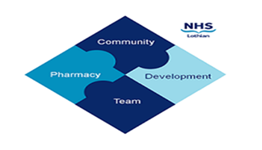

COMMUNITY PHARMACY DEVELOPMENT TEAM WEEKLY UPDATE
Wed 24th April 2024
We hope that you will take some time to read the information below and share with the whole team.

Do you want to learn how to feel more confident and in control while managing patient expectations? Or perhaps you want to get up to speed with M:CR & Serial prescriptions?
Please join us on the 21st May 18:30-21:00 at the Novotel Hotel, Edinburgh Park (food from 1830, presentations beginning 1900) for the Community Pharmacy Face-Face training event. This is a fantastic opportunity for you to meet new and old faces, get your revalidation started/finished for 2024 and enjoy some free food! If you would like to attend this event, please respond to this email with your name, branch, contact email and dietary requirements.

Cryptosporidium & Petting Event – Please see attached PHS alert. People with compatible symptoms and/or history of exposure to petting events or symptomatic contacts should have a stool sample taken.

Is your Pharmacist stuck in traffic? Perhaps the Pharmacy shutters won’t open? We have had an increase in reports of pharmacies not being open to the public with no notification to the healthboard. If for any reason the pharmacy is unable to open, or has to close at some point during the day unexpectedly, please ensure you follow local processes and e-mail a completed Temporary Closures Forms to CommunityPharmacy.Contract@nhs.scot

Are you prepared for Summer? If you missed the NES webinar on Preparing for Summer, a recording is available via TURAS Learn This webinar was designed to support community pharmacy teams with the management of common clinical conditions which are often experienced over the summer months e.g. hay fever, insect bites, sunburn. This webinar will also outline the Pharmacy First Scotland relevant PGDs relating to summer health. (Please sign into TURAS first before clicking on the link).

Have you dispensed Ivermectin 3mg? Please note there are now licensed options available for this item.

Do you need a CDRF form? These can now be downloaded from the NSS website.

