|  |  |
| --- | --- |
| **Contents**  **01: Seasonal Influenza: Prescribing of Antivirals 2023-24**  **02: British Association for Sexual Health and HIV (BASHH) Sessions**  **03: GatewayC- The early cancer diagnosis resource**  **04: Public Health Update: Gold Standard Awards** | **05: Community Pharmacy Scotland Round-Up**  **06: The Happy Place** ☺ |

## **Seasonal Influenza: Prescribing of Antivirals 2023-24**

**Please find the attached letter from Professor Sir Gregor Smith, Chief Medical Officer for Scotland and Professor Alison Strath Chief Pharmaceutical Officer.**

**Community pharmacists should not supply antiviral medicines in primary care on prescription of a GP10 prescription form.**

This communication follows SGHD/CMO/21(2023), which issued on 19 December 2023 advising that antiviral medicines (specifically oseltamivir and zanamivir) could be prescribed to treat influenza where clinically indicated, and in particular, among those vulnerable to severe disease or presenting with severe infection / symptoms. The Seasonal Flu Vaccination programme came to a close on 31 March 2024. In addition to this, Public Health Scotland confirm that the circulation of flu virus in the community has remained at baseline levels for some time.

**Therefore, the attached letter is to advise that the routine prescribing of antivirals for influenza by GPs in the community should now cease.**

## **British Association for Sexual Health and HIV (BASHH) Sessions**

Please find the attached flyer for the forthcoming British Association for Sexual Health and HIV (BASHH) Scotland Spring Meeting 2024 to be held on Friday 17th May 2024 from 1.40pm – 5pm via MS Teams.

For BASHH members there will be a business meeting 12pm – 1.15pm.

To register, please complete MS Form, link [here](https://forms.office.com/pages/responsepage.aspx?id=veDvEDCgykuAnLXmdF5Jmt8OYe-3VKxHrmOB1wXbn3xURVhaUUJFQUNWWU8wSDZDMUkxR0k5RFFZMS4u) or contact [gram.srhtraining@nhs.scot](mailto:gram.srhtraining@nhs.scot) if you have any issues. Links for the sessions will be sent via email by Thursday 16th May 2024.

## **GatewayC – The early cancer diagnosis resource**

This week the Gateway C website was launched in Scotland. This website is a free online cancer education platform for all primary care health professionals. Diagnosing cancer earlier is one of the biggest actions we can take to improve survival rates. GatewayC is here to support by providing innovative and evidence-based information. Website link [here.](https://www.gatewayc.org.uk/about-us/)

## **Public Health Update**

**Gold Standard Awards**

Last June, as a pilot project, we recruited 12 pharmacies around Grampian who worked towards a set criteria to become Gold Standard Pharmacies. These pharmacies were picked due to their existing high standard of service delivery and because they had some lower socio-economic communities within their geographical area. The main focus of the project involved creating an ethos of Making Every Opportunity Count (MEOC) and offering more advanced Public Health services. We will let you know in due course how your pharmacy can achieve this award.

Continuing our shout-outs to all the pharmacies involved who have reached Gold Standard and produced excellent work!

As already highlighted on our Facebook page this week, we give huge congratulations to:



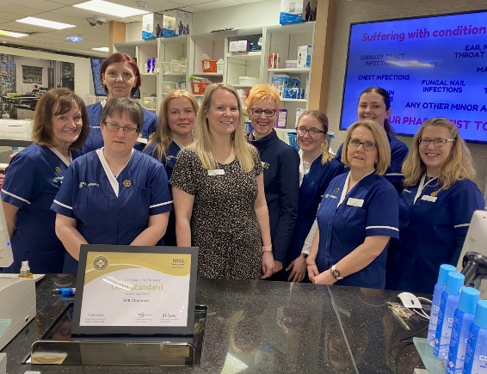

**Will Chemists, Inverurie**

Led by pharmacist Fiona Gray and Public Health Champion Cindy Farquhar. Well done team!

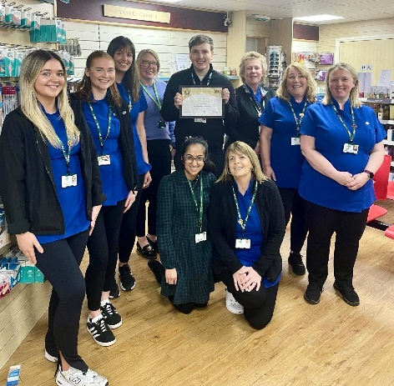**Buchanhaven Pharmacy**

Led by Pharmacy Manager Mary Connelly and Public Health Champion Matthew Mitchell. Great work!

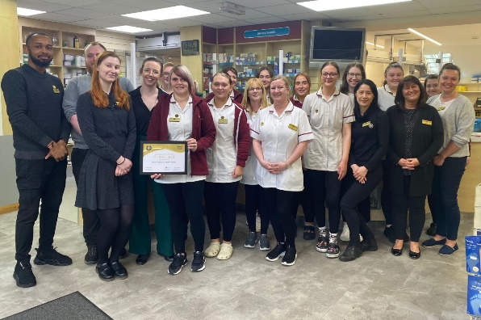**Baird’s Pharmacy, Clifton Road**

Led by Public Health Champion Ashleigh Lowe and supported by Pharmacists Nikki Young and Dougie Forsyth. Huge congratulations!

## **Community Pharmacy Scotland Round-Up**

## **The Happy Place ☺**

FacebookTwitterEmailRedditMore

**Positive Pharmacy Feedback, Boots Mannofield**

This week we received brilliant pharmacy feedback from our NHS Grampian colleagues and we wish to give a shout out to Boots Pharmacy, Mannofield, who went above and beyond to seek help and support for a patient. This highlights the unique position that community pharmacy staff are in and how they are vital in identifying and raising concerns about patients, and pro-actively supporting them to get further support.  It really shows some of the great work that goes on in community pharmacy to support vulnerable patients and their efforts were noted and very much appreciated within the Substance Use Service multidisciplinary team (MDT).

Well done to the Boots Mannofield pharmacy team, keep up the good work! ☺

***We would like to continue this section as an opportunity for reward, recognition and good news stories of the teams who read this! Please submit any items for inclusion to:*** [***gram.pharmaceuticalcareservices@nhs.scot***](mailto:gram.pharmaceuticalcareservices@nhs.scot)***.***

*All weekly updates are uploaded to the* [*CP Grampian website*](https://www.communitypharmacy.scot.nhs.uk/nhs-boards/nhs-grampian/newsletters-updates/pcs-weekly-updates/)*.*

*Remember to like our Facebook page for regular updates:* [*Community Pharmacy Grampian – NHSG*](https://www.facebook.com/NHSGrampianCommunityPharmacy/)