

The Community Pharmacy Palliative Care Network

Palliative care drugs stocked per Network
Community Pharmacy *extended palliative care drugs
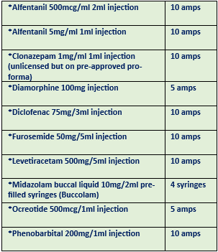
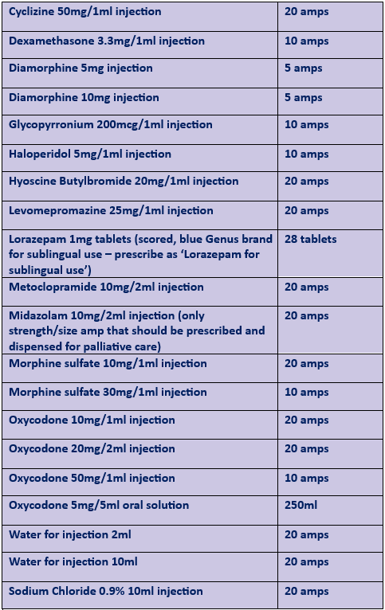
Community Pharmacy Palliative Care Network
Supports safe, effective and efficient provision of palliative care in the community. Although in most circumstances the patient’s usual community pharmacy should be the first port of call, if the medication is not available within a reasonable time the nearest network pharmacy should be contacted by the community pharmacist, patient’s GP or District Nurse to arrange prompt supply.
Within Ayrshire and Arran there are 31 community pharmacies participating in the network, of which 13 of these pharmacies stock the extended list of more unusual palliative medicines. Opening hours of the palliative network pharmacies are detailed below, with the extended palliative care pharmacies highlighted in green.
The palliative care network pharmacy service requires the pharmacy to retain a stock of specialised palliative care medicines and provide advice and support on palliative medicines to community teams.

Key points for prescribers
For some medications or formulations used in palliative care, ampoule size and strength can be specific due to their volume, risk of precipitation and syringe pump compatibility. Please prescribe exactly from the palliative care medicines list detailed to the left to prevent unnecessary delays to families accessing medicines at end of life.
To comply with legal requirements, ensure that clear directions are written on the prescription and for controlled drugs (CD), that the quantity is written in words and figures.
If medication is urgently required, please communicate this on the prescription by annotating URGENT or by phoning the pharmacy. If medication is for a JUST IN CASE bag, please annotate JIC on the prescription. JIC should not be annotated on urgent palliative care prescriptions.

Key points for pharmacists
Establish the urgency of the prescription, if possible, when it is handed in and appropriately prioritise dispensing the palliative care medication. If the medication strength or ampoule size is not in stock or not on the list, or there is an issue with the legality of the prescription, please do not give the prescription back to the patient/representative – contact the prescriber to resolve the issue. This is often a distressing time for patients and their families who do not have time to waste going to multiple pharmacies for end-of-life medicines.
Confirm recent opioid dose, especially if the prescription is for >30mg morphine or equivalent and you have no PMR history for the patient. Check that the dose increase is safe. For more information and resources go to NHS Community Pharmacy website: https://www.communitypharmacy.scot.nhs.uk/nhs-ayrshire-arran/pages/pharmacy-services/palliative-care/

Out of hours
There is a palliative care bag containing palliative medicines in each of the 3 AUCs centres.

Advice
For palliative care advice please contact:
Specialist Palliative Care Pharmacist – Fiona Knight 01292 269200/ fiona.knight@ayrshirehospice.org 24/7 advice – Ayrshire Hospice 01292 269200

Palliative Drug Network Community Pharmacies – extended palliative care pharmacies highlighted in green.

East North South

CarePoint Pharmacy  178 Main Street  Auchinleck  KA18 2AX  01290 421944  Mon-Fri 9am-5.30pm  Sat 9am-1pm | Morrisons Pharmacy  West Langlands Street  Kilmarnock  KA1 2PY  01563 523030  Mon-Fri 8.30am-8pm  Sat 8am-6pm  Sun 10am-5pm
Cumnock Pharmacy  9B Townhead Street  Cumnock  KA18 1LE  01290 421632  Mon-Fri 9am-5.30pm  Sat 9am-1pm | Well Pharmacy  1/5 Loudoun Street  Mauchline  KA5 5BA  01290 550387  Mon-Fri 9am-1pm 2pm-6pm  Sat 9am-1pm
Doon Valley Pharmacy  5 Cathcartston  Dalmellington  KA6 7QY  01292 551197  Mon-Fri 9am-6pm  Sat 9am-1pm | Farren Pharmacy  45/47 Main Street  Muirkirk  KA18 3QR  01290 661280  Mon-Fri 9am-5pm  Sat 9am-1pm
Dalrymple Pharmacy  6 Main Street  Dalrymple  KA6 6DF  01292 560931  Mon-Fri 9am-1pm 2pm-5.30pm  Sat 9am-1pm | Boots Pharmacy  1 Doonside Avenue  Patna  KA6 7LX  01292 531258  Mon-Fri 9am-6pm  Sat 9am-12.30pm
McConnell Pharmacy  4 Wallace Street  Galston  KA4 8HP  01563 820308  Mon-Fri 9am-5.30pm  Sat 9am-1pm | Stewart Pharmacy  55 High Street  Stewarton  KA3 5BP  01560 483139  Mon-Fri 9am-6pm  Sat 9am-12.30pm
Boots Pharmacy
62/70 King Street
Kilmarnock
KA1 1PA
01563 525356
Mon-Sat 9am-5.30pm
Sun 12pm-4pm

Gallagher Pharmacy  41 Glasgow Street  Ardrossan  KA22 8EP  01294 601761  Mon-Fri 9am-5.30pm  Sat 9am-5pm | Rowlands Pharmacy  28/30 New Street  Stevenston  KA20 3HF  01294 462498  Mon-Fri 9am-6pm  Sat 9am-5pm
Brodick Pharmacy  The Old Pier  Brodick  Isle of Arran  KA27 8AU  01770 302250  Mon-Fri 9am-5pm  Sat 9am-1pm | Gallagher Pharmacy  41 Hamilton Street  Saltcoats  KA21 5DT  01294 463524  Mon-Fri 9am-5.30pm  Sat 9am-5pm
Boots Pharmacy  1 Fullarton Square  Irvine  KA12 8EJ  01294 272405  Mon-Sat 9am-5.30pm  Sun 11am-5pm | Well Pharmacy  18/20 Main Street  Beith  KA15 2AD  01505 504114  Mon 9am-6pm  Tues-Fri 9am-5.30pm  Sat 9am-1pm
Boots Pharmacy  53 East Road  Irvine  KA12 0AA  01294 279312  Mon-Fri 9am-6pm  Sat 9am-5pm | Townhead Pharmacy  Station Plaza  Pennyburn Road  Kilwinning  KA13 6LB  01294 559898  Mon-Fri 9am-1pm 2pm-6pm  Sat 9am-4pm
Cumbrae Pharmacy  30 Stuart Street  Millport  KA28 0AJ  01475 530248  Mon-Fri 9am-5.30pm  Sat 9am-1pm | Superdrug Pharmacy  6B Aitken Street  Largs  KA30 8AU  01475 674865  Mon-Fri 9am-6pm  Sat 9am-5.30pm  Sun 11am-5pm
Boots Pharmacy
78 Main Street
Kilbirnie
KA25 7AA
01505 682221
Mon-Fri 9am-5.30pm
Sat 9am-1pm

Boots Pharmacy  168/170 High Street  Ayr  KA7 1PZ  01292 269323  Mon-Sat 9am-5.30pm  Sun 12pm-4pm | Toll Pharmacy  151/153 Ayr Road  Prestwick  KA9 1TP  01292 478244  Mon-Fri 8.45am-5.45pm  Sat 9am-1pm
Morrisons Pharmacy  Castlehill Road  Ayr  KA7 2HT  01292 266555  Mon-Fri 8.30am-7pm  Sat 8am-6pm  Sun 9am-5pm | Tarbolton Pharmacy  14 Cunningham Street  Tarbolton  KA5 5QF  01292 541207  Mon-Fri 9am-5.30pm  Sat 9am-12.30pm
Ayr Pharmacy  63/65 Alloway Street  Ayr  KA7 1SP  01292 263448  Mon-Fri 9am-5.30pm  Sat 9am-1pm | Willis Pharmacy  15 Templehill  Troon  KA10 6BQ  01292 312848  Mon-Fri 8.45am-5.45pm  Sat 9am-5pm
Coylton Pharmacy
13 Main Street
Coylton
KA6 6JW
01292 570449
Mon-Fri 9am-1pm 2pm-5.30pm
Sat 9am-12pm
Boots Pharmacy
39 Dalrymple Street
Girvan
KA26 9BS
01465 712234
Mon-Fri 9am-5.30pm
Sat 9am-5pm
Carrick Pharmacy
71 High Street
Maybole
KA19 7AB
01655 882235
Mon-Fri 8.45am-5.30pm
Sat 9am-5pm

